Screen Specification
ComiVerse-A Digital Comic Platform with Integrated Translation and Content Distribution Tools
CVP - Report 4

Project Name | ComiVerse
SRS Reference | SRS v1.1.0
TDS Reference | TDS v1.1.0
Spec Version | v1.1.0
Date Created | 11/06/2026
Last Updated | 11/08/2026
Authors | Bùi Quang Hiệp - HE171337  Bùi Việt Hùng - HE163146  Chu Tuấn Ngọc - HE186006  Nguyễn Xuân Hanh - HE180944  Đặng Ngọc Thành - HE186611
Reviewer | Lê Thị Tú Kiên - Instructor
Status | Approved
Design File | https://www.figma.com/make/BYen7sJH4C9hxatyQmVTUu/ComiVerse-Mockup?code-node-id=0-9&p=f&t=HaKnhJ0CEb3jHq4X-0&fullscreen=1

Document Change History
Version | Date | Changes | Author
v1.0.0 | 31/5/2026 | Begin 1.1 Design Principles ,2.1 User Roles & Navigation Access and 2.2 Site Map | Bùi Quang Hiệp
v1.0.0 | 1/6/2026 | Begin to do part 4 Screen Specifications | Bùi Quang Hiệp
v1.0.0 | 3/6/2026 | Edit part 1 , part 2 | Chu Ngọc Tuấn Nguyễn Xuân Hanh
v1.0.0 | 5/6/26 -10/6/26 | Edit part 4 | Bùi Quang Hiệp  Chu Ngọc Tuấn
V1.0.0 | 11/6/2026 | Edit part 4 and begin Appendix A : Screen Index & Design File | All Member
v1.0.0 | 12/6/26 | Edit part 4 | All Member
v1.0.0 | 6/7/26 | Edit part 4 | All Member
v1.1.0 | 8/3/25 | Edit part 1 , 2 | Bùi Quang Hiệp

Part 1 — Design Language

1.1 Design Principles
# | Principle | What It Means in Practice
1 | Dark Theme Default | All dedicated workspaces utilize a Deep Dark theme by default. This minimizes eye strain during prolonged working sessions and ensures vibrant comic illustrations and content vividly stand out.
2 | Glassmorphism & Depth | Employs semi-transparent surfaces with subtle hairline borders to establish spatial depth. This distinctively separates information blocks without imposing visual clutter or heaviness.
3 | Dynamic & Fluid Interactions | Every interaction yields intuitive visual feedback. The UI heavily leverages "Liquid Motion" on primary calls-to-action and smooth glow effects upon hover states to make the interface feel alive.
4 | No Data Flicker | Absolute prohibition of rendering raw "Loading..." text or unhydrated layouts while awaiting API responses. Instead, layout-aware Shimmer Skeletons are rendered to maintain the layout structure, completely eliminating jarring Layout Shifts.
5 | Contextual Separation | Strict architectural separation using Role-based Layouts. Users are contextually isolated within their assigned role's Workspace, preventing menu bloat and cognitive overload.

1.2 Colour Palette

Brand / Primary Colours
Name | Hex | Usage
Primary Accent | #a855f7 | Primary focal point in Dark Mode, standalone icons, and highlighted active text.
Primary Gradient | #a855f7 to #ec4899 | Applied to Liquid Motion Buttons, active input borders, and prominent dividers.
Brand Sunset | #ff6b35 to #ff9416 | Animated background blob gradients used to achieve fluid liquid effects beneath buttons.

Surface / Background Colors
Name | Hex | Usage
Deep Dark Base | #0d0919 / #0f0a1a | The root application shell and main page background.
Surface Glass | rgba(255,255,255,0.03) | Background fills for Cards, Modals, and Dropdown menus .
Border Subtle | rgba(255,255,255,0.06) | Delicate outlines for structural borders and dividers.

Text / Semantic Colours

Name | Hex | Usage
Text Heading | #ffffff | Primary titles, modal headers, and critical data labels.
Text Body | #94a3b8 / #e2e8f0 | Standard body paragraphs, descriptions, and secondary metadata.
Success / Approve | #22c55e | "Approve" actions, successful state indicators, and positive toast notifications.
Warning / Danger | #ef4444 | Destructive actions, account suspensions, rejections, and critical error states.

1.3 Typography
Font family: Primary: Inter
Fallback: Roboto, Helvetica Neue, sans-serif
Monospace (IDs, codes, tracking numbers): JetBrains Mono, monospace

Style | Size | Weight | Line Height | Used For
heading-1 | 32px | 700 (Bold) | 1.2 | Workspace headers, primary dashboard titles.
heading-2 | 24px | 600 (Semi) | 1.3 | Modal titles, section headings.
heading-3 | 18px | 600 (Semi) | 1.4 | Card titles, subtitle headings.
body-lg | 16px | 400 (Reg) | 1.6 | Comic synopsis, primary descriptive text.
body-md | 14px | 400 (Reg) | 1.6 | Standard body text, form input text.
label | 12px | 500 (Med) | 1.4 | Form field labels (UPPERCASE with letter-spacing for GlassInputs).
button | 14px | 600 (Semi) | 1.0 | Primary calls-to-action, Liquid Motion Button labels.

1.4 Layout Grid & Spacing
Spacing Tokens

Token | Value | Primary Usage
xs | 4px | Inner padding for small tags/badges, icon-to-label gaps.
sm | 8px | Distance between closely related elements.
md | 16px | Default padding inside Glassmorphism cards and standard buttons.
lg | 24px | Gaps between distinct form groups or layout columns.
xl | 32px | Major section separation.

Structural Zones

Layout Zone | Width / Constraint | Width
Left Sidebar | 260px Fixed | Constant navigation for Workspace Roles (Admin, Author, Mod).
Topbar Header | 64px Height | Fixed horizontal bar housing notifications and profile.
Main Content | 100% remaining | Flexbox container filling the viewport, scrolling vertically.
Comic Grid | Responsive | Auto-flowing CSS Grid (minmax(180px, 1fr)) with 16px-24px gaps.
Auth Wrapper | 50% / 50% | Split screen (50% Branding Graphic, 50% Form Container).
Left Sidebar | 260px Fixed | Constant navigation for Workspace Roles (Admin, Author, Mod).
Topbar Header | 64px Height | Fixed horizontal bar housing notifications and profile.

1.5 Iconography
Icon library: Lucide Icons

Icon | Meaning | Must NOT be used for
Navigation | 20px | stroke-width: 2px | Sidebar navigation items (transitions color on hover/active).
Actions | 16px | stroke-width: 1.5px | Edit, Delete, Toggle inside table rows or action bars.
System Status | 24px | stroke-width: 2px | Large indicators for Success, Error, or empty states.
Visibility | 20px | stroke-width: 1.5px | Eye icon strictly used for Password visibility toggles in GlassInputs.

Part 2 — Information Architecture

2.1 User Roles & Navigation Access
Role | Visible Navigation Sections | Landing Page After Login
Guest / Reader | HomeLayout | Omits the Sidebar entirely in favor of a top Header Navigation. Access: Homepage, Explore, Ranking, Forum, Personal Library.
Guest (Auth) | AuthLayout | Split-screen presentation (Left: Artistic Branding, Right: Glassmorphism Authentication Form) for Login and Registration.
Author | AuthorLayout | Dedicated Sidebar. Access: Dashboard Overview, Comic Management, Chapter Uploading, Revenue Analytics.
Moderator | ModeratorLayout | Dedicated Sidebar. Access: Review Queue (Approving new submissions), Project Teams (2-step Wizard Creation & Assignment), Content Report Flags.
Translator | TranslatorLayout | Dedicated Sidebar. Access: Translation Workspace, Assigned Project Teams, Job Pool.
Admin | AdminLayout | Dedicated Sidebar. Access: Account Management (Ban/Role assignment), Platform Financial Statistics, System Configurations.

2.2 Site Map
[Root]
├── [P-01] Login (Guest) [DEEP]
├── [P-02] Register (Guest) [DEEP]
├── [P-03] Recover Password (Guest) [DEEP]
├── [P-04] Homepage (Guest, Reader, Translator, Author, Moderator, Admin) [PRIMARY]
├── Reader Features
│ ├── [P-05] Reader Explore Page (Guest, Reader, Translator, Author, Moderator, Admin) [PRIMARY]
│ ├── [P-06] Ranking Page (Guest, Reader, Translator, Author, Moderator, Admin) [PRIMARY]
│ ├── [P-07] Personal Library Page (Reader, Translator, Author, Moderator, Admin) [PRIMARY]
│ ├── [P-08] Forum Page (Guest, Reader, Translator, Author, Moderator, Admin) [PRIMARY]
│ ├── [P-09] Comic Details (Guest, Reader, Translator, Author, Moderator, Admin) [DEEP]
│ └── [P-10] Comic Reader (Guest, Reader, Translator, Author, Moderator, Admin) [DEEP]
├── Account & Settings
│ ├── [P-11] Premium Plan (Reader, Translator, Author) [SUB]
│ ├── [P-12] Personal Profile (Reader, Translator, Author, Moderator, Admin) [SUB]
│ └── [P-13] User Change Password (Reader, Translator, Author, Moderator, Admin) [DEEP]
├── Translator Workspace
│ ├── [P-14] Translator Dashboard (Translator) [PRIMARY]
│ ├── [P-15] Translator Project Team (Translator) [PRIMARY]
│ ├── [P-16] Translator Payout / Revenue (Translator) [PRIMARY]
│ ├── [P-17] Project Team Homepage (Translator) [DEEP]
│ ├── [P-18] Translator Team Members (Translator) [DEEP]
│ ├── [P-19] Translator Member Requests (Translator Group Leader, Project Manager) [DEEP]
│ ├── [P-20] Members Application Profile (Translator Group Leader, Project Manager) [DEEP]
│ ├── [P-21] Translator Tasks Management (Translator) [DEEP]
│ ├── [P-22] Create Task (Translator Group Leader) [DEEP]
│ ├── [P-23] View Task (Translator) [DEEP]
│ ├── [P-24] Translator Workspace Canvas (Translator) [DEEP]
│ ├── [P-25] Translator Leader Task Review (Translator Group Leader) [DEEP]
│ ├── [P-26] Translator Project Team Setting (Translator Group Leader) [DEEP]
│ ├── [P-27] Request Payout (Translator) [DEEP]
│ └── [P-28] Resign Translator (Translator) [DEEP]
├── Creator Studio
│ ├── [P-29] Author Dashboard (Author) [PRIMARY]
│ ├── [P-30] Author Comic Management (Author) [PRIMARY]
│ ├── [P-31] Author Revenue Analytics (Author) [PRIMARY]
│ └── [P-32] Author Payout (Author) [DEEP]
├── Moderation Desk
│ ├── [P-33] Moderator Dashboard (Moderator) [PRIMARY]
│ ├── [P-34] Comic Approval Queue Page (Moderator) [PRIMARY]
│ ├── [P-35] System Comic Management (Moderator) [PRIMARY]
│ ├── [P-36] Edit System Comic (Moderator) [DEEP]
│ ├── [P-37] Comic Genre Management (Moderator) [PRIMARY]
│ ├── [P-38] Edit Genre (Moderator) [DEEP]
│ ├── [P-39] Chat Monitor (Moderator) [PRIMARY]
│ ├── [P-40] Forum Management (Moderator) [PRIMARY]
│ ├── [P-41] Projects Management (Moderator) [PRIMARY]
│ └── [P-42] Create Project Teams (Moderator) [DEEP]
└── Platform Administration
├── [P-43] Admin Dashboard (Admin) [PRIMARY]
├── [P-44] Admin Revenue Management (Admin) [PRIMARY]
├── [P-45] Admin Account Management (Admin) [PRIMARY]
├── [P-46] Admin Broadcast (Admin) [PRIMARY]
└── [P-47] Admin Payout Management (Admin) [PRIMARY]

2.3 Navigation Patterns

Primary Navigation
Attribute | Specification
Pattern | Top side bar
Desktop width | 240 px
Tablet behaviour | Collapse to Hamburger icon
Mobile behaviour | Collapse to Hamburger icon
Active state | Text on tab color turn black
Badge / count | Number on the bell

In-Page Navigation (Tabs)

Attribute | Specification
Style | Underline tabs
Position | Below page heading, above content area
Mobile | Horizontal scroll if tabs overflow screen width

Breadcrumbs

Attribute | Specification
Format | Only show the “Back button”
Current page
Mobile | Only show the “Back button”

Part 3 — Screen Flows

Flow [F-01] — Reader unlocks and reads premium chapter
Related SRS Scenario | SC-04
Primary Actor | Reader
Entry Point | Homepage
Success End State | Transaction signature is validated, permanent chapter access is granted, and the chapter renders successfully.

Flow Diagram - F-01

Entry Point: Homepage (P-04)]
│
▼
[Step 1: Open Comic Details (P-09) and select a premium chapter]
│
▼
[Step 2: Open Comic Reader (P-10)]
│
├──── [Branch: Insufficient Wallet Balance]
│ │
│ ▼
│ [Alternate path: Redirect to Premium Plan Page (P-11)]
│ │
│ ▼
│ [Resolution: Top-up via VietQR Code]
│
▼
[Step 3: Purchase chapter and validate signature]
│
├──── [Branch: Payment Hook Callback Failure]
│ │
│ ▼
│ [Error handling: System relies on 5-minute background reconciliation]
│ [User option: Click "Verify Payment" client request button]
│
▼
[Success / Confirmation: Comic Reader (P-10) refreshes to display unlocked panels]
│
▼
[End state: Chapter content renders and tracking metrics are saved after 3 seconds of inactivity]

Key Decision Points

Branch | Condition | Outcome
[Authentication] Expired Session | A user's session token exceeds the 30 minutes absolute expiration lifespan. | Terminate the session pipeline, return HTTP 401 Unauthorized, and automatically redirect the client to the Login interface (NAC-02).
[Authentication] Privileged Access | A user holding an Admin or Moderator role logs in without completing 2FA verification. | Suspend active session validation, flag the state as "Pending Enrollment", and block access to control panels with HTTP 403 Forbidden (NAC-03).
[User Setting] Offline Status | Network connectivity drops during UI layout adjustments or reading progress tracking. | Pause remote server synchronization, cache the unsynchronized payload into the Local Cache, and trigger a background batch sync once reconnected (NAC-02).
[User Setting] Data Collision | A user modifies conflicting interface settings on two distinct devices simultaneously. | Resolve the conflict by prioritizing the latest timestamp payload and reject the older request with HTTP 409 Conflict (NAC-03).
[Moderation] Emergency Takedown | A Moderator executes an emergency Unpublish command due to severe DMCA or safety violations. | Instantly remove global visibility (< 2 seconds) and isolate binary files inside a locked, read-only storage bucket (BR-08).
[Kanban] Quality Gate | A Group Leader clicks Submit to Moderator while some sub-tasks remain incomplete or unapproved. | Prevent the status transition, highlight invalid sub-tasks in red on the UI, and return HTTP 422 Unprocessable Entity (NAC-01).
[Comic Reader] Guest Limit | An unauthenticated Guest attempts to load chapter sequence 4 or higher. | Block image delivery, redirect the user to the sign-up interface, and return HTTP 403 Forbidden (NAC-01 / BR-14).
[Comic Reader] Premium Content | An authenticated user successfully requests a premium or locked chapter. | Process images through an inline filter to apply a dynamic watermark containing User ID + UTC timestamp before rendering (BR-13).
[Engagement] Spam Control | A user submits comments within the 30-second cooldown period or exceeds the 5 comments per minute limit. | Block the database write, display a countdown timer on the UI, and return HTTP 429 Too Many Requests (NAC-01 / NAC-02).
[Policy/Audit] Data Privacy | The daily compliance cron job detects an account inactive for more than 365 days. | Start a background worker to remove PII and replace email addresses with randomized hashes to anonymize the account (BR-18).
[Policy/Audit] Strike Escalation | A user reaches the 3rd confirmed copyright or severe safety strike. | Automatically apply global account suspension and revoke all active session keys within 200 milliseconds (BR-08).
[Financial] Wallet Deficit | A user attempts to unlock a premium chapter costing more tokens than available in the wallet (e.g., 50 required, 49 available). | Reject the transaction, keep the chapter locked, and return HTTP 422 Unprocessable Entity (NAC-01).
[Financial] Ledger Imbalance | A calculation error or latency causes credit totals not to match the debit amount during revenue distribution. | Trigger a transaction constraint failure, perform an atomic rollback, and return HTTP 500 Internal Server Error (NAC-02).

Flow [F-02] — Collaborative translation group manages workflow
Related SRS Scenario | SC-02
Primary Actor | Translator
Entry Point | Translator Dashboard
Success End State | Localization pipeline completes and chapter transitions from "Draft" to "Scheduled".

Flow Diagram - F-02
[Entry Point: Translator Dashboard (P-14)]
│
▼
[Step 1: Open Translator Project Team (P-15)]
│
▼
[Step 2: Open Project Team Homepage (P-17)]
│
▼
[Step 3: Access Translator Tasks Management (P-21) and View Task (P-23)]
│
├──── [Branch: Action on Closed/Locked Milestone]
│ │
│ ▼
│ [Alternate path: Show "CANVAS_LOCKED" error code 409]
│
▼
[Step 4: Open Translator Workspace Canvas (P-24), modify text layer and check Glossary]
│
├──── [Branch: Glossary Term Conflict]
│ │
│ ▼
│ [Alternate path: Prompt "Terminology has been updated by another user"]
│
▼
[Success / Confirmation: Task moved to "Ready for Check" state]
│
▼
[Step 5: Group Leader reviews task in Translator Leader Task Review (P-25)]
│
▼
[End state: All sub-tasks approved, leader submits chapter for schedule]

Key Decision Points
Branch | Condition | Outcome
Branch 1 | Group Leader triggers "Submit to Moderator" command AND all constituent sub-tasks under the chapter parent node are completed and approved (BR-04). | Enforce optimistic locking, save the first request, and alert the second user.
Branch 2 | Quality Gate Breach. | If a leader submits while tasks are incomplete, block transition, flag in red, and return HTTP 422 error

Flow [F-03] — Moderator audits community forum and processes violation reports
Related SRS Scenario | SC-03
Primary Actor | Translator
Entry Point | Translator Dashboard
Success End State | Localization pipeline completes and chapter transitions from "Draft" to "Scheduled".
Design File | [Link]

Flow Diagram - F-03
[Entry Point: Moderator Dashboard (P-33)]
│
▼
[Step 1: Open Forum Management (P-40)]
│
├──── [Branch: Mass False Reporting (Spam)]
│ │
│ ▼
│ [Alternate path: System rate-limiting logic detects anomaly]
│ │
│ ▼
│ [Resolution: Temporarily ignore duplicate reports and flag submitters]
│
▼
[Step 2: Review high-priority report ticket against forum thread in Forum Management (P-40)]
│
├──── [Branch: Violation not confirmed]
│ │
│ ▼
│ [Alternate path: Reject report ticket and keep thread visible]
│
▼
[Step 3: Execute "Takedown" action on the forum content]
│
▼
[End State: Hide thread, close ticket, and generate immutable log to Audit Trail]

Key Decision Points
Branch | Condition | Outcome
Branch 1 | Glossary Term Conflict. | Enforce optimistic locking, save the first request, and alert the second user.
Branch 2 | Quality Gate Breach. | If a leader submits while tasks are incomplete, block transition, flag in red, and return HTTP 422 error

Flow [F-04] — Author manages comic metadata and views revenue
Related SRS Scenario | SC-06
Primary Actor | Author
Entry Point | Author Dashboard
Success End State | Comic metadata is stored in the Database and author tracks monetization success on charts
Design File | [Link]

Flow Diagram - F-04
[Entry Point: Author Dashboard (P-29)]
│
▼
[Step 1: Open Author Comic Management (P-30)]
│
├──── [Branch: Upload cover image > 5MB]
│ │
│ ▼
│ [Alternate path: Display "File size exceeds the maximum limit of 5MB"]
│ │
│ ▼
│ [Resolution: Author compresses file and retries upload]
│
▼
[Step 2: Save new comic synopsis and metadata in Author Comic Management (P-30)]
│
▼
[Step 3: Navigate to Author Revenue Analytics (P-31)]
│
▼
[End state: Analytics Engine queries payment records and renders interactive line chart]

Key Decision Points
Branch | Condition | Outcome
Branch 1 | Invalid Metadata Format | Frontend intercepts the request, rejects the upload, and displays validation error to protect server capacity
Branch 2 | Exceeding Maximum Schedule Window | If a chapter is scheduled more than 30 days in advance, block submission and return HTTP 400 error

Flow [F-05] — Reader customizes reading experience and saves progress
Related SRS Scenario | SC-01
Primary Actor | Reader
Entry Point | Personal Library
Success End State | Reader successfully reads with the selected translation version, and final reading coordinates are saved to the system database.
Design File | [Link]

Flow Diagram - F-05
[Entry Point: Personal Library (P-07)]
│
▼
[Step 1: Open Comic Details (P-09), select a chapter, then open Comic Reader (P-10)]
│
▼
[Step 2: Begin reading vertically in Comic Reader (P-10)]
│
▼
[Step 3: Open reading toolbar and select "Switch Translation Version"]
│
├──── [Branch: Network Disruption]
│ │
│ ▼
│ [Alternate path: Display localized toast message "Connection lost..."]
│ │
│ ▼
│ [Resolution: Retain already-cached default panels on screen]
│
▼
[Step 4: System dynamically swaps image text layers for the selected group's version]
│
▼
[Step 5: Close browser application]
│
▼
[End State: Frontend captures final coordinates, Backend securely updates progress record]

Key Decision Points
Branch | Condition | Outcome
Branch 1 | Network Disruption. | Temporarily halts version switch, alerts the user, but preserves the reading session UI without breaking it.

Flow [F-06] — Reader manages personal library and receives notifications
Related SRS Scenario | SC-05
Primary Actor | Reader
Entry Point | Explore Page
Success End State | Comic is added to personal library, and push notifications are delivered upon new releases
Design File | [Link]

Flow Diagram - F-06
[Entry Point: Reader Explore Page (P-05)]
│
▼
[Step 1: Open Comic Details (P-09) and click "Bookmark Comic" button]
│
├──── [Branch: Duplicate Bookmark]
│ │
│ ▼
│ [Alternate path: Duplicate already exists in Personal Library (P-07)]
│ │
│ ▼
│ [Resolution: Display notification "Already saved in Favorites collection"]
│
▼
[Step 2: Save to Personal Library (P-07); enable new-release notifications]
│
▼
[Step 3: Author publishes new chapter]
│
├──── [Branch: Push Notification Delivery Failure]
│ │
│ ▼
│ [Alternate path: User's device is offline or notifications disabled]
│ │
│ ▼
│ [Resolution: Store notification in In-App Notification Center]
│
▼
[End State: System delivers push alert or user sees update upon next login]

Key Decision Points
Branch | Condition | Outcome
Branch 1 | Duplicate Bookmark | Prevents duplicate entry and informs the use
Branch 2 | Push Notification Delivery Failure | Fallback to in-app notification center to prevent missed updates

Flow [F-07] — Admin configures system settings and broadcasts
Related SRS Scenario | SC-07
Primary Actor | Admin
Entry Point | Admin Dashboard
Success End State | Platform settings are updated in the database, and a global announcement is distributed to all active users
Design File | [Link]

Flow Diagram - F-07
[Entry Point: Admin Dashboard (P-43)]
│
▼
[Step 1: Request access to "Configure Platform Settings" module]
│ [Current Site Map: no dedicated P-ID for this module]
│
├──── [Branch: Unauthorized Configuration Access]
│ │
│ ▼
│ [Alternate path: Moderator attempts to access Admin route]
│ │
│ ▼
│ [Resolution: RBAC middleware intercepts and returns HTTP 403 Forbidden]
│
▼
[Step 2: Input scheduled downtime parameters and save configuration to database]
│
▼
[Step 3: Navigate to Admin Broadcast (P-46) and draft notice]
│
▼
[End State: Publish notice; Notification Service broadcasts the global banner]

Key Decision Points
Branch | Condition | Outcome
Branch 1 | Unauthorized Configuration Access | System integrity is maintained by blocking non-Admin roles with an HTTP 403 error

Flow [F-08] — Creator requests payout and Admin executes audit
Related SRS Scenario | SC-08
Primary Actor | Author / Translator
Entry Point | Author Revenue Analytics / Translator Revenue
Success End State | Payout request is approved, accounting ledger matches, and final manual check distribution is initialized
Design File | [Link]

Flow Diagram - F-08
[Entry Point A: Author Revenue Analytics (P-31)]
│
├──── [Author path: Open Author Payout (P-32) and submit payout request]
│
├──────────────────────────────────────────────────────────┐
│ │
[Entry Point B: Translator Payout / Revenue (P-16)] │
│ │
└──── [Translator path: Open Request Payout (P-27) and submit request]
│
▼
[Step 1: Freeze requested amount; mark status "Pending Administrative Review"]
│
▼
[Step 2: Admin reviews records in Admin Revenue Management (P-44)]
│
▼
[Step 3: Admin opens Admin Payout Management (P-47) and processes the queue]
│
├──── [Branch: Ledger Balance Discrepancy]
│ │
│ ▼
│ [Alternate: Payout > certified bank total]
│ │
│ ▼
│ [Resolution: Freeze transaction and flag audit failure]
│ [System flag: "CRITICAL ANOMALY: FAILED AUDIT"]
│ [Action: Halt balance-mutation script]
│
▼
[Step 4: Run "Audit Financial System" module to cross-reference signatures]
│
▼
[End State: Audit passes with zero discrepancies; Admin authorizes the payout row]

Key Decision Points
Branch | Condition | Outcome
Branch 1 | Financial audit query engine processes table matching with zero data discrepancies between requested cash thresholds and raw historical VietQR logs | Admin signs ledger row entry, switches transaction status properties to authorized, and dispatches data payload blocks to manual banking distribution hooks.
Branch 2 | Automated audit scanner flags a structural mismatch where the creator's requested payout balance is higher than the sum of certified bank transaction records. | Payment block system triggers an immediate transactional freeze loop, flags queue entry as "CRITICAL ANOMALY: FAILED AUDIT", and permanently halts balance mutation scripts.

Part 4 — Screen Specifications

4.0 — Shared Layout

4.0.1 — Reader Layout
Shell layout structure
Shell Layout Structure
┌──────────────────────────────────────────────────────────────────────────────┐
│ [ComiVerse Logo] [Home] [Explore] [Ranking] [Library] [Forum] │
│ [Search] [Login] [Register / Account] │
├──────────────────────────────────────────────────────────────────────────────┤
│ │
│ [Featured Comic / Page Header Area] │
│ │
├──────────────────────────────────────────────────────────────────────────────┤
│ [Category / Content Navigation Tabs] │
├───────────────────────────────────────────────────────┬──────────────────────┤
│ │ │
│ Main Reader Content │ Community Feed │
│ │ │
│ • Recommended Comics │ • Online room │
│ • Updated Comics │ • Recent messages │
│ • Rankings │ • Message input │
│ • Comic Cards │ │
│ │ │
└───────────────────────────────────────────────────────┴──────────────────────┘

Nav Item | Icon | Visible to Roles | Shows Badge?
Home | house | All Roles | No
Explore | compass | All Roles | No
Ranking | trending-up | All Roles | No
Library | book-open | Reader, Translator, Author, Moderator, Admin | No
Forum | message-square | All Roles | No
Login | log-in | Guest | No
Register | user-plus | Guest | No

4.0.2 — Translator Layout
Shell layout structure
Shell Layout Structure
┌──────────────────────┬───────────────────────────────────────────────────────┐
│ Translator Hub │ Workspace: Translator [Bell] [Profile] [Logout] │
│ Translation ├───────────────────────────────────────────────────────┤
│ Management │ │
│ │ [Page Title] │
│ [Dashboard] │ │
│ [Projects] │ [Main Content Area] │
│ [Revenue] │ │
│ [Payout] │ • Summary Cards │
│ │ • Project Information │
│ │ • Activity Lists │
│ │ • Revenue and Payout Information │
│ │ │
│ [Back to Home] │ │
└──────────────────────┴───────────────────────────────────────────────────────┘

Nav Item | Icon | Visible to Roles | Shows Badge?
Dashboard | house | Translator | No
Projects | book-open | Translator | No
Revenue | trending-up | Translator | No
Payout | credit-card | Translator | No
Back to Home | arrow-left | Translator | No

4.0.3 — Author Layout
Shell layout structure
Shell Layout Structure
┌──────────────────────┬───────────────────────────────────────────────────────┐
│ Author Hub │ Workspace: Author [Bell] [Profile] [Logout] │
│ Author Area ├───────────────────────────────────────────────────────┤
│ │ │
│ [Dashboard] │ [Page Title] │
│ [My Comics] │ │
│ [Revenue] │ [Main Content Area] │
│ [Payout] │ │
│ │ • Statistic Cards │
│ │ • Growth Charts │
│ │ • Comic Performance Table │
│ │ • Rating Distribution │
│ │ │
└──────────────────────┴───────────────────────────────────────────────────────┘

Nav Item | Icon | Visible to Roles | Shows Badge?
Dashboard | book-open | Author | No
My Comics | cloud-upload | Author | No
Revenue | trending-up | Author | No
Payout | credit-card | Author | No

4.0.4 — Moderator Layout

Shell layout structure
Shell Layout Structure
┌──────────────────────┬───────────────────────────────────────────────────────┐
│ Moderator Panel │ Workspace: Moderator [Bell] [Profile] [Logout] │
│ Content Management ├───────────────────────────────────────────────────────┤
│ │ │
│ [Dashboard] │ [Page Title] │
│ [Review Queue] [4] │ │
│ [Comic Management] │ [Main Content Area] │
│ [Genre Management] │ │
│ [Project Teams] │ • Moderation Summary Cards │
│ [Chat Monitor] [4] │ • Recent Submissions │
│ [Forum] [2] │ • Forum Reports │
│ │ • Project Team Information │
│ │ │
└──────────────────────┴───────────────────────────────────────────────────────┘

Nav Item | Icon | Visible to Roles | Shows Badge?
Dashboard | layout-grid | Moderator | No
Review Queue | clipboard-check | Moderator | Yes — Displays the number of pending reviews.
Comic Management | database | Moderator | No
Genre Management | filter | Moderator | No
Project Teams | users | Moderator | No
Chat Monitor | message-square | Moderator | Yes — Displays the number of flagged messages.
Forum | hash | Moderator | Yes — Displays the number of unresolved forum reports.

4.0.5 — Admin Layout
Shell layout structure
Shell Layout Structure
┌──────────────────────┬───────────────────────────────────────────────────────┐
│ Admin Portal │ Workspace: Admin [Bell] [Profile] [Logout] │
│ System Administration├───────────────────────────────────────────────────────┤
│ │ │
│ [Statistics │ [Page Title] │
│ Dashboard] │ │
│ [Revenue Management] │ [Main Content Area] │
│ [Account Management] │ │
│ [Broadcast] │ • System Statistic Cards │
│ [Payout Management] │ • User Growth Charts │
│ [System Settings] │ • Content Growth Charts │
│ │ • Revenue and Management Information │
│ │ │
└──────────────────────┴───────────────────────────────────────────────────────┘

Nav Item | Icon | Visible to Roles | Shows Badge?
Statistics Dashboard | bar-chart-3 | Admin | No
Revenue Management | dollar-sign | Admin | No
Account Management | users | Admin | No
Broadcast | megaphone | Admin | No
Payout Management | credit-card | Admin | No
System Settings | settings | Admin | No

4.1 — Login Page
Page ID | P-01
Screen name | Login Page
Design file | Figma - Frame “Login Page”
SRS Feature | FT-01
SRS Scenario | SC-01
Roles with access | Guest

Screen States
State | When It Appears | Design File Frame
Populated — default | The baseline login interface layout displayed when a user first navigates to the page. | Login - Populated Default
Loading | The system is processing/verifying login credentials or generating session tokens upon successful authentication. | Loading Frame
Error | Triggered by invalid credentials, mismatched formats, or server connection time-outs. | Error State
Locked | Appears when a user exceeds the maximum allowed failed login attempts within a short window | Login - Locked

Layout Description

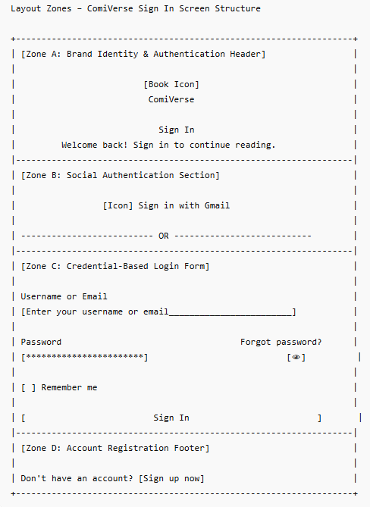

Zone descriptions:
- Zone A: Brand Identity & Form Header
  - Contains the centralized ComiVerse brand logo and visual identity assets.
  - Displays the primary heading "Sign In" together with a short descriptive subtitle introducing the authentication process.
- Zone B: Social Media Quick Login / OAuth
  - Provides a dedicated "Continue with Google" button allowing users to authenticate through Google OAuth services.
  - Includes a horizontal divider labeled "or" separating social authentication from standard credential-based authentication.
- Zone C: Primary Credentials Input Form
  - Identity Input: Contains the "Email or Username" field with the placeholder text "Enter email or username".
  - Password Input: Contains the "Password" field together with the "Forgot Password?" navigation link and password visibility toggle icon.
  - Session Persistence Control: Includes a "Remember Me" checkbox that enables extended session persistence.
  - Primary Authentication Action: Contains a full-width "Sign In" button used to submit credentials for authentication.
- Zone D: Secondary Navigation Footer
  - Establishes a localized user conversion segment positioned at the absolute base of the interface hierarchy.
  - Juxtaposes a passive helper string "Don't have an account?" with an explicit, underlined hyperlink anchor labeled "Sign up now" to switch client application state directly toward the account initialization wizard.

Key Interactions
User Action | What Happens | Notes
Click Sign in with Gmail" button | 1. Dispatches an authorization request payload to the external Google OAuth2 federated service module.  2. Upon successful token return, evaluates internal identity mappings.  3. Staff Entities: Intercepts the workflow and programmatically redirects to the localized 2FA Verification sub-state.  4. General Entities: Instantiates a valid system session token. | FT-01 AC-01, FT-01 AC-03, FT-01 NAC-03
Click password visibility toggle | Alternates the cryptographic visibility attribute of the password input field stream, toggling dynamically between a secure dot-masked array and plaintext string rendering canvas. | FT-01 AC-01
Click "Forgot Password?" hyperlink | Interrupts active page execution context and redirects the browser window location to the global identity credential recovery workspace. | FT-01 AC-01
Click primary "Sign In" button | 1. Executes synchronous client-side data sanitation and regex format validations.  2. Encrypts client credentials and posts a secure payload to the centralized Auth Core API entrypoint.  3. Success: Validates authentication, prompts immediate multi-factor authentication workflow, and holds session generation pending 2FA compliance.  4. Success: Grants access, generates active session token matching a strict 7-day expiration constraint.  5. Failure: Retains form inputs, rejects session instantiation, and renders dynamic validation inline alert messages beneath the non-compliant fields. | FT-01 AC-01, FT-01 AC-02, FT-01 AC-03, FT-01 NAC-01, FT-01 NAC-02, FT-01 NAC-03
Click "Sign up now" hyperlink | Diverts current system application path and commands the browser router to mount the user initialization and registration wizard screen. | FT-01 AC-01

Mockup
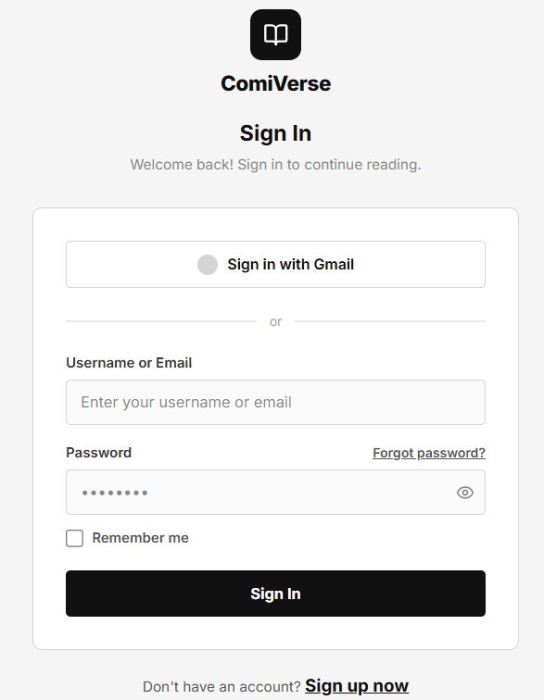
Figure 1: Reader Login Page

4.2 — Register Screen
Page ID | P-02
Screen name | Register
Design file | Figma — Frame "Register Screen"
SRS Feature | FT-01
SRS Scenario | SC-01
Roles with access | Guest

Screen States
State | When It Appears | Design File Frame
Loading | Registration page is loading | Loading Frame
Empty | Initial screen before data entry | Register - Empty
Populated — default | User has entered one or more fields | Register - Default
Error | Validation or registration request fails | Error Frame
Success | Account successfully created | Register - Success

Layout Description
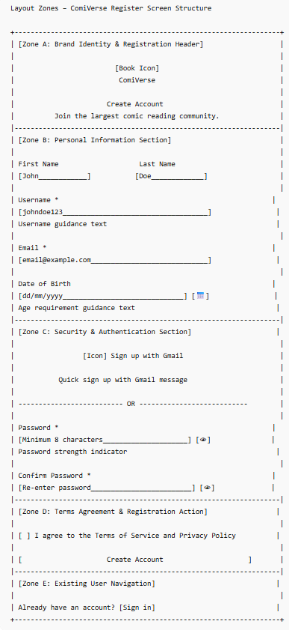

Zone descriptions:
- Zone A: Contains the ComiVerse logo, page title "Create Account", and introductory text describing the platform. No primary action buttons are displayed in this section.
- Zone B: Personal Information section containing user profile fields including First Name, Last Name, Username, Email Address, and Date of Birth. Validation hints are displayed below relevant fields.
- Zone C: Security & Authentication section containing Google Registration, Password, Password Strength Indicator, Confirm Password, and Password Visibility controls. This section supports both standard registration and OAuth-based registration.
- Zone D: Contains the Terms of Service and Privacy Policy acceptance checkbox, the Create Account button, and the Login navigation link for existing users.

Key Interactions
User Action | What Happens | Notes
Enter registration information | System validates format and required fields in real time | FT-01 AC-01, FT-01 NAC-01
Enter password | Password strength indicator updates dynamically | FT-01 AC-01, FT-01 NAC-01
Click password visibility icon | Toggle password visibility | FT-01 AC-01
Click "Sign up with Gmail" | Redirect user to Google OAuth authentication flow | FT-01 AC-01, FT-01 NAC-01
Click "Create Account" | Validate form and create account | FT-01 AC-01, FT-01 NAC-01
Submit invalid form | Display validation messages beside corresponding fields | FT-01 NAC-01
Registration fails | Display error message and allow retry | FT-01 NAC-01
Registration succeeds | Redirect to Login / Email Verification screen | FT-01 AC-01

Mockup
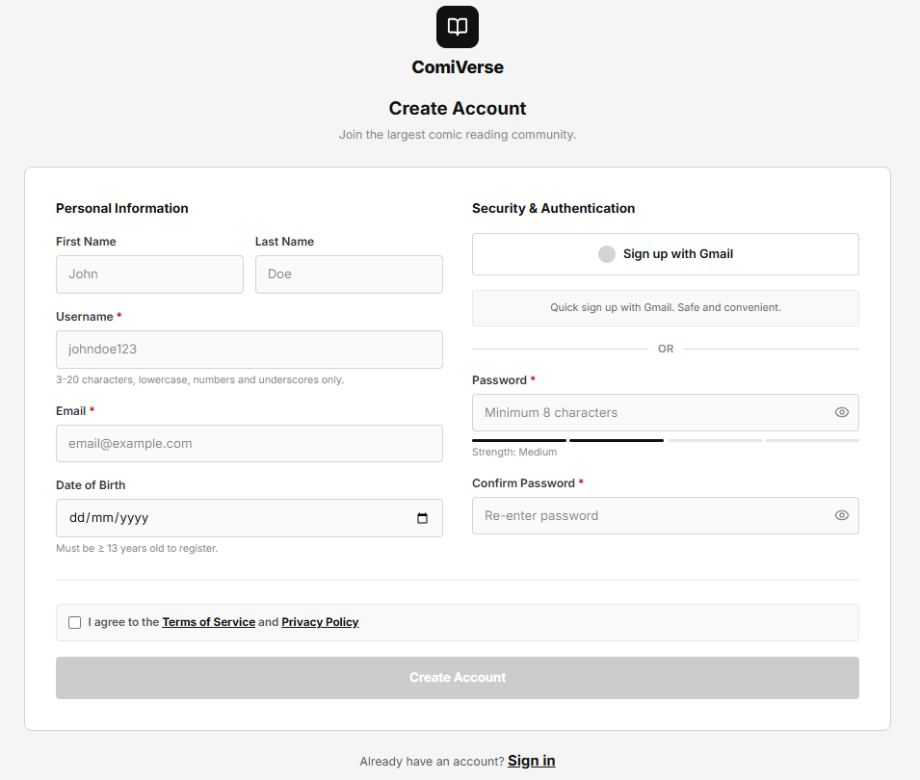

Figure 2: Register Page

4.3 — Recover Password
Page ID | P-03
Screen name | Recover Password
Design file | Figma – Frame "Recover Password"
SRS Feature | FT-01
SRS Scenario | SC-01
Roles with access | All

Screen States
State | When It Appears | Design File Frame
Loading | System is validating email and sending OTP request | Loading
Empty | Initial page before user enters email | Recover Password - Default
Populated — default | Email entered and form ready for submission | Recover Password - Filled
Error | Invalid email format, email not found, or OTP sending failed | Error
Success | OTP sent successfully to registered email | Recover Password - OTP Sent

Layout Description
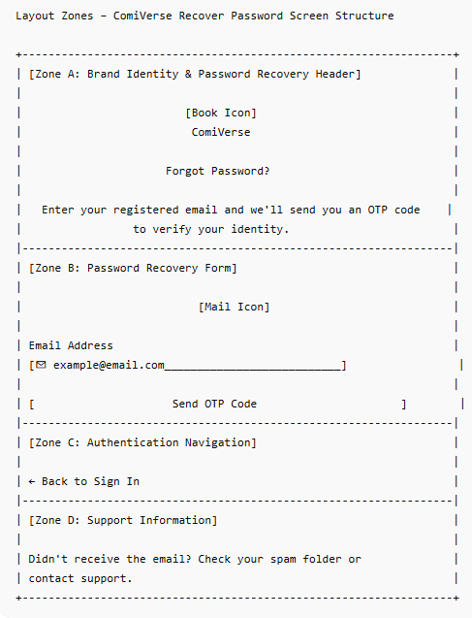

Zone descriptions:
- Zone A: Displays ComiVerse logo, application name, page title "Forgot Password?", and a short instruction informing users to enter their registered email address to receive an OTP verification code.
- Zone B: Contains the password recovery form:
- Email Address input field
- Email icon inside input field
- "Send OTP" primary action button
- Zone C: Provides navigation back to the Login Page through the "Back to Sign in" link.

Key Interactions
User Action | What Happens | Notes
Enter email address | System validates email format in real time | FT-01 NAC-01
Click "Send OTP Code" | System verifies email existence and sends OTP to registered email | FT-01 AC-01
OTP sent successfully | Success notification displayed and user redirected to OTP Verification Page | FT-01 AC-01
Enter invalid email format | Validation error message displayed below email field | FT-01 NAC-01
Email not found | Error notification displayed; OTP not sent | FT-01 NAC-01
Click "Back to sign in" | Navigate to Login Page | FT-01 AC-01
OTP sending failure | Error message displayed with retry option | FT-01 NAC-01
Click Support link | Open Help/Support Page | FT-01 NAC-01

Mockup
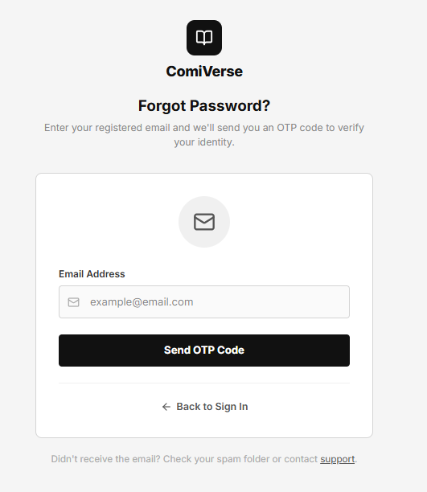
Figure 3: Recover Password

4.4 — Homepage
Page ID | P-04
Screen name | Homepage
Design file | Figma - Frame “Homepage”
SRS Feature | FT-09, FT-10, FT-13
SRS Scenario | SC-01
Roles with access | User

Screen States
State | When It Appears | Design File Frame
Loading | Fetching comic data, featured banner, and chat history. | Loading frame
Empty | First time use with no data, or no comics match the applied filter. | Empty - Homepage
Populated — default | Normal state showing the banner, comic lists, and chat widget as designed. | All Default - Homepage
Error | Failed to connect to the server to fetch comic lists or failed to send a comment. | Error Frame
Filtered | When the user clicks on category filter buttons (Action, Romance, Fantasy...). | Category Default - Homepage

Layout Description
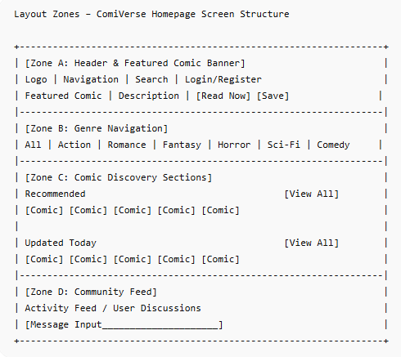

Zone descriptions:
- Zone A: Header navigation including the logo, menu links (Explore, Categories...), search bar, and Login/Register buttons. Right below is the Hero Banner highlighting a featured comic (e.g., "Kiếm Thần Vô Địch") with detailed information and two primary call-to-action buttons: "Read Now" and "Save".
- Zone B: Category filter button row (All, Action, Romance,...). The default state is "All".
- Zone C: Main content area displaying comic card grids, divided into multiple sections: "Recommended for you", "Updated today", and "Newly released". Each card includes a cover image placeholder, comic title, and the latest chapter number. Each row has a "See all >" link on the right.
- Zone D: Right sidebar for the "World Chat" widget, showing a real-time community chat/comment stream. The bottom of the widget has a text input field and a "Send" button for users to participate in the discussion.

Key Interactions
User Action | What Happens | Notes
Click "Login/Register" button in Zone A | Opens Login modal or navigates to the Auth page. | FT-01 AC-01
Click "Read Now" button on the Hero Banner | Navigates the user directly to the reading interface of the latest (or first) chapter of the featured comic. | FT-10 AC-01, FT-10 NAC-01
Click a filter button (e.g., Action) in Zone B | The comic grids in Zone C reload to display only comics belonging to the selected category. | FT-09 AC-01, FT-09 NAC-03
Click a comic card in Zone C | Navigates the user to the Comic Detail Page of that specific card. | FT-10 AC-01, FT-10 NAC-01
Enter text and click "Send" in Zone D | Adds a new comment to the "World Chat" stream. Requires logged-in state; if not logged in, triggers the login popup. | FT-13 AC-01, FT-13 NAC-01, FT-13 NAC-02, FT-13 NAC-03

Mockup
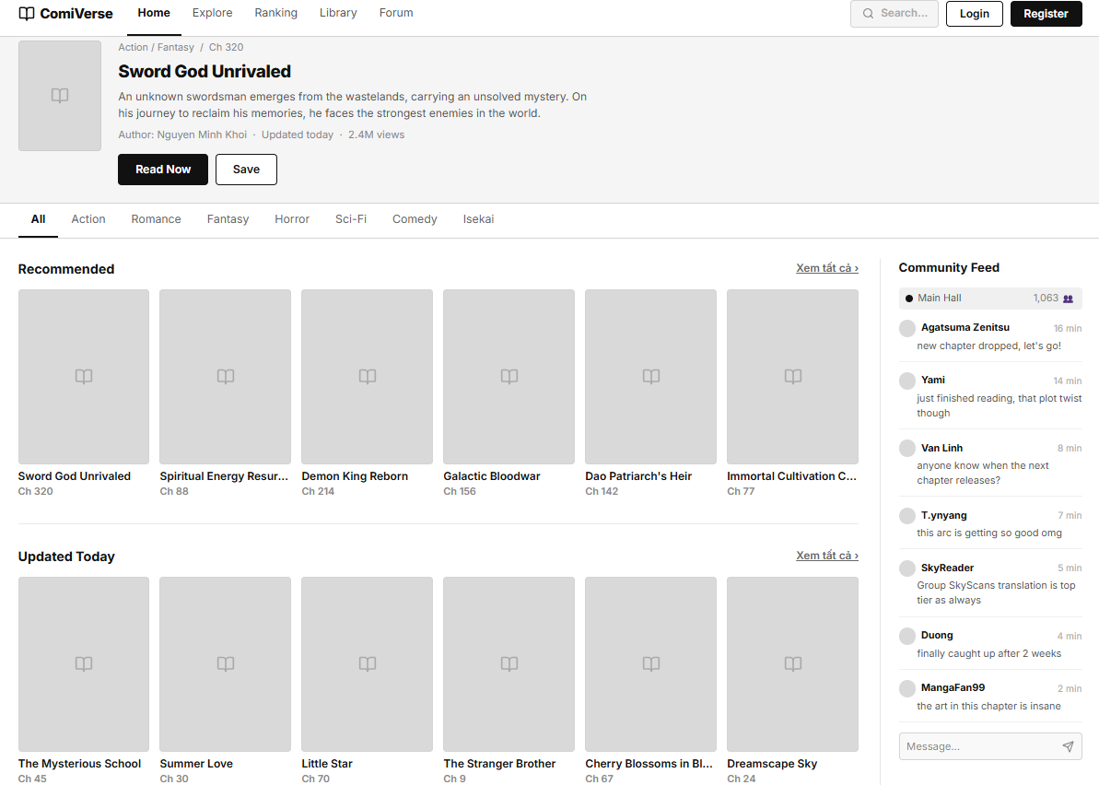
Figure 4: Homepage

4.5 — Comic Details
Page ID | P-05
Screen name | Comic Details
Design file | Figma - Frame “Comic Details”
SRS Feature | FT-01, FT-09, FT-10, FT-12
SRS Scenario | SC-01
Roles with access | User

Screen States
State | When It Appears | Design File Frame
Loading | Comic metadata, ratings, and chapter list are being loaded. | Loading Frame
Empty | First time use with no data, or no comics match the applied filter. | Empty - Comic Details
Populated — default | Normal state showing the banner, comic lists, and chat widget as designed. | Default - Comic Details
Error | Failed to retrieve comic information or chapter data. | Error Frame

Layout Description

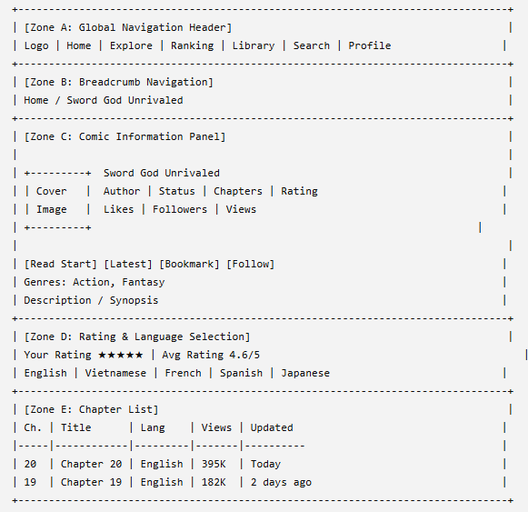
Zone descriptions:
- Zone A — Global Navigation Header, Provides access to platform-wide navigation and user account functions, including logo, search bar, notifications, and authentication controls.
- Zone B — Comic Information Panel, Displays the comic cover image together with core comic metadata. Information includes title, alternative title, author, creation date, translation group, chapter count, publication status, age rating, likes, followers, and total views. This zone also contains the primary action buttons allowing users to start reading, jump to the latest chapter, bookmark the comic, or follow the comic for updates.
- Zone C — Genre & Synopsis, Displays genre/category tags associated with the comic and the comic synopsis. Users can review the story summary and navigate to other comics with similar genres through the displayed tags.

- Zone D — Rating & Language Selection, Allows users to submit personal ratings and view the community average rating together with the total number of votes. This zone also provides language selection options that determine which chapter versions are displayed in the chapter list.
- Zone E — Chapter List, Displays all available chapters for the currently selected language. Each row contains chapter number, chapter title, language, view count, and upload timestamp. Users can select any available chapter to open it in the comic reader.

Key Interactions
User Action | What Happens | Notes
Click "Login/Register" button in Zone A | Opens Login modal or navigates to the Auth page. | FT-01 AC-01
Click "Read Now" button on the Hero Banner | Navigates the user directly to the reading interface of the latest (or first) chapter of the featured comic. | FT-10 AC-01, FT-10 NAC-01
Click a filter button (e.g., Action) in Zone B | The comic grids in Zone C reload to display only comics belonging to the selected category. | FT-09 AC-01, FT-09 NAC-03
Click a comic card in Zone C | Navigates the user to the Comic Detail Page of that specific card. | FT-10 AC-01, FT-10 NAC-01
Enter text and click "Send" in Zone D | Adds a new comment to the "World Chat" stream. Requires logged-in state; if not logged in, triggers the login popup. | FT-12 AC-03, FT-12 NAC-01, FT-12 NAC-02, FT-12 NAC-03

Mockup
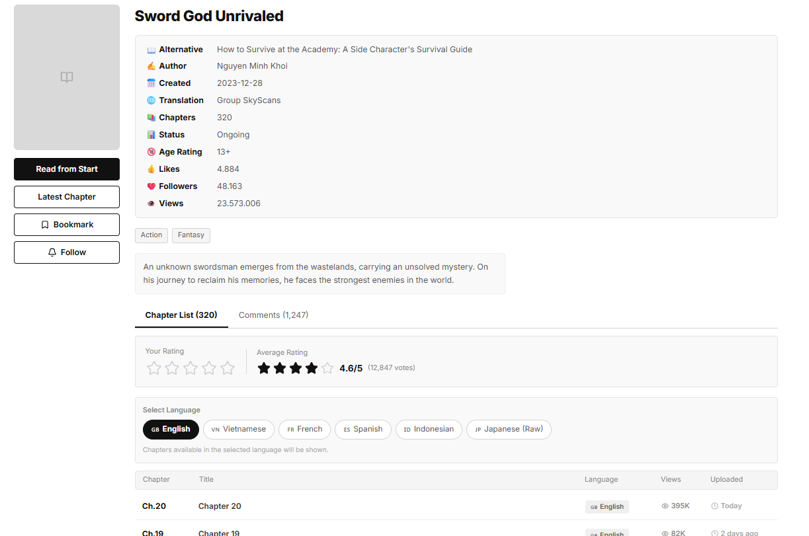
Figure 5: Comic Details

4.6 — Comic Reader
Page ID | P-06
Screen name | Comic Reader
Design file | Figma - Frame “Comic Reader”
SRS Feature | FT-02, FT-10,FT-11
SRS Scenario | SC-01
Roles with access | Guest, Logged-in User

Screen States
State | When It Appears | Design File Frame
Loading | Fetching chapter content, page images, reading preferences, and navigation data. | Loading Frame
Empty | The selected chapter contains no available pages or content cannot be displayed. | Empty - Comic Reader
Populated — default | Normal state showing chapter content, navigation controls, chapter selector, and reading settings. | Default - Comic Reader
Error | Failed to load chapter content, page images, or navigation data from the server. | Error Frame

Layout Description
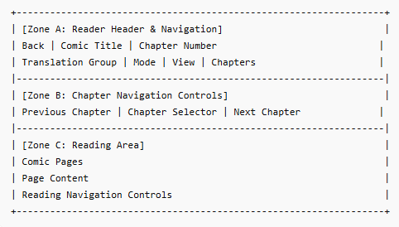
Zone descriptions:
- Zone A: Displays navigation controls including the back button, comic title, current chapter information, translation group selector, reading mode options, view settings, and chapter navigation menu.
- Zone B: Provides chapter navigation controls allowing readers to move to the previous chapter, select a specific chapter, or continue to the next chapter.
- Zone C: Displays comic page content within the reading area and provides page navigation controls for progressing through the chapter.

Key Interactions
User Action | What Happens | Notes
Click "Back" in Zone A | Returns the user to the Comic Detail Page of the current comic. | FT-10 AC-01
Click "Previous" or "Next" in Zone B | Loads the previous or next chapter and updates the reading content. | FT-10 AC-01, FT-10 NAC-01
Select a chapter from the chapter selector in Zone B | Loads the selected chapter into the reading area. | FT-10 AC-01, FT-10 NAC-01
Change reading mode or view settings in Zone A | Updates the reading interface according to the selected display preferences. | FT-02 AC-01, FT-02 AC-02, FT-02 NAC-01
Read through pages in Zone C | Displays comic page content and automatically updates the user's reading progress. | FT-11 AC-01, FT-11 AC-02, FT-11 AC-03, FT-11 NAC-01, FT-11 NAC-02, FT-11 NAC-03

Mockup
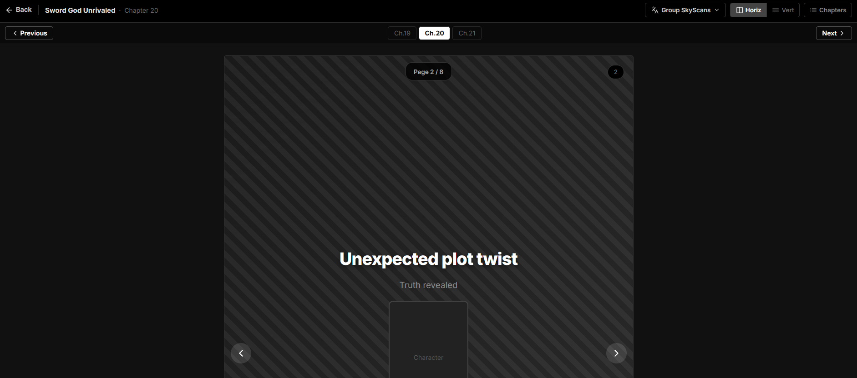
Figure 6: Comic Reader

4.7 — Reader Explore Page
Page ID | P-07
Screen name | Search & Filter Screen
Design file | Figma - Frame “Search & Filter Screen”
SRS Feature | FT-10,FT-09
SRS Scenario | SC-01,SC-04
Roles with access | Guest, Reader, Translator

Screen States
State | When It Appears | Design File Frame
Loading | Data is being fetched | Loading Frame
Empty | No comics match the selected filters or search query (0 kết quả) | Reader Explore - Empty
Populated — default | Normal data present showing all available comics | Reader Explore - Default
Error | Data fetch failed due to network or server issues | Error Frame
Filtered | User selects specific categories, status, or sorting criteria | Reader Explore - Filtered

Layout Description
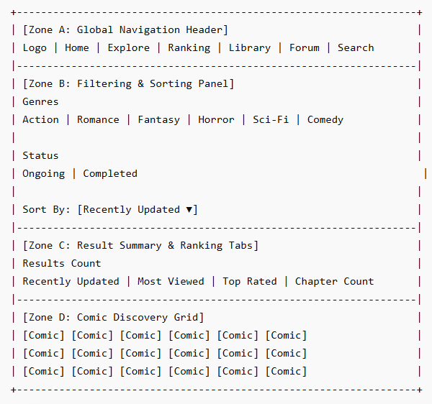

Zone descriptions:
- Zone A: Header navigation including the logo, menu links (Explore, Categories...), search bar, and Login/Register buttons. Right below is the Hero Banner highlighting a featured comic (e.g., "Kiếm Thần Vô Địch") with detailed information and two primary call-to-action buttons: "Read Now" and "Save".
- Zone B: Category filter button row (All, Action, Romance,...). The default state is "All".
- Zone C: Main content area displaying comic card grids, divided into multiple sections: "Recommended for you", "Updated today", and "Newly released". Each card includes a cover image placeholder, comic title, and the latest chapter number. Each row has a "See all >" link on the right.
- Zone D: Right sidebar for the "World Chat" widget, showing a real-time community chat/comment stream. The bottom of the widget has a text input field and a "Send" button for users to participate in the discussion.

Key Interactions
User Action | What Happens | Notes
Click a Genre/Status item (Sidebar) | Highlights the selected filter; content grid dynamically filters and reloads the matching comic list. | FT-09 AC-01, FT-09 NAC-03
Click a Quick Sort Tab (Top Toolbar) | Activates the clicked sorting tab (adds black background active state); reorders the grid items based on the selection. | FT-09 AC-01
Click a Comic Card | Navigates the user to the specific Comic Detail page (P-xx). | FT-10 AC-01, FT-10 NAC-01
Click a Genre Tag inside a Card | Dynamically applies that genre filter in the sidebar and updates the main content grid accordingly. | FT-09 AC-01, FT-09 NAC-03

Mockup
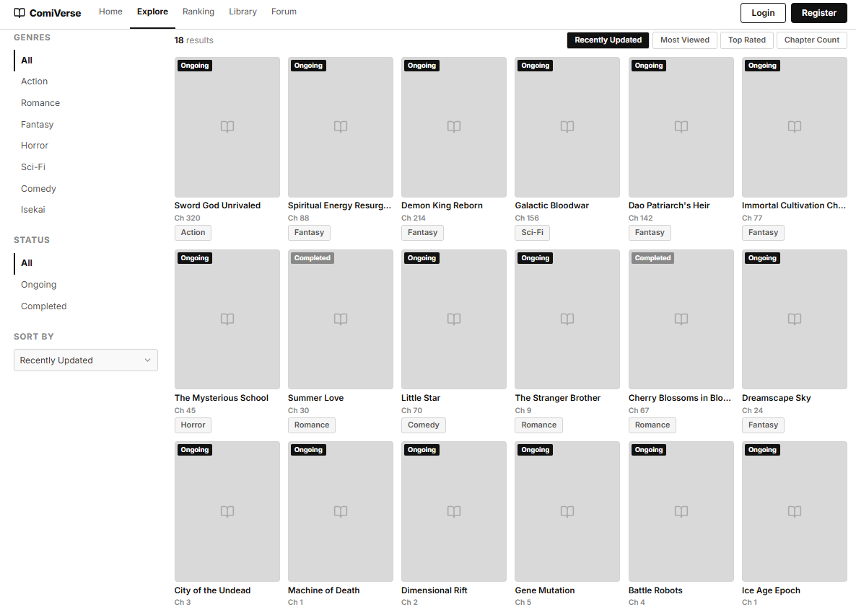

Figure 7: Reader Explore Page

4.8 — Ranking Page
Page ID | P-08
Screen name | Ranking Page
Design file | Figma – Frame "Ranking Page"
SRS Feature | FT-09, FT-10, FT-17
SRS Scenario | SC-01
Roles with access | User

Screen States
State | When It Appears | Design File Frame
Loading | Ranking metrics and comic statistics are being retrieved from the server. | Loading Frame
Empty | No ranking data is available for the selected category or time period. | Ranking Page – Empty
Populated — default | Ranking data is successfully loaded and displayed. | Ranking Page – Default
Error | Ranking data retrieval fails due to network or system errors. | Error Frame
Filtered | User selects a genre or ranking period filter. | Ranking Page – Filtered

Layout Description
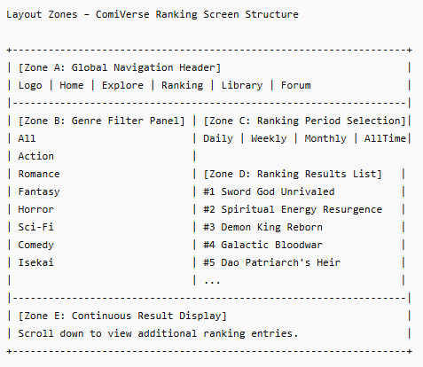

Zone descriptions:
- Zone A: Displays the global navigation bar including the ComiVerse logo, navigation menu, search bar, Premium button, notification icon, and user profile menu.
- Zone B: Displays the page title "Bảng xếp hạng" and ranking update information indicating when the statistics were last refreshed.
- Zone C: Provides ranking filters including genre categories (e.g., Action, Romance, Fantasy) and ranking periods (Day, Week, Month, All-Time). The default period is Week.
- Zone D: Displays the ranking list containing rank position, comic cover image, comic title, author name, genre tags, chapter count, view count, and average rating. Selecting a comic opens its detail page.]
- Zone E: N/A. Ranking results are displayed in a single scrollable list without pagination controls. Continuous scrolling is used to browse additional entries.

Key Interactions
User Action | What Happens | Notes
Click a comic title or row | Navigate to Comic Detail Page | FT-10 AC-01
Select a genre category | Ranking list refreshes using the selected genre filter | FT-09 AC-01
Select Day / Week / Month / All-Time | Ranking metrics are recalculated and displayed for the selected period | FT-17 AC-01
Use search bar | Navigate to Search Results Page with matching comics | FT-09 AC-01, FT-09 NAC-03
Retry after error state | System reloads ranking metrics and ranking data | FT-17 NAC-01

Mockup
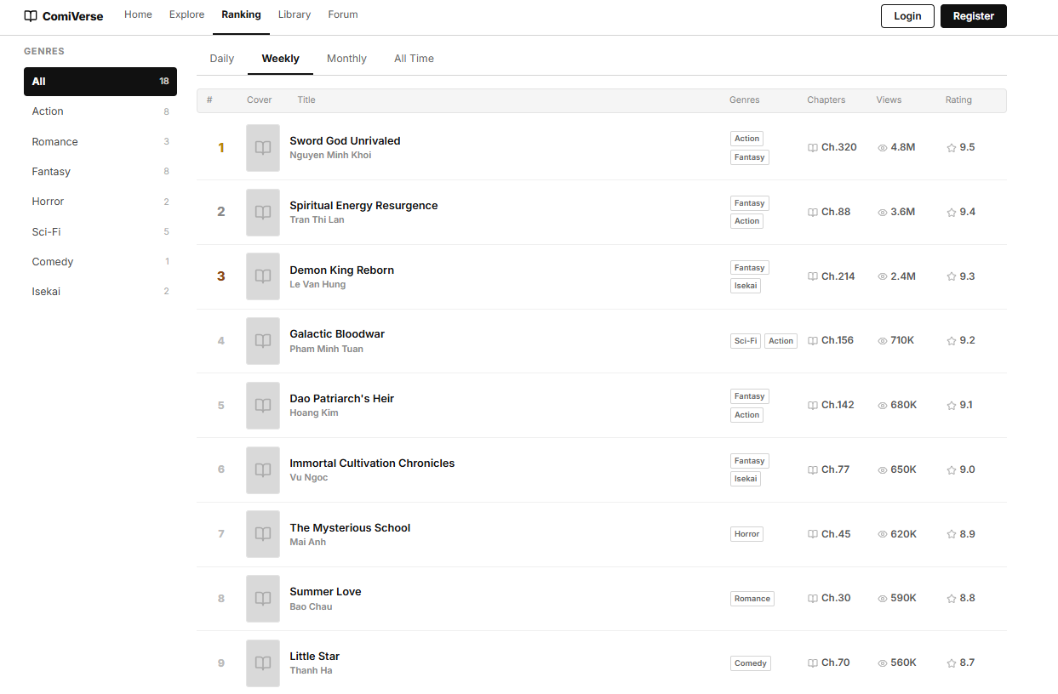
Figure 8: Ranking Page

4.9 — Personal Library Page
Page ID | P-09
Screen name | Library Page
Design file | Figma – Frame "Personal Library Page"
SRS Feature | FT-09, FT-10, FT-11
SRS Scenario | SC-01, SC-05
Roles with access | Reader, Translator, Author, Moderator, Admin

Screen States
State | When It Appears | Design File Frame
Loading | User library and reading progress data are being loaded. | Loading Frame
Empty | User has not added any comics to the library. | Empty Frame
Populated — default | Library data is successfully loaded and displayed. | Library Page – Default
Error | Library data cannot be retrieved due to system or network failure. | Library Page – Error
Filtered | User selects a library tab or sorting option. | Library Page – Filtered

Layout Description
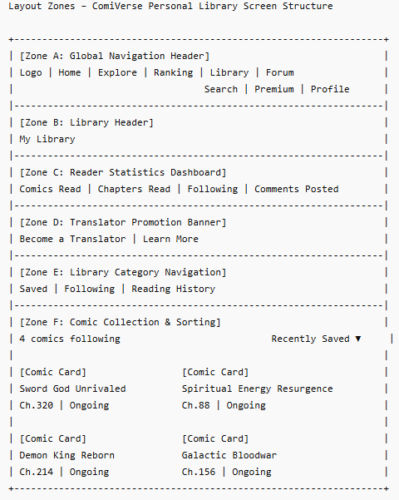

Zone descriptions:
- Zone A: Global Navigation Header, Displays the ComiVerse logo, navigation menu, search functionality, premium access button, notification controls, and user profile menu.
- Zone B: Library Header, Displays the page title "My Library" indicating the user's personal comic collection area.
- Zone C: Reader Statistics Dashboard, Provides a summary of reading activity including comics read, chapters read, followed comics, and comments posted.
- Zone D: Translator Promotion Banner, Promotes translator participation and provides access to additional information about joining translation groups.
- Zone E: Library Category Navigation, Allows users to switch between Saved, Following, and Reading History collections.
- Zone F: Comic Collection & Sorting, Displays comic cards belonging to the selected library category and provides sorting options such as Recently Saved and Recently Updated. Each card shows comic information, status, genres, and latest chapter details.

Key Interactions
User Action | What Happens | Notes
Click a comic card | Navigate to the Comic Detail Page or continue reading from the last saved position. | FT-11 AC-03, FT-10 AC-01
Select Reading / Following / History tab | Library content refreshes according to the selected category. | FT-11 AC-03
Change sorting option | Comic list is reordered based on the selected sorting criteria. | FT-09 AC-01
Continue reading a comic | Open the latest synchronized chapter and reading position. | FT-11 AC-02, FT-11 AC-03, FT-11 NAC-01, FT-11 NAC-02
Retry after error state | Reload library data and reading progress information. | FT-11 NAC-01

Mockup
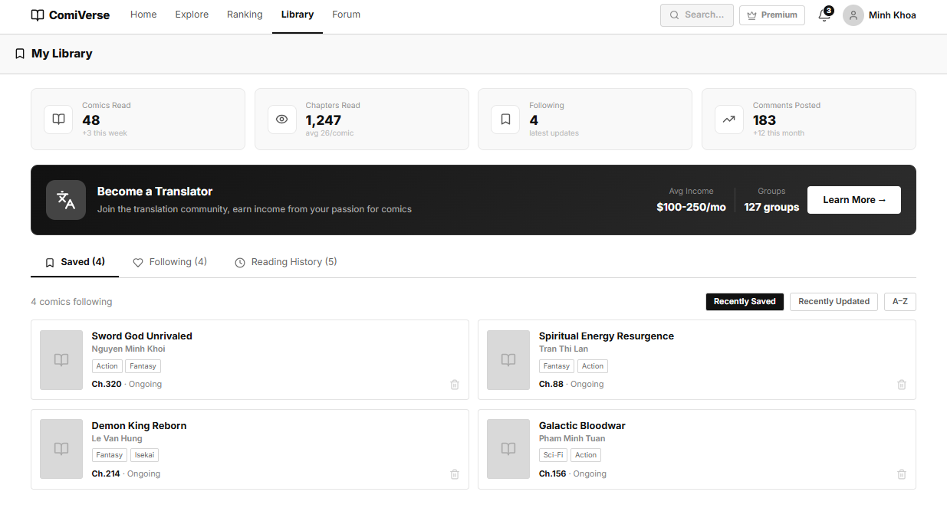
Figure 9: Personal Library Page

4.10 — Forum Page
Page ID | P-10
Screen name | Forum Page
Design file | Figma – Frame "Forum Page"
SRS Feature | FT-13
SRS Scenario | SC-03
Roles with access | Guest, Reader, Translator, Author, Moderator, Admin

Screen States
State | When It Appears | Design File Frame
Loading | Forum categories and discussion threads are being loaded. | Loading Frame
Empty | No discussion threads exist in the selected category. | Forum Page – Empty
Populated — default | Forum categories and thread listings are successfully displayed. | Forum Page – Default
Error | Forum data cannot be retrieved due to system or network failure. | Error Frame
Filtered | User selects a category, thread type, or search keyword. | Forum Page – Filtered

Layout Description
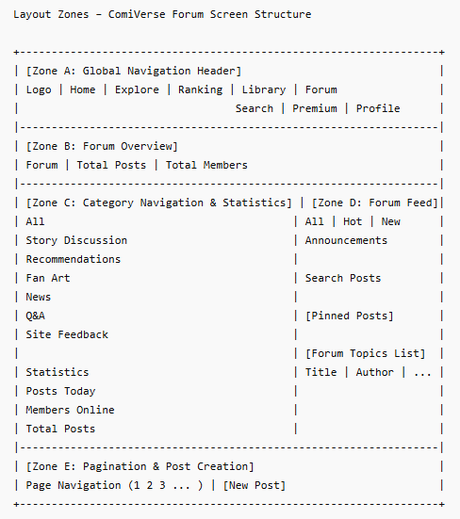
Zone descriptions:
- Zone A: Displays the ComiVerse logo, navigation menu, search functionality, premium access button, notifications, and user profile menu.
- Zone B: Displays forum summary information including the total number of posts and registered members.
- Zone C: Provides forum category filters such as Story Discussion, Recommendations, Fan Art, News, Q&A, and Site Feedback. Also displays forum statistics including posts today, members online, and total posts.
- Zone D: Displays discussion topics and announcements. Provides filtering options such as All, Hot, New, and Announcements, together with a search box for locating posts. Each topic displays title, author, views, replies, likes, and creation time.
- Zone E: Provides page navigation controls for browsing forum topics and a "New Post" button for creating discussions.

Key Interactions
User Action | What Happens | Notes
Click a discussion thread | Navigate to Thread Detail Page. | FT-13 AC-02
Click "New Post" | Open Create Post Page or Post Editor. | FT-13 AC-01, FT-13 NAC-01, FT-13 NAC-02
Select a forum category | Thread list refreshes according to the selected category. | FT-13 AC-02
Search for a keyword | Display matching discussion threads. | FT-13 AC-02
Change page number | Load the corresponding page of forum threads. | FT-13 AC-02

Mockup
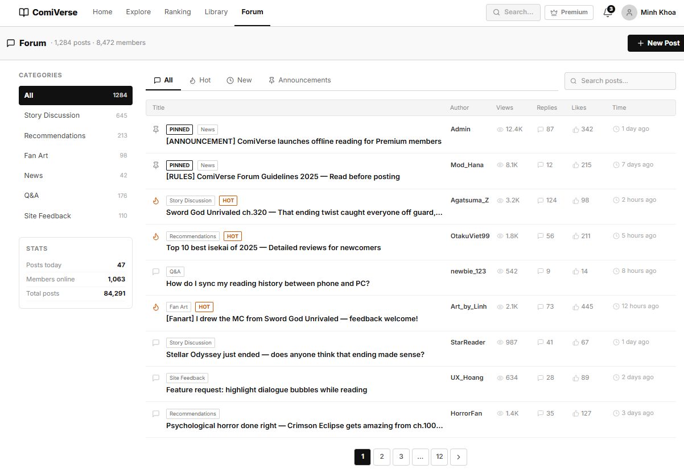
Figure 10: Forum Page

4.11 — Premium Plan
Page ID | P-11
Screen name | Premium Plan Page
Design file | Figma – Frame "Premium Plan Page"
SRS Feature | FT-16
SRS Scenario | SC-04
Roles with access | Reader, Translator, Author, Moderator, Admin

Screen States
State | When It Appears | Design File Frame
Loading | Subscription plans and pricing information are being loaded. | Loading Frame
Empty | No subscription plans are currently available. | Premium Plan – Empty
Populated — default | Available subscription plans are displayed successfully. | Premium Plan – Default
Error | Subscription information cannot be retrieved. | Error Frame
[Other, e.g. Filtered] | User currently has an active subscription plan. | Premium Plan – Active

Layout Description
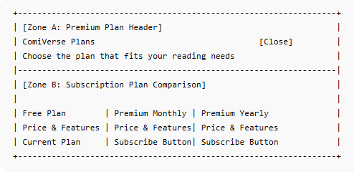

Zone descriptions:
- Zone A: Displays the subscription page title, a brief description of available plans, and a close button for exiting the premium plan dialog.
- Zone B: Displays available subscription plans including Free, Premium Monthly, and Premium Yearly. Each plan presents pricing information, included benefits, feature comparisons, and the corresponding subscription action button.

Key Interactions
User Action | What Happens | Notes
Click "Select Monthly Plan" | Initiates the monthly subscription purchase process. | FT-16 AC-01, FT-16 NAC-01
Click "Select Annual Plan" | Initiates the annual subscription purchase process. | FT-16 AC-01, FT-16 NAC-01
View Plan Details | Display benefits, pricing, and subscription limitations. | FT-16 AC-01
Upgrade from Free Plan | Redirect users to payment and subscription confirmation flow. | FT-16 AC-01, FT-16 NAC-01, FT-16 NAC-02
Close Subscription Window | Return the user to the previous page without changes. | FT-16 AC-01

Mockup
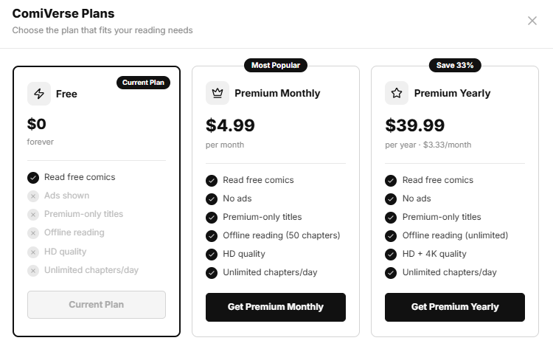

Figure 11: Premium Plan

4.12 — Personal Profile
Page ID | P-12
Screen name | Personal Profile Page
Design file | Figma – Frame "Personal Profile"
SRS Feature | FT-01, FT-02
SRS Scenario | SC-05
Roles with access | Reader, Translator, Author, Moderator, Admin

Screen States
State | When It Appears | Design File Frame
Loading | User profile information is being retrieved from the server. | Loading Frame
Empty | Optional profile fields have not been completed. | Personal Profile – Empty
Populated — default | User profile information is successfully displayed. | Personal Profile – Default
Error | Profile information cannot be loaded or updated. | Error Frame
[Other, e.g. Filtered] | User modifies profile information before saving. | Personal Profile – Edit

Layout Description
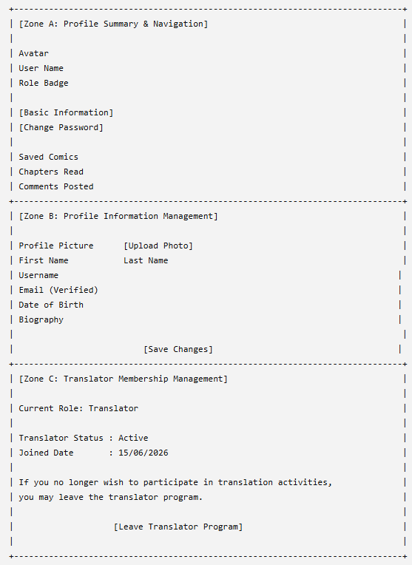

Zone descriptions:
- Zone A — Profile Summary & Navigation
- Displays the user's profile overview and account navigation options. This zone contains the profile avatar, display name, membership information, assigned role badge, and personal activity statistics including saved comics, chapters read, and comments posted. It also provides navigation links for profile-related functions such as Basic Information and Change Password.
- Zone B — Profile Information Management
- Provides profile management functionality that allows users to view and update personal account information. This zone contains profile picture upload controls, editable fields for first name, last name, username, date of birth, and biography, together with email information and verification status. A Save Changes button is provided to validate and persist profile updates.
- Zone C – Translator Membership Management: Displays translator membership information for users currently assigned the Translator role. This zone shows translator status and participation details, and provides the Leave Translator Program action, allowing users to voluntarily withdraw from translator activities. Upon confirmation, the system removes translator privileges and updates the user's role permissions accordingly.

Key Interactions
User Action | What Happens | Notes
Upload a profile picture | System validates and uploads the selected image. | FT-02 AC-01, FT-02 NAC-01, FT-02 NAC-02
Edit profile information | Updated values are entered into editable profile fields. | FT-02 AC-01, FT-02 NAC-01
Click "Save Changes" | The system validates input and saves profile changes. | FT-02 AC-02, FT-02 NAC-01, FT-02 NAC-03
Select "Change Password" | Navigate to Change Password Page. | FT-01 AC-01, FT-01 NAC-01
Retry after error state | Reload profile information or resubmit update request. | FT-02 NAC-02

Mockup
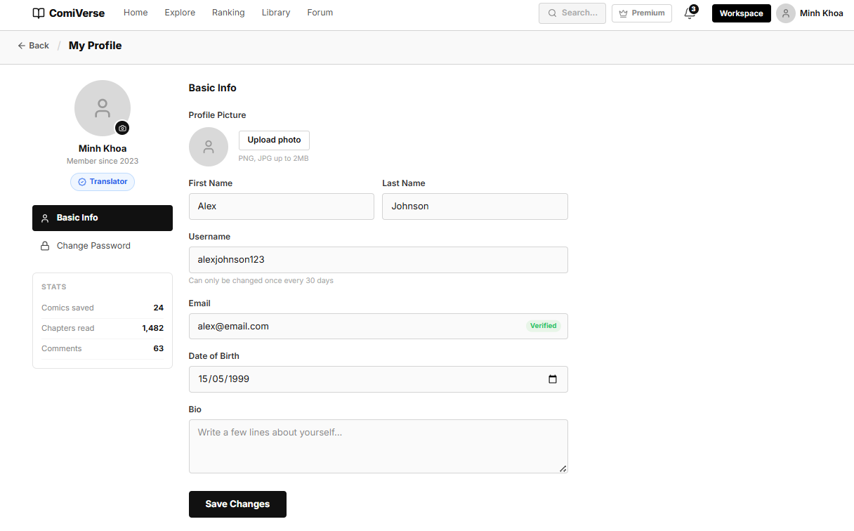

Figure 12: Personal Profile

4.13 — Resign Translator Modal
Page ID | P-13
Screen name | Resign Translator Modal
Design file | Figma — Frame "Resign Translator Modal"
SRS Feature | FT-05, FT-06, FT-07, FT-16, FT-17
SRS Scenario | SC-02
Roles with access | Translator

Screen States
State | When It Appears | Design File Frame
Confirmation — default | The Translator selects the option to resign from the Translator role. The modal explains the consequences and asks for confirmation. | Resign Translator Modal — Default
Processing | The user selects “Yes, Resign” and the system is processing the resignation request. The confirmation button is disabled to prevent duplicate submissions. | Resign Translator Modal — Processing
Blocked | The Translator cannot resign because they still have active project responsibilities, unfinished translation tasks, pending group ownership transfer, or unresolved payout requests. | Resign Translator Modal — Blocked
Error | The resignation request cannot be completed because of a network, authentication, validation, or server error. | Resign Translator Modal — Error
Success | The resignation request is completed successfully. The Translator role and associated permissions are removed, and the account is converted to a regular Reader account. | Resign Translator Modal — Success

Layout Description
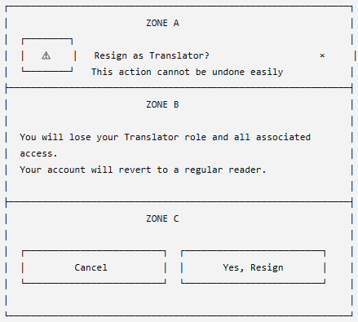
Zone descriptions:
- Zone A: Displays a warning icon, the modal title “Resign as Translator?”, a short warning message, and a close icon. It informs the user that resigning is a significant action that may not be easily reversed.
- Zone B: Describes the consequences of the action. The user will lose the Translator role, access to translator workspaces, assigned projects, translation tools, group-management features, and translator-specific statistics. The account will remain active and revert to the Reader role.
- Zone C: Provides the available actions. The “Cancel” button dismisses the modal without making changes, while the “Yes, Resign” button submits the resignation request.

Key Interactions

User Action | What Happens | Notes
Selects “Resign as Translator” from the account or translator settings page | The system opens the resignation confirmation modal above the current page. | The background page is dimmed and cannot be interacted with while the modal is open.
Selects “Cancel” | The modal closes and the user remains a Translator. | No account, role, project, or permission data is changed.
Selects the close icon (×) | The modal closes without submitting the resignation request. | Behaves the same as the “Cancel” action.
Clicks outside the modal | The modal may close without saving, depending on the configured modal behavior. | Recommended to disable outside-click dismissal because the action is sensitive.
Selects “Yes, Resign” | The system validates the user’s current Translator responsibilities and submits the resignation request. | The button changes to a loading state and is temporarily disabled to prevent duplicate requests.
Has active or unfinished translation tasks | The system blocks the resignation and displays a message requiring the user to complete or transfer the tasks first. | No Translator permissions are removed.
Owns or manages an active translation group | The system requires group ownership or management responsibilities to be transferred before resignation. | Prevents translation groups from being left without an authorized owner or manager.
Has a pending payout or unresolved translator earnings | The system blocks the resignation or requires the financial request to be resolved first. | Existing transaction and earnings records must remain available for audit purposes.
Passes all resignation validations | The system removes the Translator role and translator-specific access permissions. | Historical translations, activities, transactions, and audit records are preserved.
Resignation succeeds | The modal closes, a success notification is displayed, and the user is redirected to the Reader homepage or profile page. | Navigation and available features are refreshed according to the Reader role.
Resignation fails | The modal remains open and displays an error message with an option to retry or cancel. | The user retains the Translator role and all existing permissions.
Presses the Esc key | The modal closes without applying changes. | Should behave the same as “Cancel”, unless disabled for sensitive confirmation dialogs.

Mockup
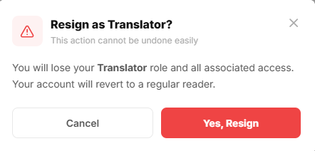
Figure 13: Resign Translator Modal

4.14 — User Change Password
Page ID | P-14
Screen name | User Change Password
Design file | Figma — Frame "User Change Password"
SRS Feature | FT-01, FT-02
SRS Scenario | SC-02
Roles with access | Translator

Screen States
State | When It Appears | Design File Frame
Loading | The system is retrieving the user profile information or processing the password update request. | User Change Password — Loading
Default | The page is loaded successfully and displays the current password, new password, and confirmation fields. | User Change Password — Default
Validation Error | One or more password fields are empty, the current password is incorrect, the new password does not meet security requirements, or the confirmation password does not match. | User Change Password — Validation Error
OTP Verification | The new password has passed validation and the system requires the user to verify the change using an email OTP. | User Change Password — OTP Verification
Success | The password is updated successfully. Other active sessions are terminated and the user is redirected to log in again or shown a success notification. | User Change Password — Success
Error | The password update cannot be completed because of a network, authentication, OTP, or server error. | User Change Password — Error

Layout Description
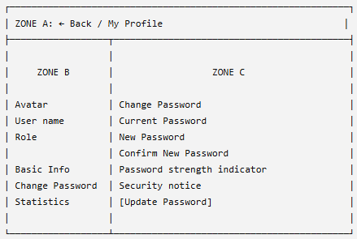
Zone descriptions:
- Zone A: Displays the Back button and breadcrumb showing the current My Profile section.
- Zone B: Displays the user avatar, name, membership date, current role, profile navigation menu, and user activity statistics. The Change Password item is highlighted.
- Zone C: Displays the password-change form, including the current password, new password, confirmation password, password-strength indicator, security warning, and Update Password button.

Key Interactions

User Action | What Happens | Notes
Click Back | Returns to the previous profile page. | Unsaved values are discarded.
Click Basic Info | Navigates to the profile information screen. | —
Enter current password | The system records the password for account verification. | Required field.
Click password visibility icon | Shows or hides the entered password. | Available for all password fields.
Click Forgot password? | Opens the password-recovery process. | Verification through registered email.
Enter new password | The system checks password length and strength. | Must be at least 8 characters and different from the current password.
Enter confirmation password | The system checks whether both new-password values match. | Displays an inline error if they differ.
Click Update Password | Validates the form and submits the password-change request. | Button is disabled while processing.
Validation fails | Displays an error beside the related field. | Password is not changed.
Update succeeds | Displays a success message and signs out other active sessions. | Email OTP verification may be required.
Update fails | Displays an error message and allows the user to retry. | The current password remains unchanged.

Mockup
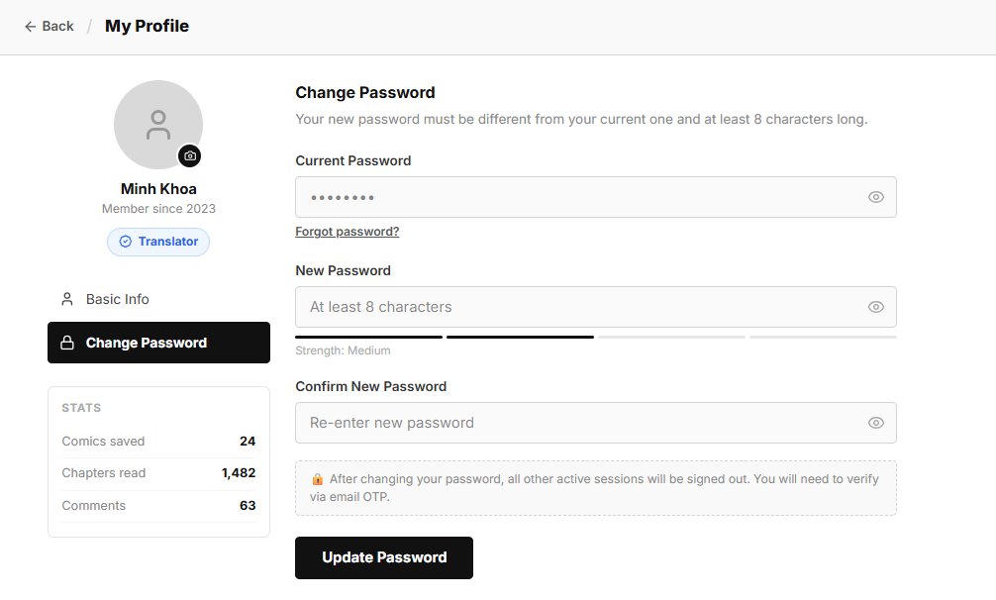
Figure 14: User Change Password

4.15 — Translator Dashboard
Page ID | P-15
Screen name | Translator Dashboard
Design file | Figma — Frame "Translator Dashboard"
SRS Feature | FT-05, FT-06, FT-07, FT-16, FT-17
SRS Scenario | SC-02
Roles with access | Translator

Screen States
State | When It Appears | Design File Frame
Loading | Dashboard statistics, assigned projects, and recent activity data are being retrieved from the server. | Loading Frame
Empty | The translator has not joined any translation groups or has no active assignments. | Translator Dashboard - Empty
Populated — default | Dashboard metrics and recent activities are successfully loaded and displayed. | Translator Dashboard - Default
Error | Dashboard data cannot be loaded due to network, authentication, or server errors. | Error Frame
Updated | Dashboard statistics automatically refresh after a completed chapter submission, approval, or project assignment update. | Translator Dashboard - Updated

Layout Description
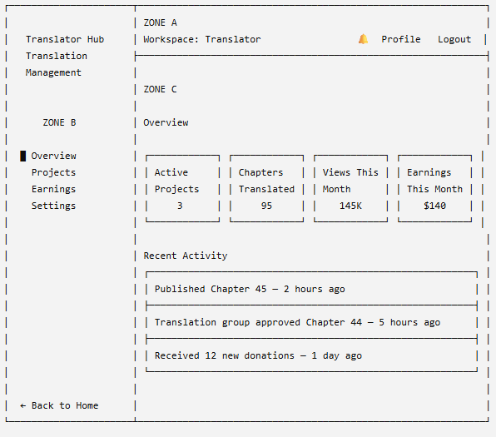
Zone descriptions:
- Zone A: Displays the current Translator workspace, notification control, profile access, and logout action.
- Zone B: Provides navigation to Overview, Projects, Earnings, and Settings, together with the Back to Home option.
- Zone C: Displays dashboard statistics, including active projects, translated chapters, monthly views, earnings, and recent activities.

Key Interactions

User Action | What Happens | Notes
Click Overview | Displays the Translator Dashboard. | Current menu item remains highlighted.
Click Projects | Opens the Translator Projects page. | FT-05, FT-06
Click Earnings | Opens the Translator Earnings page. | FT-16
Click Settings | Opens Translator Account Settings. | FT-05
View statistic cards | Displays current project, chapter, view, and earning totals. | FT-17
Click a recent activity | Opens the related project, chapter, or transaction details. | FT-06, FT-07
Click notification icon | Opens the notification list. | —
Click Profile | Opens the User Profile page. | FT-02
Click Logout | Ends the session and redirects to the Login page. | FT-01
Click Back to Home | Returns to the platform Homepage. | —
Retry after an error | Reloads dashboard statistics and activities. | Existing data is not modified.

Mockup
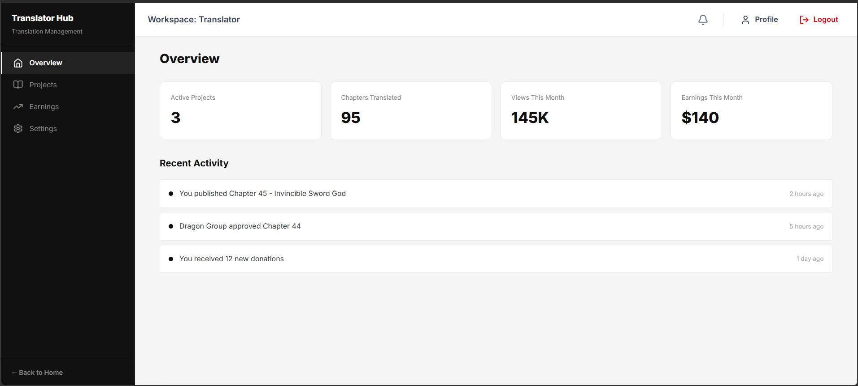
Figure 15: Translator Dashboard

4.16 — Translator Project Team
Page ID | P-16
Screen name | Translator Projection
Design file | Figma — Frame "Translator Projection"
SRS Feature | FT-05, FT-06
SRS Scenario | SC-02
Roles with access | Translator

Screen States
State | When It Appears | Design File Frame
Loading | Translation project data is being fetched from the server. | Loading Frame
Empty | No translation projects are assigned to the translator or no projects match the current criteria. | Translator Projection Empty Frame
Populated — default | Translation projects are displayed with project information, chapter statistics, status, and available actions. | Translator Projection Default Frame
Error | Failed to load project data or perform a project-related action. | Error Frame
Project Selected | Appears after the user clicks "Continue" on a project. The selected project workspace is opened for further work. | Translator Projection Filtered Frame

Layout Description
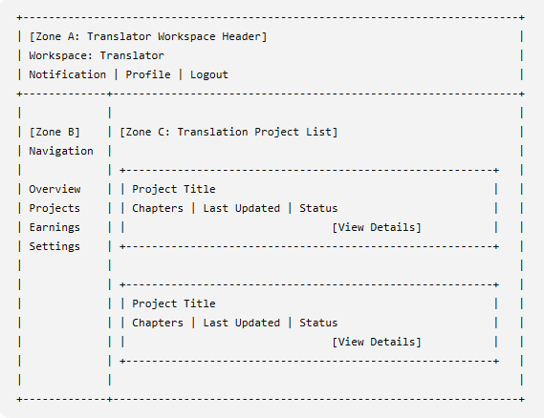
Zone descriptions:
- Zone A — Translator Workspace Header
- Displays the current translator workspace context and account controls. This zone includes the workspace title, notification icon, profile access, and logout functionality. It remains visible throughout the translator workspace to provide quick access to personal account actions.
- Zone B — Translator Navigation Menu
- Provides navigation links to translator workspace modules. Available options include Overview, Projects, Earnings, and Settings. The currently selected module is visually highlighted to indicate the active page.
- Zone C — Translation Project List
- Displays all translation projects assigned to the current translator. Each project card contains project information including comic title, chapter count, latest update timestamp, and project status. This zone also provides access to project-specific actions such as viewing project details and opening the project workspace for translation activities.

Key Interactions
User Action | What Happens | Notes
Click Groups in sidebar | System displays the Translation Groups management page. | FT-06 AC-01
Search or filter groups | Group list reloads based on keyword or selected filter. | FT-06 AC-01
Click Create New Group | System opens a form/modal to create a new translation group. | FT-05 AC-01, FT-06 AC-01
Click a Group Card | The system selects the group and shows available actions. | FT-06 AC-01
Click View Details | System navigates to the selected group detail page. | FT-06 AC-01
Access group without permission | System blocks access and shows an authorization error. | FT-06 NAC-01
Data loading fails | System shows an error state with retry option. | FT-06 NAC-02

Mockup
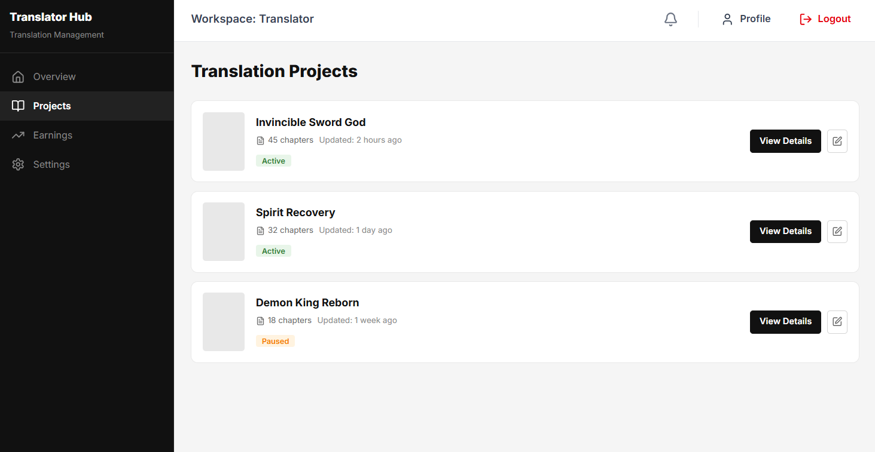Figure 16: Translator Project Team

4.17 — Project Team Homepage
Page ID | P-17
Screen name | Project Team Homepage
Design file | Figma — Frame "Project Team Homepage"
SRS Feature | FT-05, FT-06
SRS Scenario | SC-02
Roles with access | Translator

Screen States
State | When It Appears | Design File Frame
Loading | Translation project data is being fetched from the server. | Loading Frame
Empty | No translation projects are assigned to the translator or no projects match the current criteria. | Project Team Homepage - Empty
Populated — default | Translation projects are displayed with project information, chapter statistics, status, and available actions. | Project Team Homepage - Default
Error | Failed to load project data or perform a project-related action. | Project Team Homepage - Error
Project Selected | Appears after the user clicks "Continue" on a project. The selected project workspace is opened for further work. | Project Team Homepage - Filtered

Layout Description
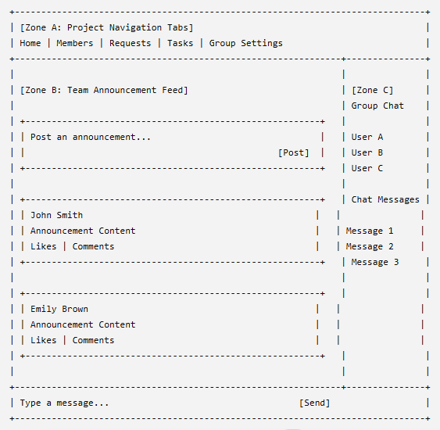

Zone descriptions:
- Zone A: Displays the translator workspace title, notification controls, profile access, and logout functionality.
- Zone B: Provides navigation links to translator modules including Overview, Groups, Projects, Earnings, and Settings.
- Zone C: Displays translation groups associated with the translator. Provides search and filtering capabilities, group summary information, group creation functionality, and access to detailed group management pages.

Key Interactions
User Action | What Happens | Notes
Click Home tab | Displays the project homepage feed. | FT-05 AC-01
Click Members tab | Navigates to the project member management page. | FT-05 AC-01
Click Requests tab | Displays pending member requests and invitations. | FT-05 AC-01
Click Tasks tab | Opens the project task management workspace. | FT-06 AC-01
Click Group Settings tab | Opens project configuration and management settings. | FT-06 AC-01
Enter Announcement and Click Post | Creates a new announcement in the team feed. | FT-05 AC-02
Click Like on a Post | Records the user's reaction to the announcement. | FT-05 AC-02
Click Comment on a Post | Opens the comment section for the selected announcement. | FT-05 AC-02
Send Chat Message | Publishes a new message to the group chat channel. | FT-05 AC-03
Access Project Without Permission | System blocks access and displays an authorization error. | FT-06 NAC-01
Feed or Chat Data Fails to Load | System displays an error state with retry option. | FT-06 NAC-02

Mockup
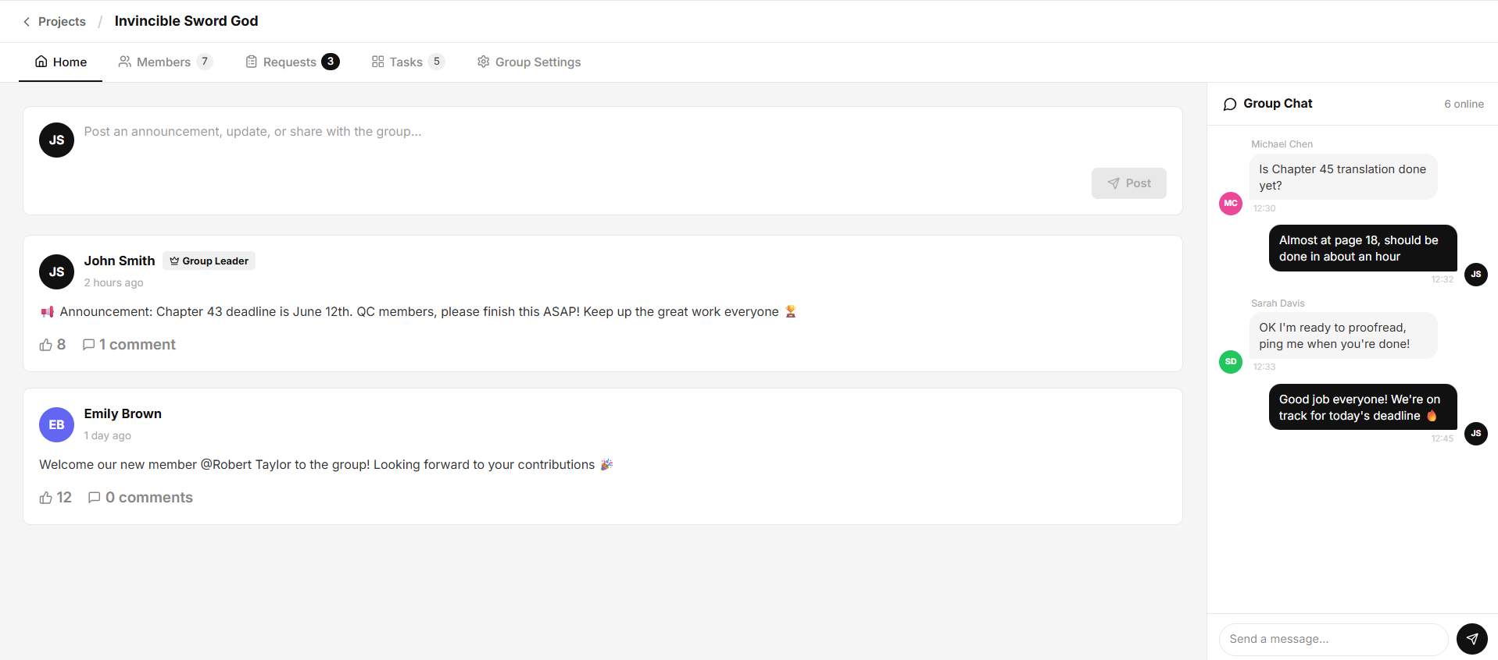
Figure 17: Project Team Homepage

4.18 — Translator Team Members
Page ID | P-18
Screen name | Translator Team Members
Design file | Figma — Frame "Translator Team Members"
SRS Feature | FT-05, FT-06
SRS Scenario | SC-02
Roles with access | Translator

Screen States
State | When It Appears | Design File Frame
Loading | Team member data is being retrieved from the server. | Translator Team Members — Loading
Empty | The team has no members other than the Group Leader or no members match the search keyword. | Translator Team Members — Empty
Populated — default | The member list is loaded successfully. | Translator Team Members — Default
Filtered | The user searches for a member by name. | Translator Team Members — Filtered
Error | Member data cannot be loaded or a management action fails. | Translator Team Members — Error

Layout Description
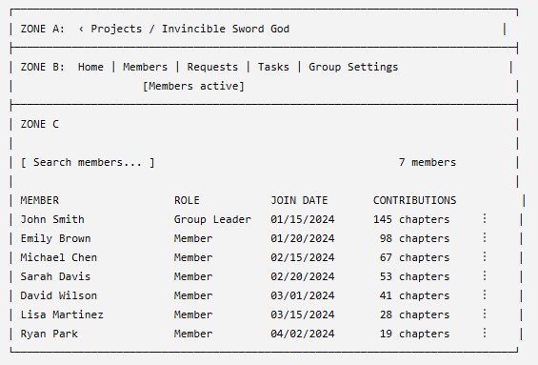
Zone descriptions:
- Zone A: Displays the breadcrumb and current translation project name.
- Zone B: Provides navigation between Home, Members, Requests, Tasks, and Group Settings. The Members tab is highlighted.
- Zone C: Displays the member search field, total member count, and member list with name, online status, role, join date, contribution count, and action menu.

Key Interactions
User Action | What Happens | Notes
Click Home | Opens the project homepage. | FT-05
Click Members | Displays the current team member list. | Active tab
Click Requests | Opens pending membership requests. | FT-05
Click Tasks | Opens the translation task workspace. | FT-06
Click Group Settings | Opens team configuration settings. | Leader or Manager only
Enter a member name | Filters the member list. | Search updates dynamically
Click a member | Opens the selected member’s profile or contribution details. | —
Click the action menu ⋮ | Displays available member-management actions. | Based on user permission
Remove or update a member | The system validates permission and updates the member list. | Leader or Manager only
Access without permission | The system blocks the action and displays an authorization error. | FT-06 NAC-01
Retry after an error | Reloads team member data. | FT-06 NAC-02

Mockup
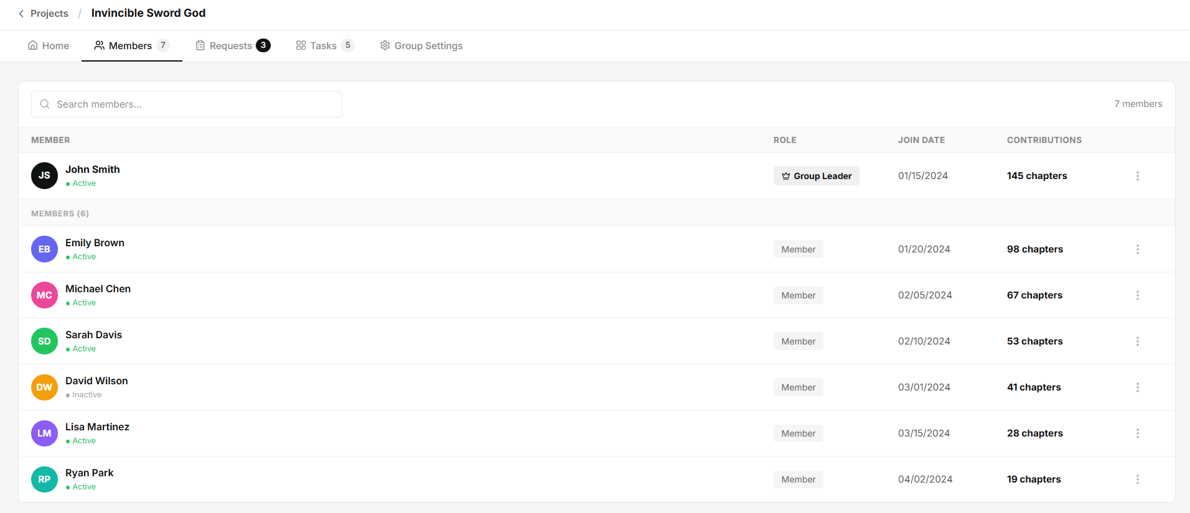Figure 18: Translator Team Members

4.19 — Translator Member Requests
Page ID | P-19
Screen name | Translator Member Requests
Design file | Figma — Frame "Translator Member Requests"
SRS Feature | FT-05, FT-06, FT-07, FT-13
SRS Scenario | SC-02
Roles with access | Translator Group Owner, Group Manager

Screen States
State | When It Appears | Design File Frame
Loading | Member request data is being fetched from the server. | Loading Frame
Empty | No translation projects are assigned to the translator or no projects match the current criteria. | Translator Projection Empty Frame
Populated — default | Translation projects are displayed with project information, chapter statistics, status, and available actions. | Translator Projection Default Frame
Error | Failed to load project data or perform a project-related action. | Error Frame
Project Selected | Appears after the user clicks "Continue" on a project. The selected project workspace is opened for further work. | Translator Projection Filtered Frame

Layout Description
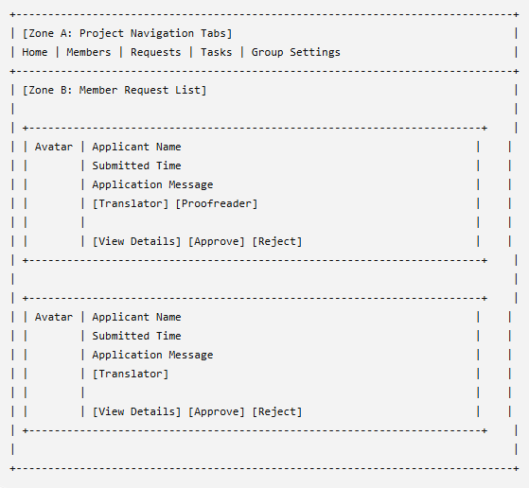
Figure: Translator Member Requests
Zone descriptions:
- Zone A – Project Navigation Tabs: Displays navigation tabs for the current translation project workspace, including Home, Members, Requests, Tasks, and Group Settings. The Requests tab is highlighted to indicate the active page.
- Zone B – Member Request List: Displays all pending membership applications submitted to the translation group. Each request card shows the applicant's avatar, name, submission time, self-introduction message, and requested roles. Group Owners and Group Managers can review applicant information and perform request actions directly from the card.

Key Interactions
User Action | What Happens | Notes
Click View Details | Opens the selected applicant's detailed profile and application information. | FT-13 AC-01
Click Approve | Approves the membership request and adds the applicant to the translation group with the requested role. | FT-07 AC-01, FT-07 AC-02
Click Reject | Displays a confirmation dialog and rejects the selected request after confirmation. | FT-07 AC-03
Click Requests Tab | Displays all pending membership requests for the current project. | FT-05 AC-01
Access Request Management Without Permission | System blocks access and displays an authorization error. | FT-07 NAC-01
Request Data Loading Fails | System displays an error message and provides a retry option. | FT-13 NAC-01
Click View Details | Opens the selected applicant's detailed profile and application information. | FT-13 AC-01

Mockup
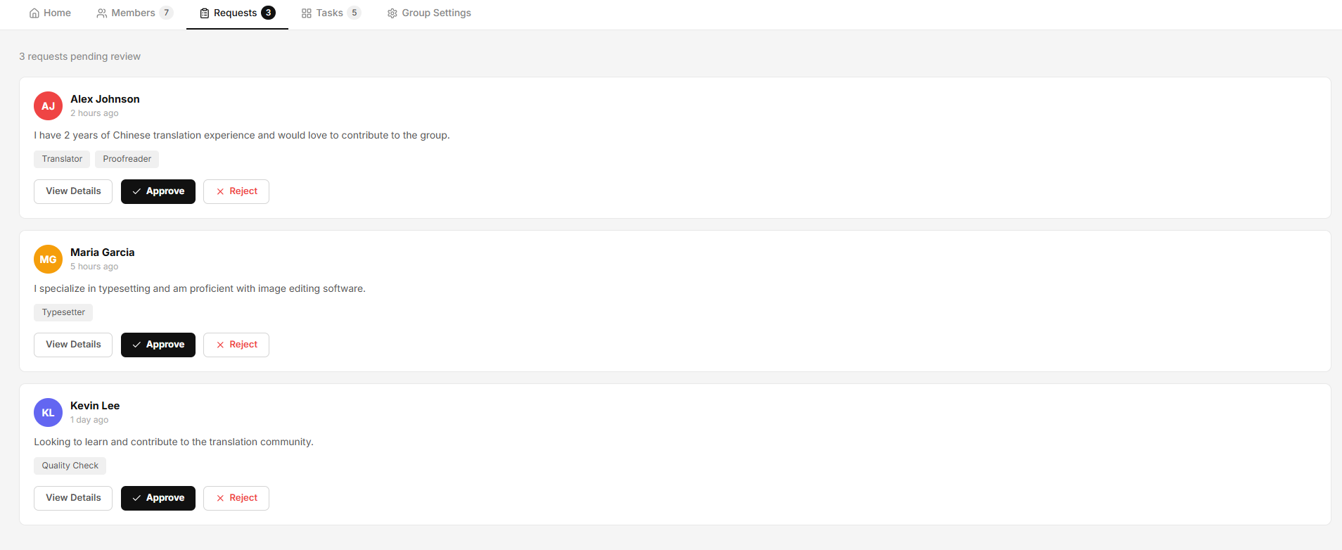Figure 19: Translator Projection

4.20 — Member Application Profile
Page ID | P-20
Screen name | Member Application Profile
Design file | Figma — Frame "Members Application Profile"
SRS Feature | FT-05, FT-06, FT-07, FT-13
SRS Scenario | SC-02
Roles with access | Translator

Screen States
State | When It Appears | Design File Frame
Loading | Applicant profile information is being retrieved from the server. | Loading Frame
Empty | Applicant profile information is unavailable or the application record no longer exists. | Members Application Profile – Empty
Populated — default | Applicant information, introduction, skills, and membership actions are displayed. | Members Application Profile – Default
Error | Failed to load applicant information or process the application decision. | Error Frame
Project Selected | Appears after the application has been approved or rejected and the modal is refreshed or closed. | Members Application Profile – Updated

Layout Description
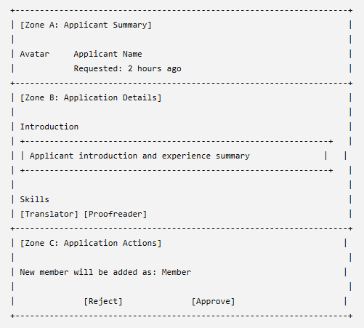

Zone descriptions:
- Zone A – Applicant Summary: Displays the applicant's avatar, display name, and application submission timestamp. This section provides a quick overview of the applicant before reviewing the application details.
- Zone B – Application Details: Displays information submitted by the applicant, including their introduction message, experience summary, and requested contribution skills. Requested roles are presented as skill tags to help reviewers evaluate the application.
- Zone C – Application Actions: Provides actions for reviewing the application. Authorized users can approve or reject the application. The section also displays the role assignment information that will be applied if the applicant is accepted into the group.

Key Interactions
User Action | What Happens | Notes
Open Applicant Profile | Displays the selected applicant's detailed application information. | FT-13 AC-01
Click Approve | Approves the application and adds the applicant to the translation group. | FT-07 AC-01, FT-07 AC-02
Click Reject | Displays a confirmation dialog and rejects the application after confirmation. | FT-07 AC-03
Close Profile Modal | Closes the application profile and returns to the Member Requests page. | FT-13 AC-01
Application Processing Fails | System displays an error message and allows the reviewer to retry the action. | FT-07 NAC-01
User Lacks Permission | System blocks approval or rejection actions and displays an authorization error. | FT-07 NAC-02
Open Applicant Profile | Displays the selected applicant's detailed application information. | FT-13 AC-01

Mockup
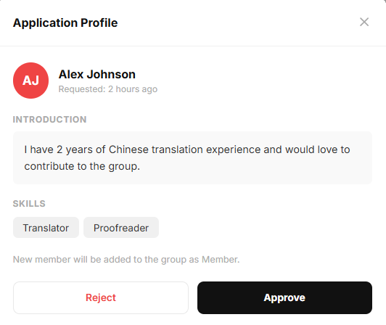
Figure 20: Translator Team Members

4.21 — Translator Tasks Management
Page ID | P-21
Screen name | Translator Tasks Management
Design file | Figma — Frame "Translator Tasks Management"
SRS Feature | FT-05, FT-06, FT-07, FT-13
SRS Scenario | SC-02
Roles with access | Translator

Screen States
State | When It Appears | Design File Frame
Loading | Task board data is being retrieved from the server. | Loading Frame
Empty | No tasks exist in the current project workspace. | Translator Tasks Management – Empty
Populated — default | Tasks are displayed across workflow columns with status and progress information. | Translator Tasks Management – Default
Error | Failed to load task data or perform a task-related action. | Error Frame
Project Selected | Appears after a task is created, moved, or updated and the board is refreshed. | Translator Tasks Management – Updated

Layout Description
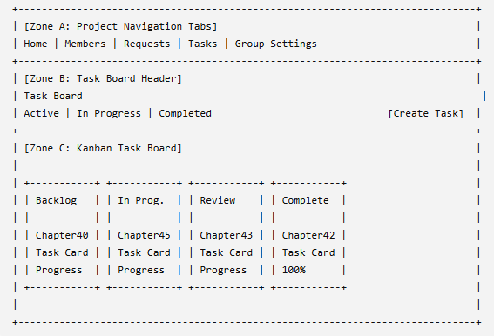

Zone descriptions:
- Zone A – Project Navigation Tabs: Displays navigation tabs for the current project workspace including Home, Members, Requests, Tasks, and Group Settings. The Tasks tab is highlighted to indicate the active page.
- Zone B – Task Board Header: Displays the task board title, workflow summary counters, and task management actions. This zone provides an overview of task distribution across workflow stages and includes the Create Task button for authorized users.
- Zone C – Kanban Task Board: Displays project tasks organized by workflow status columns including Backlog, In Progress, Under Review, and Completed. Each task card contains chapter information, task title, assigned members, progress indicators, priority markers, and update timestamps. Users can monitor task progress and manage workflow activities directly from the board.

Key Interactions
User Action | What Happens | Notes
Click Tasks Tab | Displays the project task management board. | FT-06 AC-01
Click Create Task | Opens the task creation form or modal. | FT-06 AC-02
Click a Task Card | Opens the selected task details page or task editor. | FT-06 AC-01
Move Task Between Columns | Updates the task workflow status and refreshes the board. | FT-06 AC-03
View Task Progress | Displays task completion status and assigned contributors. | FT-06 AC-01
Update Task Information | Saves modifications to task details and progress. | FT-06 AC-03
Access Task Without Permission | System blocks access and displays an authorization error. | FT-06 NAC-01

Mockup
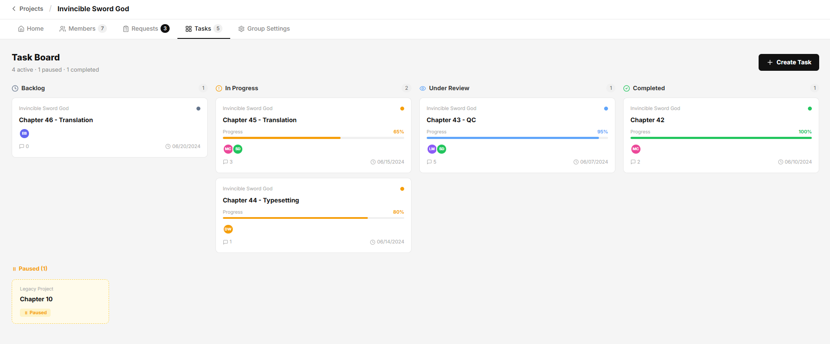Figure 21: Translator Tasks Management

4.22 — Translator Leader Create Task Modal
Page ID | P-22
Screen name | Translator Leader Create Task Modal
Design file | Figma — Frame "Translator Leader Create Task Modal"
SRS Feature | FT-05, FT-06, FT-07, FT-13
SRS Scenario | SC-02
Roles with access | Translator

Screen States
State | When It Appears | Design File Frame
Loading | Required task creation data such as available members is being loaded. | Loading Frame
Empty | No eligible members are available for assignment. | Translator Projection Empty Frame
Populated — default | Task creation form is displayed and ready for input. | Translator Projection Default Frame
Validation Error | One or more required fields contain invalid or missing values. | Error Frame
Submission Error | Task creation fails due to a server or network error. | Error Frame
Task Created | Task is successfully created and the modal closes or refreshes the task board. | Create Task Modal – Success

Layout Description
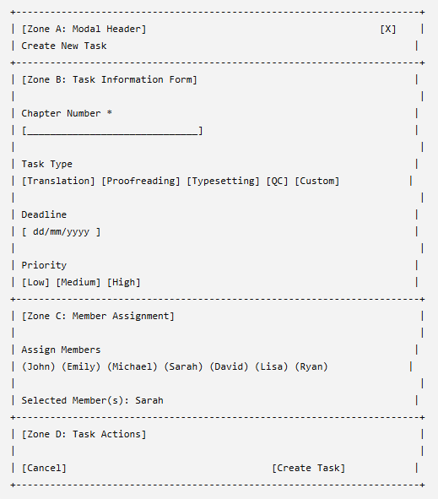
Zone descriptions:
- Zone A – Modal Header: Displays the Create New Task title and provides a close action for dismissing the modal without creating a task.
- Zone B – Task Information Form: Allows users to define task details including chapter number, task type, deadline, and priority level. The form validates required fields before task creation. Priority selection is fixed after task creation as indicated by the interface.
- Zone C – Member Assignment: Displays available project members and allows the creator to assign one or more members to the task. Selected members are visually highlighted. The system may automatically assign the creator to the task when applicable.
- Zone D – Task Actions: Provides actions to cancel task creation or submit the form to create a new task. The Create Task button remains disabled until all required information is valid..

Key Interactions
User Action | What Happens | Notes
Enter Chapter Number | Updates the chapter associated with the task. | FT-06 AC-02
Select Task Type | Assigns the selected workflow type to the task. | FT-06 AC-02
Select Deadline | Sets the task deadline. | FT-06 AC-02
Select Priority | Assigns a priority level to the task. | FT-06 AC-02
Select Member | Adds or removes a member from the task assignment list. | FT-06 AC-02
Click Create Task | Validates all required fields and creates the new task. | FT-06 AC-03
Click Cancel | Closes the modal without saving changes. | FT-06 AC-01
Click Close (X) | Closes the modal without creating a task. | FT-06 AC-01
Submit Invalid Data | Validation errors are displayed and task creation is blocked. | FT-06 NAC-01
Task Creation Fails | System displays an error message and allows retry. | FT-06 NAC-02

Mockup
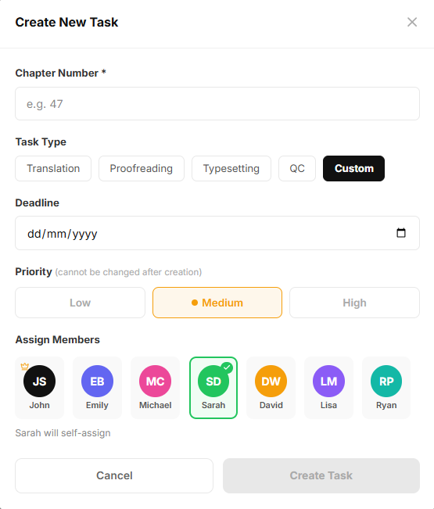
Figure 22: Translator Leader Create Task Modal

4.23 — Translator Leader View Task Modal
Page ID | P-23
Screen name | Translator Leader View Task Modal
Design file | Figma — Frame "Translator Leader View Task Modal"
SRS Feature | FT-05, FT-06, FT-07, FT-13
SRS Scenario | SC-02
Roles with access | Translator

Screen States
State | When It Appears | Design File Frame
Loading | Task details are being retrieved from the server. | Loading Frame
Populated — default | Task information is successfully loaded and displayed. | Empty Frame
Editing | The user modifies task status or progress before saving changes. | Translator Leader View Task Modal – Edit
Error | Failed to load task details or update task information. | Error Frame
Task Updated | Appears after task information is successfully updated. | Translator Leader View Task Modal – Updated

Layout Description
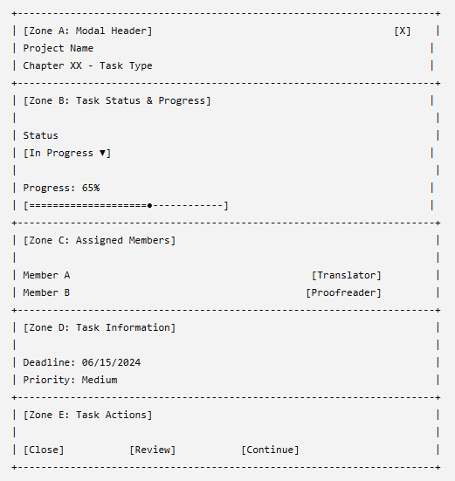

Zone descriptions:
- Zone A – Modal Header: Displays project information, task title, and a close action. This section provides context about the selected task and allows users to dismiss the modal.
- Zone B – Task Status & Progress: Displays the current workflow status and task completion progress. Authorized users can update the task status and adjust progress values to reflect ongoing work.
- Zone C – Assigned Members: Displays all members assigned to the task together with their roles. This section allows users to review responsibility allocation and participant involvement.
- Zone D – Task Information: Displays task metadata including deadline and priority level. Priority is displayed as read-only information once the task has been created.
- Zone E – Task Actions: Provides actions related to task management. Users can close the modal, submit the task for review, or continue working on the task depending on their permissions and workflow status.

Key Interactions
User Action | What Happens | Notes
Open Task Card | Displays detailed task information in the modal. | FT-06 AC-01
Change Task Status | Updates the workflow status of the task. | FT-06 AC-03
Adjust Progress | Updates the task completion percentage. | FT-06 AC-03
Click Review | Submits the task for review and moves it to the review stage. | FT-06 AC-03, FT-07 AC-01
Click Continue | Opens the task workspace and allows further work on the task. | FT-06 AC-01
Click Close | Closes the modal and returns to the task board. | FT-06 AC-01
Click Close Icon (X) | Closes the modal without modifying task data. | FT-06 AC-01
Update Task Fails | System displays an error message and allows retry. | FT-06 NAC-02
User Lacks Permission | System blocks restricted actions and displays an authorization error. | FT-06 NAC-01
Open Task Card | Displays detailed task information in the modal. | FT-06 AC-01

Mockup
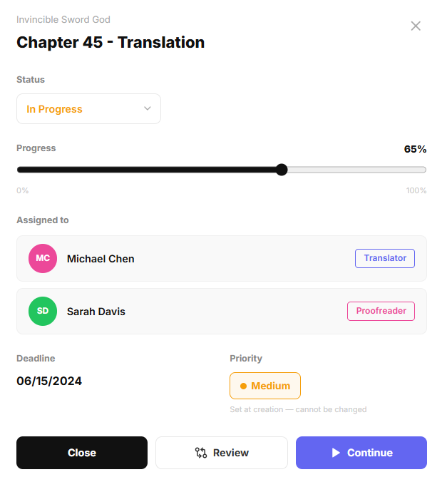
Figure 23: Translator Leader View Task Modal

4.24 — Translator Workspace
Page ID | P-24
Screen name | Translator Workspace
Design file | Figma — Frame "Translator Workspace"
SRS Feature | FT-05, FT-06, FT-07, FT-13
SRS Scenario | SC-02
Roles with access | Translator

Screen States
State | When It Appears | Design File Frame
Loading | Translation workspace assets, chapter pages, and translation data are being loaded. | Loading Frame
Empty | No chapter or page has been selected for translation. | Translator Projection Empty Frame
Populated — default | Translation content, source text, and editing tools are successfully loaded. | Translator Projection Default Frame
Error | Failed to load workspace data or save translation changes. | Error Frame
Saving | Translation changes are being saved to the server. | Translator Workspace – Saving
Translation Updated | Appears after translation content is successfully saved and synchronized. | Translator Workspace – Updated

Layout Description
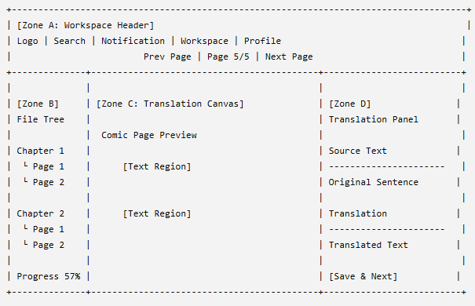

Zone descriptions:
- Zone A – Workspace Header: Displays global workspace controls including navigation links, search functionality, notifications, workspace access, user profile information, chapter navigation controls, and translation mode selection.
- Zone B – Project File Explorer: Displays the project file structure including chapters and pages available for translation. Users can browse chapters, select pages, monitor chapter progress, and navigate between translation assets.
- Zone C – Translation Canvas: Displays the selected comic page and editable text regions. Users can view original page content, select text bubbles, adjust translation overlays, zoom the page, and manage translation placement directly on the canvas.
- Zone D – Translation Editor Panel: Displays source text, translation editing tools, text formatting controls, glossary access, and translation input fields. Users can enter translated content, apply formatting, navigate between text segments, and save translation progress.

Key Interactions
User Action | What Happens | Notes
Select Chapter from File Explorer | Loads pages belonging to the selected chapter. | FT-05 AC-01
Select Page | Displays the selected comic page in the translation canvas. | FT-05 AC-01
Click a Text Region | Loads the corresponding source text into the translation editor. | FT-06 AC-01
Enter Translation Text | Updates the translation content for the selected text region. | FT-06 AC-02
Modify Text Formatting | Applies font, size, alignment, or styling changes to the translated text. | FT-06 AC-02
Switch to Glossary Tab | Displays glossary terms and translation references. | FT-13 AC-01
Click Previous Page | Opens the previous page within the chapter. | FT-05 AC-01
Click Next Page | Opens the next page within the chapter. | FT-05 AC-01
Click Save & Next | Saves current translations and loads the next untranslated item. | FT-06 AC-03
Auto-Save Triggered | System automatically saves translation progress in the background. | FT-06 AC-03
Save Operation Fails | System displays an error message and allows retry. | FT-06 NAC-01
User Lacks Edit Permission | Editing functions are disabled and an authorization message is displayed. | FT-06 NAC-02

Mockup
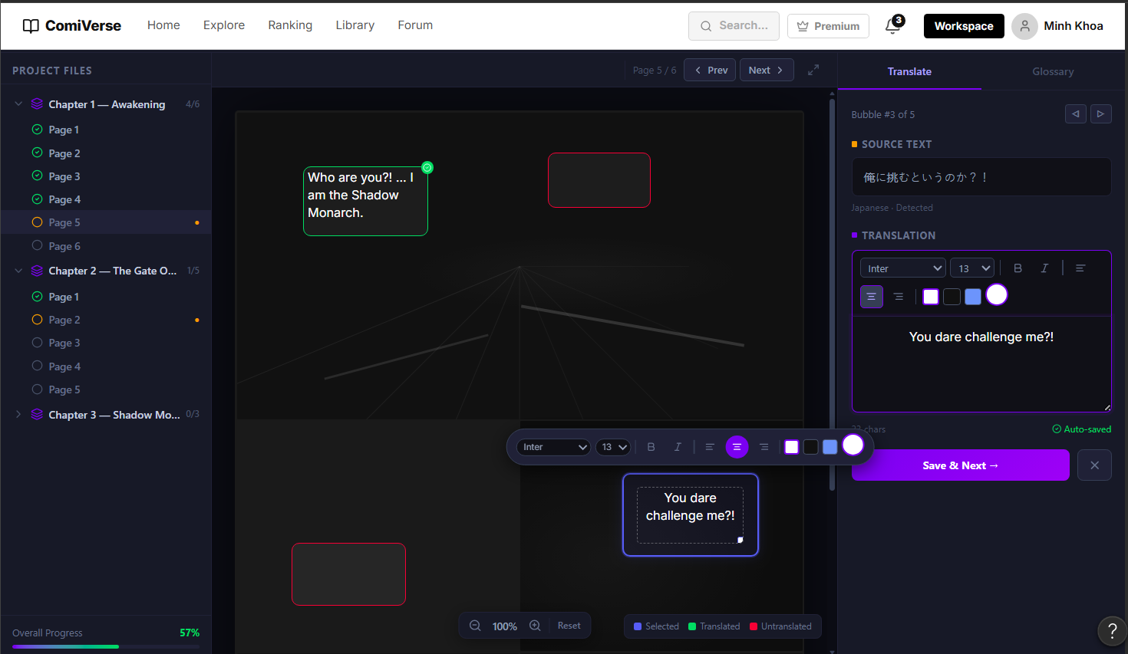Figure 24: Translator Workspace

4.25 — Translator Leader Task Review
Page ID | P-25
Screen name | Translator Leader Task Review
Design file | Figma — Frame "Translator Leader Task Review"
SRS Feature | FT-05, FT-06, FT-07, FT-13
SRS Scenario | SC-02
Roles with access | Translator

Screen States
State | When It Appears | Design File Frame
Loading | Translation review data, comments, and page assets are being loaded. | Loading Frame
Empty | No translated content is available for review. | Translator Leader Task Review – Empty
Populated — Default | Original content, translated content, and review tools are successfully displayed. | Translator Leader Task Review – Default
Commenting | The reviewer is creating or editing a review comment. | Translator Leader Task Review – Commenting
Error | Failed to load review data or submit review feedback. | Error Frame
Review Submitted | Review decision has been successfully submitted. | Translator Leader Task Review – Updated

Layout Description
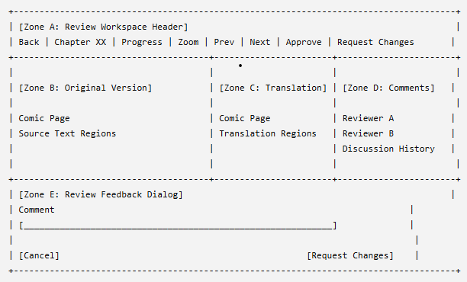

Zone descriptions:
- Zone A – Review Workspace Header: Displays task information, chapter details, review progress, zoom controls, page navigation, and review actions. Authorized reviewers can approve the translation or request revisions directly from this section.
- Zone B – Original Content Preview: Displays the original untranslated comic page for comparison. Reviewers can inspect the source content and compare it against the translated version.
- Zone C – Current Translation Preview: Displays the translated comic page with translated text overlays. Reviewers can select translated text regions and evaluate translation quality, formatting accuracy, and content consistency.
- Zone D – Review Comments Panel: Displays reviewer comments, discussion history, and feedback tools. Reviewers can add comments to specific translation regions, discuss issues with translators, and submit revision requests.
- Zone E – Review Feedback Dialog: Displays the revision request form used when reviewers choose to request changes. The dialog allows reviewers to provide feedback and specify required corrections before resubmission.

Key Interactions
User Action | What Happens | Notes
Open Review Task | Loads the review workspace for the selected translation task. | FT-07 AC-01
Select Translation Region | Highlights the selected translated text and displays related comments. | FT-07 AC-01
Add Review Comment | Creates a comment associated with the selected translation region. | FT-07 AC-02
Reply to Comment | Adds a response to an existing review discussion thread. | FT-07 AC-02
Click Approve | Marks the translation task as approved and moves it to the completed workflow stage. | FT-07 AC-03
Click Request Changes | Opens the revision request dialog. | FT-07 AC-04
Submit Revision Request | Sends feedback to assigned translators and returns the task to an editable state. | FT-07 AC-04
Navigate Between Pages | Loads the previous or next page within the review task. | FT-06 AC-01
Adjust Zoom Level | Updates the preview zoom level for both comparison panels. | FT-06 AC-01
Review Submission Fails | System displays an error message and allows retry. | FT-07 NAC-01
User Lacks Review Permission | System blocks review actions and displays an authorization error. | FT-07 NAC-02

Mockup
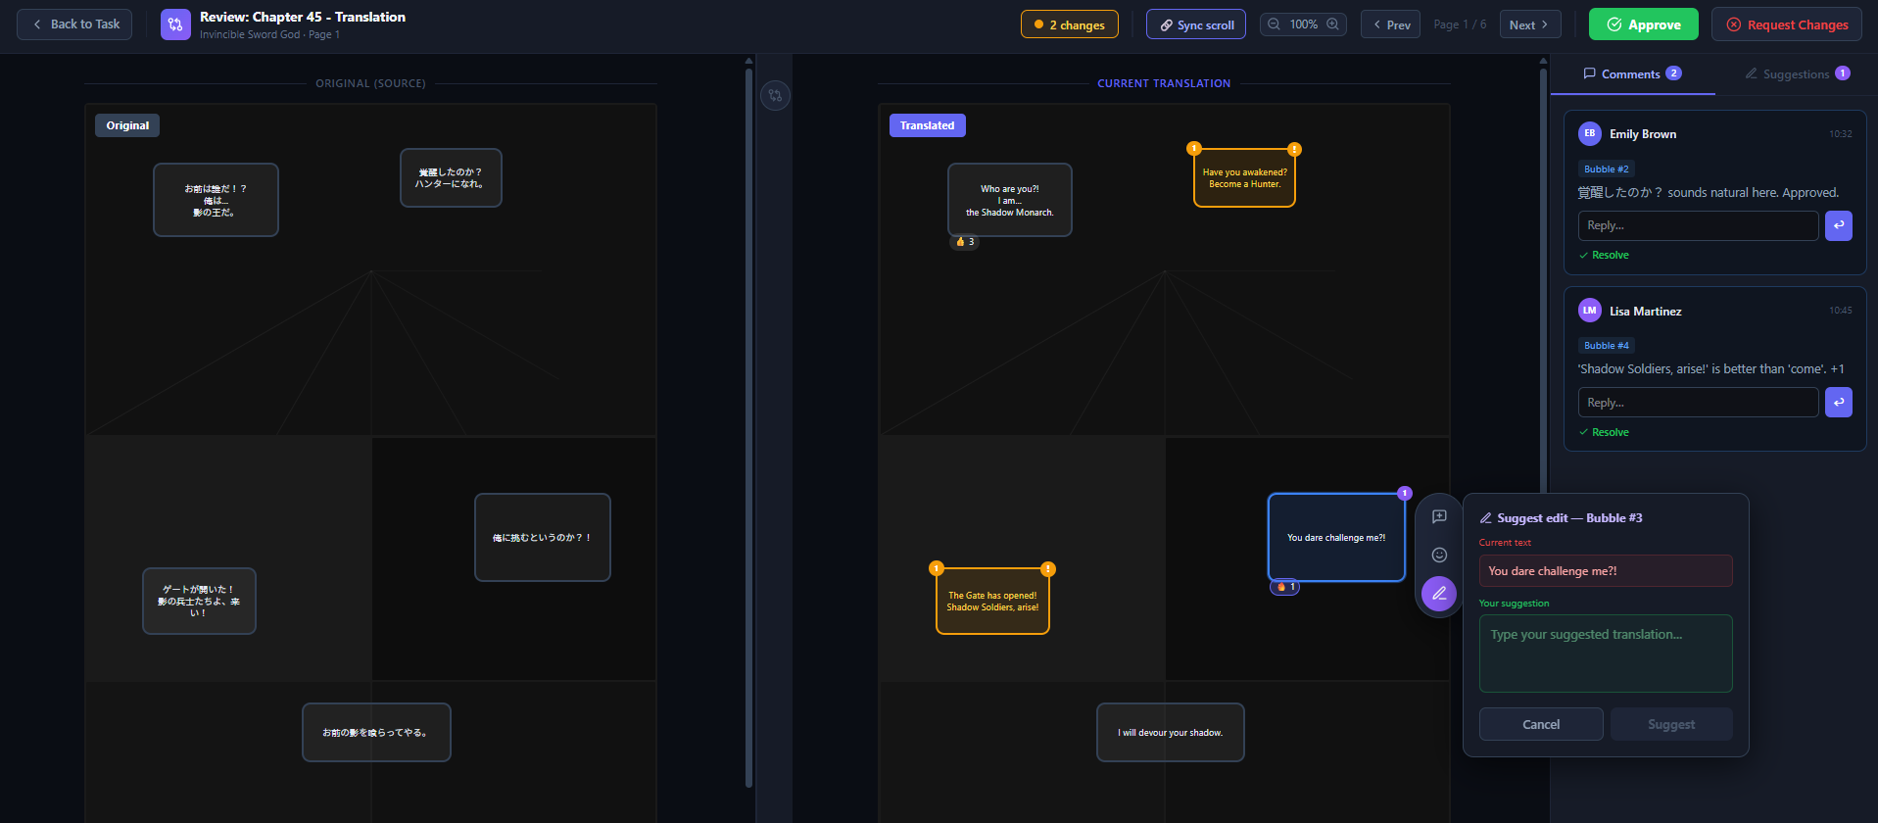
Figure 25: Translator Leader Task Review

4.26 — Translator Project Team Setting
Page ID | P-26
Screen name | Translator Project Team Setting
Design file | Figma — Frame "Translator Project Team Setting"
SRS Feature | FT-05, FT-06
Roles with access | Translator

Screen States
State | When It Appears | Design File Frame
Loading | Group information and configuration settings are being retrieved from the server. | Loading Frame
Empty | Group information has not been configured yet. | Group Settings – Empty
Populated — Default | Group information and settings are successfully loaded and displayed. | Group Settings – Default
Editing | User modifies group settings before saving changes. | Group Settings – Edit
Error | Failed to load or update group settings. | Error Frame
Updated | Group settings have been successfully saved. | Group Settings – Updated

Layout Description
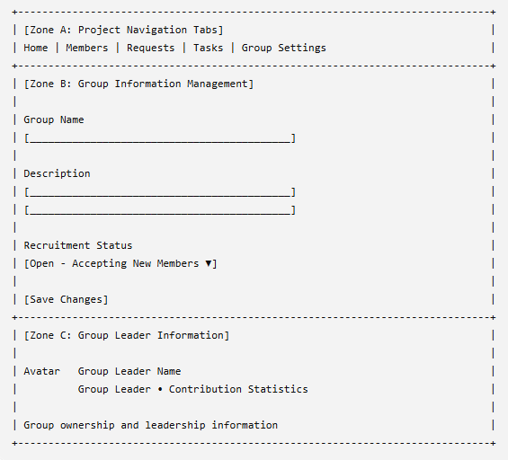

Zone descriptions:
- Zone A – Project Navigation Tabs: Displays navigation tabs for the current project workspace including Home, Members, Requests, Tasks, and Group Settings. The Group Settings tab is highlighted to indicate the active page.
- Zone B – Group Information Management: Displays editable group configuration fields including group name, description, and recruitment status. Authorized users can modify these settings and save changes to update project team information.
- Zone C – Group Leader Information: Displays information about the current group leader including profile summary, leadership role, and contribution statistics. This section provides visibility into project ownership and team management responsibilities.

Key Interactions
User Action | What Happens | Notes
Edit Group Name | Updates the group name field. | FT-05 AC-01
Edit Description | Updates the group description. | FT-05 AC-01
Change Recruitment Status | Updates whether the group accepts new member applications. | FT-05 AC-01, FT-07 AC-01
Click Save Changes | Validates input and saves updated group settings. | FT-05 AC-02
View Group Leader Information | Displays leader profile and contribution details. | FT-06 AC-01
Submit Invalid Data | Validation errors are displayed and changes are not saved. | FT-05 NAC-01
Attempt Unauthorized Modification | System blocks the action and displays an authorization error. | FT-06 NAC-01
Save Operation Fails | System displays an error message and allows retry. | FT-06 NAC-02
Retry After Error | Reloads group settings and attempts the operation again. | FT-06 NAC-02
Edit Group Name | Updates the group name field. | FT-05 AC-01
Edit Description | Updates the group description. | FT-05 AC-01
Change Recruitment Status | Updates whether the group accepts new member applications. | FT-05 AC-01, FT-07 AC-01

Mockup
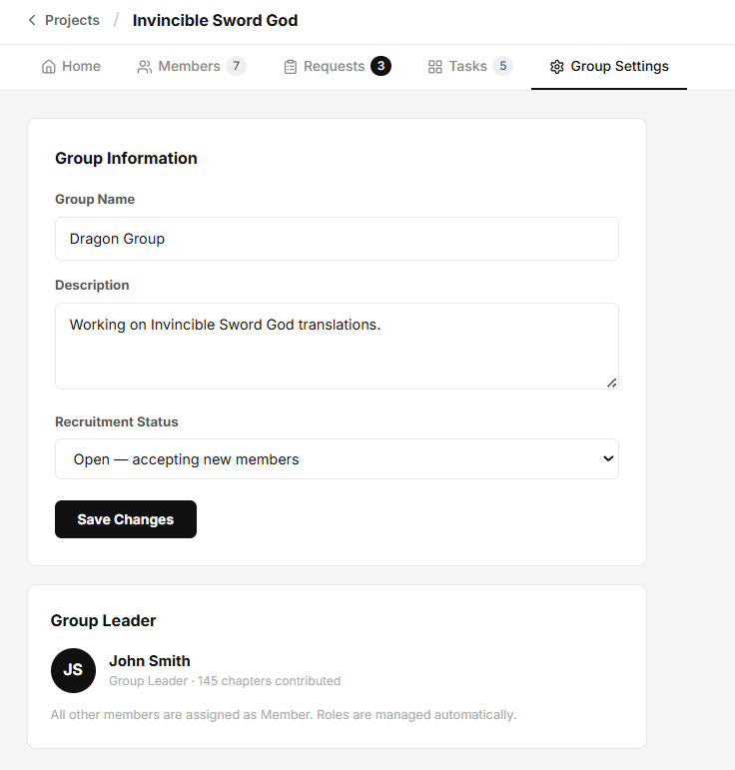
Figure 26 : Translator Revenue

4.27 — Translator Payout
Page ID | P-27
Screen name | Translator Payout
Design file | Figma — Frame "Translator Payout"
SRS Feature | FT-17
SRS Scenario | SC-07
Roles with access | Group Leader, Translator, Proofreader, Quality Checker

Screen States
State | When It Appears | Design File Frame
Loading | Payout information, payment settings, and payout history are being loaded. | Loading Frame
Empty | No payout records exist and no earnings are available for withdrawal. | Translator Payout – Empty
Populated — Default | Payout balances, payment settings, and payout history are successfully displayed. | Translator Payout – Default
Editing | User is modifying payout settings before saving changes. | Translator Payout – Edit
Error | Failed to load payout information or process a payout request. | Error Frame
Payout Requested | A payout request has been successfully submitted. | Translator Payout – Updated

Layout Description
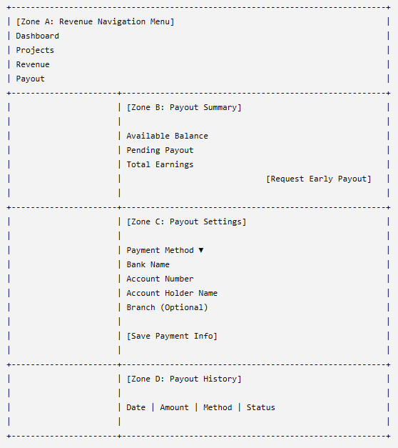

Zone descriptions:
- Zone A – Revenue Navigation Menu: Provides navigation links to revenue-related modules including Dashboard, Projects, Revenue, and Payout. The active menu item is highlighted to indicate the current page.
- Zone B – Payout Summary: Displays financial summary information including available balance, pending payout amount, and total historical earnings. This section provides a quick overview of the user's payout status and includes the Request Early Payout action.
- Zone C – Payout Settings: Allows users to configure payout information including payment method, bank name, account number, account holder name, and branch information. Users can update payment details and save changes for future withdrawals.
- Zone D – Payout History: Displays historical payout transactions including payout date, amount, payment method, and processing status. Users can review previously completed payout requests and payment records.

Key Interactions
User Action | What Happens | Notes
View Payout Summary | Displays available balance, pending payouts, and total earnings. | FT-17 AC-01
Click Request Early Payout | Submits an early payout request if eligibility requirements are met. | FT-17 AC-02
Change Payment Method | Updates the selected payout method. | FT-17 AC-01
Edit Bank Information | Updates banking and payment details. | FT-17 AC-01
Click Save Payment Info | Validates and saves payout settings. | FT-17 AC-02
View Payout History | Displays historical payout transactions and statuses. | FT-17 AC-01
Submit Invalid Payment Information | Validation errors are displayed and changes are not saved. | FT-17 NAC-01
Request Payout Below Minimum Threshold | System rejects the request and displays an explanatory message. | FT-17 NAC-02
Payout Request Fails | System displays an error message and allows retry. | FT-17 NAC-03
Retry After Error | Reloads payout information and retries the failed operation. | FT-17 NAC-03

Mockup
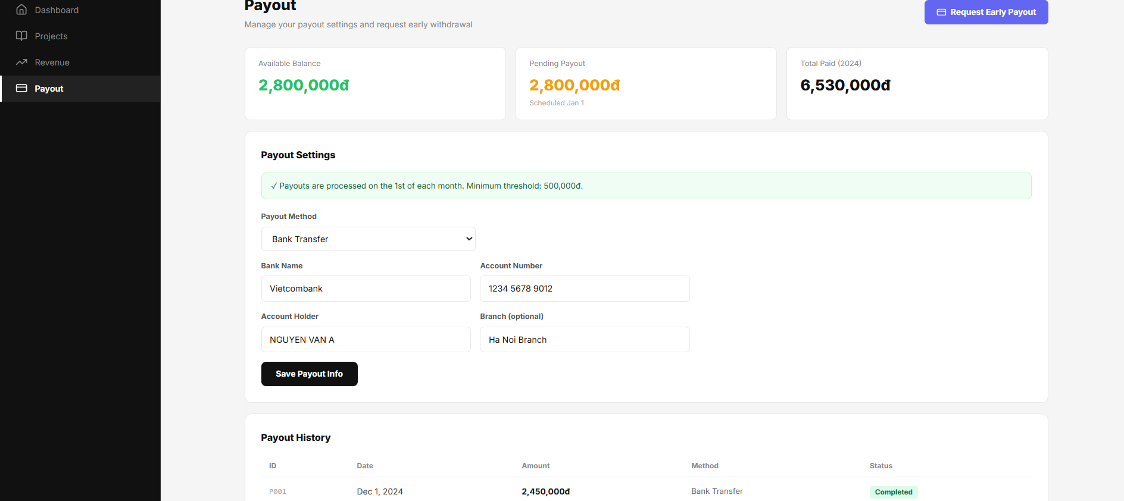
Figure 27: Translator Payout

4.28 — Translator Request Payout Modal
Page ID | P-28
Screen name | Translator Request Payout Modal
Design file | Figma — Frame "Translator Request Payout Modal"
SRS Feature | FT-17
SRS Scenario | SC-07
Roles with access | Group Leader, Translator, Proofreader, Quality Checker

Screen States
State | When It Appears | Design File Frame
Loading | Payout eligibility and account balance information are being loaded. | Loading Frame
Populated — Default | The payout request form is displayed and ready for input. | Request Payout Modal – Default
Validation Error | One or more required fields contain invalid values or violate payout rules. | Request Payout Modal – Validation Error
Submission Error | The payout request cannot be submitted due to a server or network error. | Error Frame
Request Submitted | The payout request is successfully submitted for processing. | Request Payout Modal – Success

Layout Description
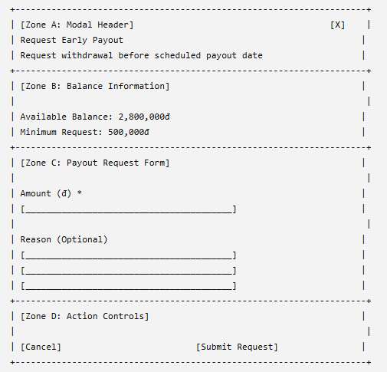

Zone descriptions:
- Zone A – Modal Header: Displays the payout request title, explanatory information about early withdrawal, and a close action for dismissing the modal.
- Zone B – Balance Information: Displays the user's available balance and the minimum payout threshold required for submitting an early payout request.
- Zone C – Payout Request Form: Allows users to enter the requested withdrawal amount and provide an optional explanation for the payout request. Input validation ensures that requests comply with platform payout policies.
- Zone D – Action Controls: Provides actions to cancel the request or submit the payout request for processing. The submit action remains disabled until all required validation conditions are satisfied.

Key Interactions
User Action | What Happens | Notes
Enter Amount | Updates the payout amount field. | FT-17 AC-01
Enter Reason | Records the optional explanation for the payout request. | FT-17 AC-01
Click Submit Request | Validates eligibility and submits the payout request for processing. | FT-17 AC-02
Click Cancel | Closes the modal without creating a payout request. | FT-17 AC-01
Click Close (X) | Closes the modal and returns to the Payout page. | FT-17 AC-01
Enter Amount Below Minimum Threshold | System displays a validation error and blocks submission. | FT-17 NAC-01
Enter Amount Greater Than Available Balance | System displays a validation error and blocks submission. | FT-17 NAC-02
Payout Request Submission Fails | System displays an error message and allows retry. | FT-17 NAC-03
Retry After Error | Attempts to resubmit the payout request. | FT-17 NAC-03

Mockup
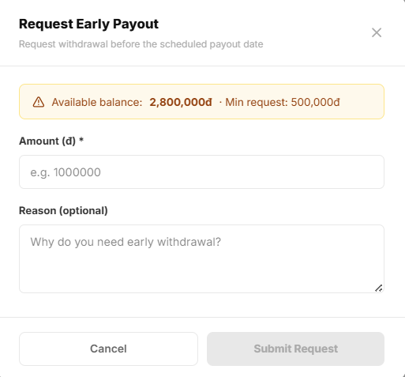
Figure 28: Translator Request Payout Modal

4.29 — Author Dashboard
Page ID | P-29
Screen name | Author Dashboard
Design file | Figma — Frame "Author Dashboard"
SRS Feature | FT-17
SRS Scenario | SC-07
Roles with access | Group Leader, Translator, Proofreader, Quality Checker

Screen States
State | When It Appears | Design File Frame
Loading | Activity records are being loaded. | Loading Frame
Empty | No activity records exist. | Group Activity Log – Empty
Populated — default | Activity records are available. | Group Activity Log – Default
Error | Activity retrieval fails. | Error Frame

Layout Description
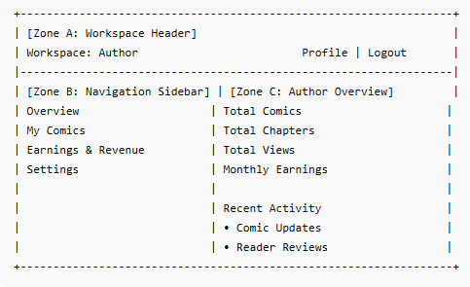

Zone descriptions:
- Zone A: Displays the author workspace title, notification controls, profile access, and logout functionality.
- Zone B: Provides navigation links to author modules including Overview, My Comics, Earnings & Revenue, and Settings.
- Zone C: Displays author performance metrics including total comics, total chapters, total views, and monthly earnings. Also presents recent activities such as comic updates and reader reviews.

Key Interactions
User Action | What Happens | Notes
Open Activity Log page | Loads recent group activities in descending chronological order. | FT-17 AC-01
Click an activity record | Opens the related task, chapter, or resource if available. | FT-17 AC-01
Scroll or load more activities | Retrieves additional historical activity records. | FT-17 AC-01
Refresh page | Reloads the latest activity data. | FT-17 AC-01
Retry after error | Attempts to reload activity records. | FT-17 NAC-01

Mockup
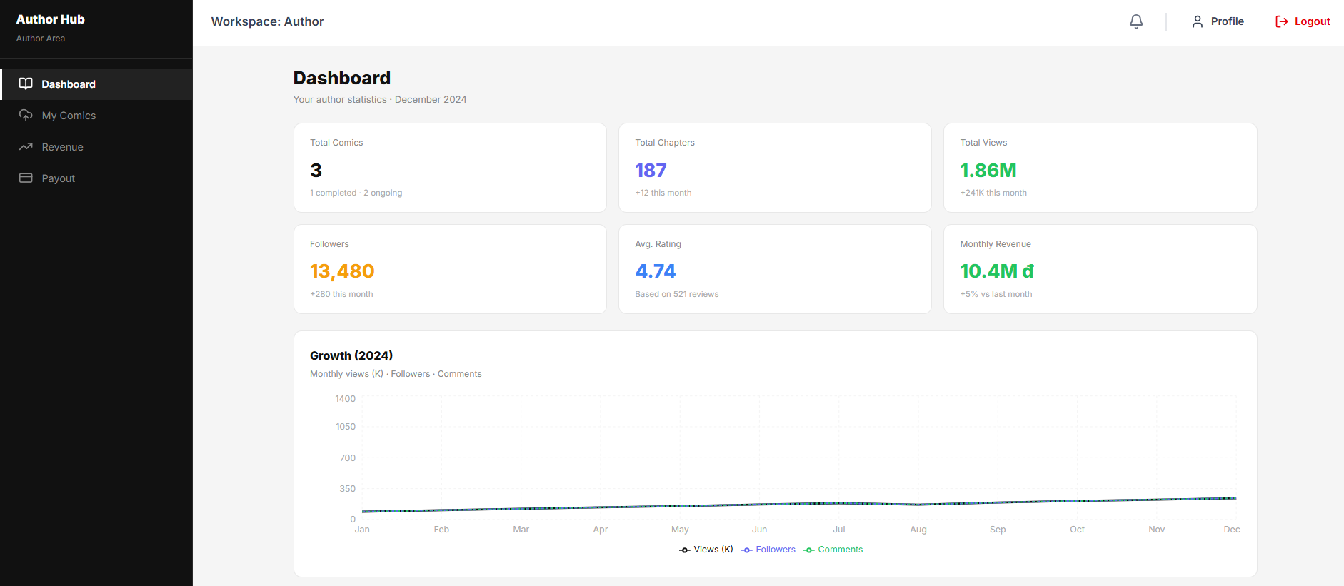
Figure 29 :Author Dashboard

4.30 — Author Comic Management
Page ID | P-30
Screen name | Author Comic Management
Design file | Figma — Frame "Author Comic Management"
SRS Feature | FT-03
SRS Scenario | SC-06
Roles with access | Author

Screen States
State | When It Appears | Design File Frame
Loading | Fetching the list of stories and their respective performance metrics from the database. | Loading frame
Empty | The author has not created any stories yet. A clean slate screen prompting them to create their first story. | Author Management - empty frame
Populated — default | Displays a list of the author's existing stories with quick management tools | Author Comic Management screen
Error | Failed to retrieve story data due to server downtime or a connection timeout. | Error frame

Layout Description

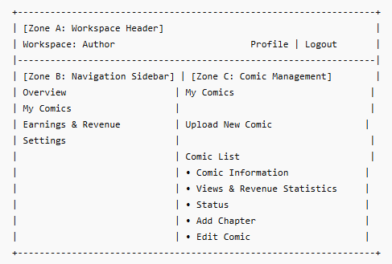

Zone descriptions:
- Zone A: Displays the author workspace title, notification controls, profile access, and logout functionality.
- Zone B: Provides navigation links to author modules including Overview, My Comics, Earnings & Revenue, and Settings.
- Zone C: Displays the author's published comics together with chapter count, view statistics, revenue information, and publication status. Provides actions for uploading new comics, adding chapters, and managing existing comic information.

Key Interactions
User Action | What Happens | Notes
Click "Create New Comic" | Opens the comic creation page. | FT-03 AC-01, FT-03 NAC-01
Click a comic card | Opens the selected comic details page. | FT-03 AC-01
Click "Add Chapter" | Opens the chapter creation page for the selected comic. | FT-03 AC-01, FT-03 NAC-02, FT-03 NAC-03
Click "Edit Comic" | Opens the comic editing form populated with existing information. | FT-03 AC-01, FT-03 NAC-01
Retry after error | Reloads comic data and retries the failed operation. | FT-03 NAC-03

Mockup
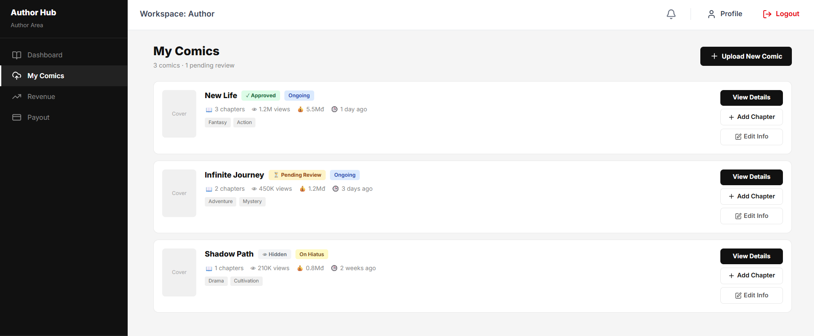
Figure 30:Author Comic Management

4.31 — Upload New Comic Modal
Page ID | P-31
Screen name | Upload New Comic Modal
Design file | Figma — Frame " Upload New Comic Model"
SRS Feature | FT-03, FT-04
SRS Scenario | SC-03
Roles with access | Author

Screen States
State | When It Appears | Design File Frame
Step 1 — Default | The Author opens the modal to enter comic information. | Upload New Comic Modal — Step 1
Step 1 — Validation Error | Required information is missing or invalid. | Upload New Comic Modal — Step 1 Error
Step 2 — Default | Comic information is valid and the Author proceeds to upload assets. | Upload New Comic Modal — Step 2
Uploading | Cover image or chapter files are being uploaded. | Upload New Comic Modal — Uploading
Submission Processing | The comic is being submitted for moderation review. | Upload New Comic Modal — Processing
Success | The comic is submitted successfully and marked as pending review. | Upload New Comic Modal — Success
Error | Uploading or submission fails due to invalid files, network issues, or server errors. | Upload New Comic Modal — Error

Layout Description

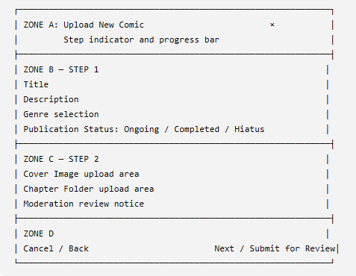
Zone descriptions:
- Zone A: Displays the modal title, current step, progress indicator, and close button.
- Zone B: Contains the comic title, description, genres, and publication status fields in Step 1.
- Zone C: Contains the cover image upload, optional chapter folder upload, and moderation notice in Step 2.
- Zone D: Provides navigation and submission actions, including Cancel, Back, Next, and Submit for Review.

Key Interactions
User Action | What Happens | Notes
Enter comic title | Records the comic title. | Required field
Enter description | Records the comic synopsis. | Optional or subject to length limit
Select genres | Adds or removes genres from the comic. | Multiple genres may be selected
Select publication status | Sets the comic as Ongoing, Completed, or Hiatus. | One option only
Click Next | Validates Step 1 and opens Step 2. | Disabled until required fields are valid
Upload cover image | Uploads and previews the selected cover image. | JPG or PNG; recommended 800×1200 px
Upload chapter folder | Uploads chapter images and sorts them by filename. | Optional
Click Back | Returns to Step 1 while retaining entered data. | Uploaded data remains temporarily stored
Click Submit for Review | Submits the comic to the moderation queue. | Comic status becomes Pending Review
Click Cancel or × | Closes the modal without submitting. | Unsaved data is discarded
Upload invalid file | Displays file type or size validation error. | Submission is blocked
Submission succeeds | Displays confirmation and closes the modal. | Moderator review normally follows
Submission fails | Displays an error and allows retry. | Entered data is retained

Mockup
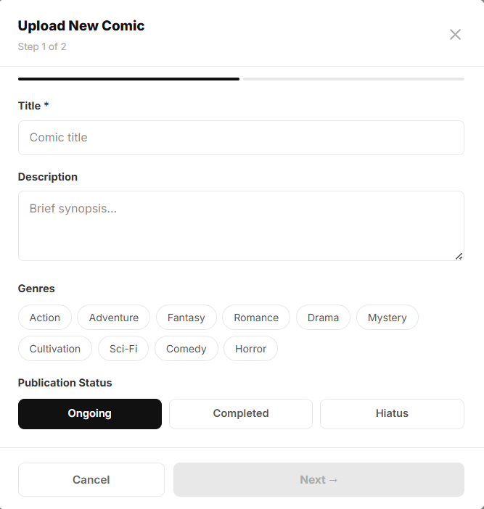
Figure 31: Upload New Comic Modal Step 1

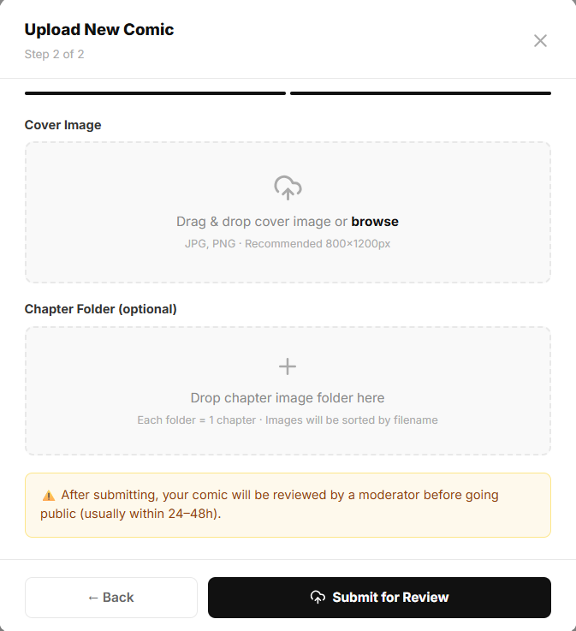
Figure 32 : Upload New Comic Modal Step 2

4.32 — Author Comic Detail
Page ID | P-32
Screen name | Author Comic Detail
Design file | Figma — Frame " Author Comic Detail"
SRS Feature | FT-03, FT-04
SRS Scenario | SC-03
Roles with access | Author

Screen States
State | When It Appears | Design File Frame
Loading | Comic information, statistics, and chapter data are being retrieved. | Author Comic Detail — Loading
Empty | The comic exists but has no uploaded chapters. | Author Comic Detail — Empty
Populated — default | Comic details, statistics, and chapter list are loaded successfully. | Author Comic Detail — Default
Filtered | The chapter list is filtered by status or visibility. | Author Comic Detail — Filtered
Error | Comic information or chapter data cannot be loaded. | Author Comic Detail — Error
Updated | Comic statistics or chapter status changes after an author or moderator action. | Author Comic Detail — Updated

Layout Description

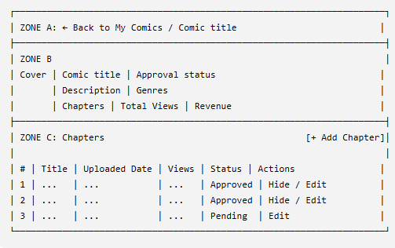
Zone descriptions:
- Zone A: Displays breadcrumb navigation and returns the Author to the My Comics page.
- Zone B: Displays the comic cover, title, approval status, description, genres, chapter count, views, and revenue statistics.
- Zone C: Displays the chapter list and available actions such as adding, editing, hiding, or viewing chapter information.

Key Interactions
User Action | What Happens | Notes
Click Back to My Comics | Returns to the Author Comic Management page. | —
Click Add Chapter | Opens the chapter upload form or modal. | FT-03
Click Edit | Opens the selected chapter for editing. | Only permitted chapters can be edited
Click Hide | Removes the chapter from public visibility. | Confirmation may be required
View comic statistics | Displays chapter count, total views, and revenue. | FT-17
View chapter status | Shows Approved, Pending, or Rejected status. | Updated after moderation
Open a chapter row | Displays the selected chapter details. | —
Action without permission | The system blocks the action and shows an error. | Author ownership required
Retry after an error | Reloads comic and chapter data. | Existing data is unchanged

Mockup
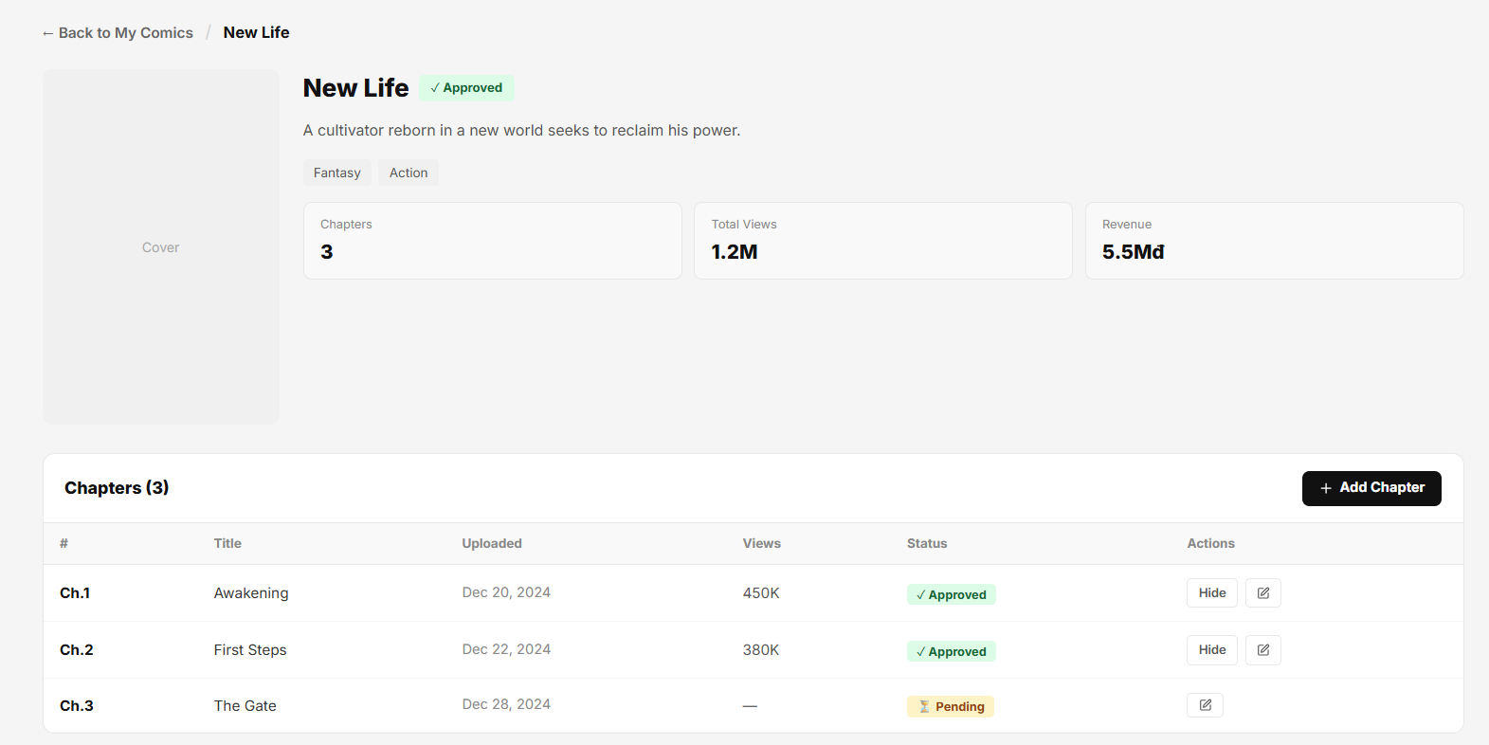
Figure 33: Author Comic Detail

4.33 — Author Add New Chapter Modal
Page ID | P-31
Screen name | Author Add New Chapter Modal
Design file | Figma — Frame " Author Add New Chapter Modal"
SRS Feature | FT-03, FT-04
SRS Scenario | SC-03
Roles with access | Author

Screen States
State | When It Appears | Design File Frame
Default | The Author opens the modal to add a chapter. | Add New Chapter Modal — Default
Validation Error | Chapter number is invalid or no page images are selected. | Add New Chapter Modal — Validation Error
Uploading | Chapter page images are being uploaded. | Add New Chapter Modal — Uploading
Processing | The chapter is being submitted for moderator review. | Add New Chapter Modal — Processing
Success | The chapter is submitted successfully with Pending status. | Add New Chapter Modal — Success
Error | Uploading or submission fails due to invalid files, network, or server errors. | Add New Chapter Modal — Error

Layout Description

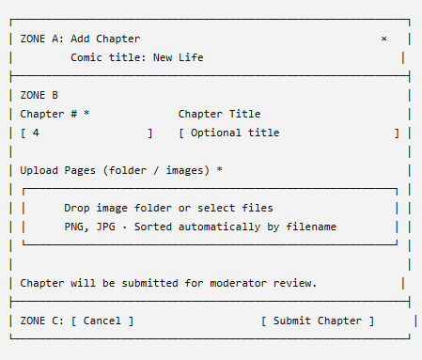
Zone descriptions:
- Zone A: Displays the modal title, comic name, and close button.
- Zone B: Contains the chapter number, optional chapter title, page upload area, and moderation notice.
- Zone C: Provides Cancel and Submit Chapter actions.

Key Interactions
User Action | What Happens | Notes
Enter chapter number | Sets the chapter sequence number. | Required and must be unique
Enter chapter title | Adds an optional title for the chapter. | Optional
Upload folder or images | Uploads chapter pages and sorts them by filename. | PNG and JPG supported
Upload invalid files | Displays a validation error. | Submission is blocked
Click Submit Chapter | Validates and submits the chapter for moderation. | Status becomes Pending
Click Cancel or × | Closes the modal without submitting. | Unsaved data is discarded
Submission succeeds | Closes the modal and adds the chapter to the chapter list. | Awaiting moderator review
Submission fails | Displays an error and allows retry. | Entered data is retained

Mockup
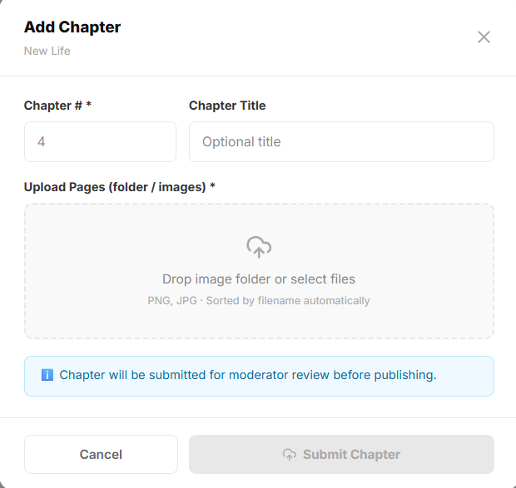
Figure 34: Author Add New Chapter Modal

4.34 — Author Revenue Analytics
Page ID | P-34
Screen name | Author Revenue Analytics
Design file | Figma — Frame "Author Revenue Analytics"
SRS Feature | FT-17
SRS Scenario | SC-06
Roles with access | Author

Screen States
State | When It Appears | Design File Frame
Loading | Fetching financial records, transaction histories, and balance updates from the server. | Loading frame
Empty | A newly registered author with zero accrued earnings or transactions. | Empty Author Revenue Analytics frame
Populated — default | Displays current monthly premium revenue, cumulative totals, and pending payouts | Author Revenue Analytics frame
Error | Financial ledger database failure or timeout when loading wallet states. | Error frame

Layout Description

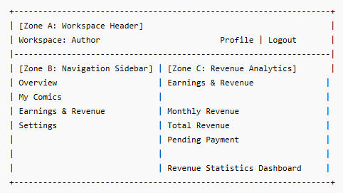
Zone descriptions:
- Zone A: Displays the author workspace title, notification controls, profile access, and logout functionality.
- Zone B: Provides navigation links to author modules including Overview, My Comics, Earnings & Revenue, and Settings.
- Zone C: Displays author revenue information including monthly revenue, total revenue, pending payments, and overall earnings statistics.

Key Interactions
User Action | What Happens | Notes
Open Earnings & Revenue page | Loads revenue statistics and payment information. | FT-17 AC-01
View revenue summary cards | Displays current financial metrics and earnings totals. | FT-17 AC-01, FT-17 AC-03
Review revenue analytics | Displays detailed revenue performance and earning trends. | FT-17 AC-01, FT-17 AC-02
Refresh page | Reloads the latest revenue and payment data. | FT-17 AC-01
Retry after error | Attempts to retrieve revenue statistics again. | FT-17 NAC-01, FT-17 NAC-02

Mockup
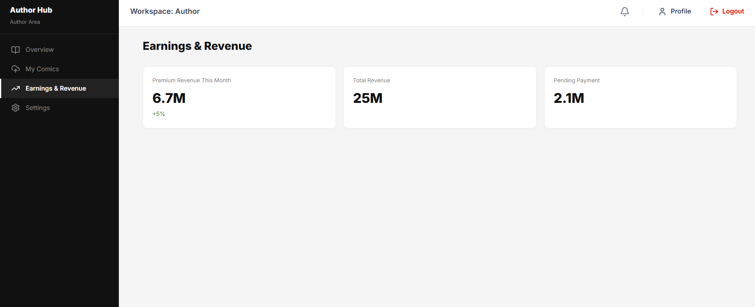
Figure 35: Author Revenue Analytics

4.35 — Author Payout
Page ID | P-35
Screen name | Author Payout
Design file | Figma — Frame “Author Payout”
SRS Feature | FT-16
SRS Scenario | SC-03
Roles with access | Author

Screen States

State | When It Appears | Design File Frame
Loading | Payout settings and banking information are being retrieved. | Author Payout — Loading
Empty | The Author has not configured a payout method or banking information. | Author Payout — Empty
Populated — default | Payout method, banking details, and revenue split are displayed successfully. | Author Payout — Default
Editing | The Author modifies payout or bank account information. | Author Payout — Editing
Success | Payout settings are saved or a payout request is submitted successfully. | Author Payout — Success
Error | Payout information cannot be loaded, saved, or submitted. | Author Payout — Error

Layout Description
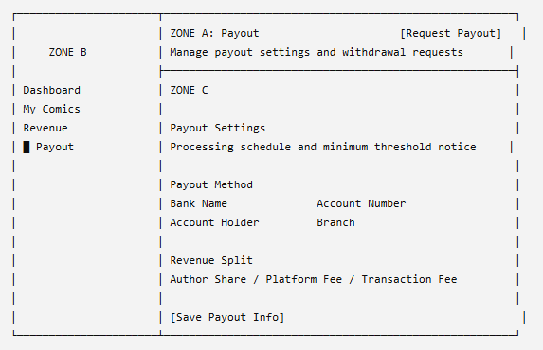
Zone descriptions:
- Zone A: Displays the page title, description, and Request Early Payout button.
- Zone B: Provides navigation to Dashboard, My Comics, Revenue, and Payout. The Payout item is highlighted.
- Zone C: Displays payout schedule information, payment method, banking details, revenue split, and the Save Payout Info button.

Key Interactions
User Action | What Happens | Notes
Click Dashboard | Opens the Author Dashboard. | —
Click My Comics | Opens the Author Comic Management page. | —
Click Revenue | Opens Author Revenue Analytics. | FT-16
Select payout method | Updates the preferred withdrawal method. | Required
Enter banking information | Records the Author’s bank account details. | Required for bank transfer
Click Save Payout Info | Validates and saves payout settings. | Sensitive data must be protected
Click Request Early Payout | Opens or submits an early payout request. | Balance and minimum threshold are validated
Insufficient balance | The system blocks the payout request. | Displays the minimum payout requirement
Save or request succeeds | Displays a success notification. | Information is refreshed
Operation fails | Displays an error and allows retry. | Existing payout information remains unchanged

Mockup
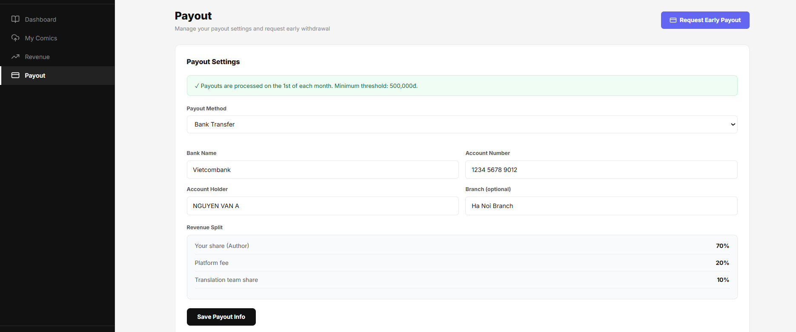
Figure 36 : Author Payout

4.36 — Moderator Dashboard
Page ID | P-36
Screen name | Moderator Dashboard
Design file | Figma— Frame "Moderator Dashboard"
SRS Feature | FT-04, FT-13, FT-17
SRS Scenario | SC-03
Roles with access | Moderator

Screen States

State | When It Appears | Design File Frame
Loading | Dashboard metrics and moderation data are being loaded. | Loading Frame
Empty | No moderation activities, reports, or submissions are available. | Moderator Dashboard – Empty
Populated — default | Dashboard metrics and moderation data are displayed. | Moderator Dashboard – Default
Error | Dashboard data cannot be retrieved. | Error Frame

Layout Description
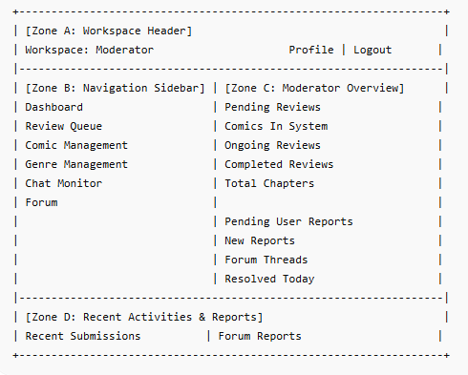

Zone descriptions:
- Zone A: Displays the moderator workspace title, notification controls, profile access, and logout functionality.
- Zone B: Provides navigation links to moderator modules including Dashboard, Review Queue, Comic Management, Genre Management, Chat Monitor, and Forum.
- Zone C: Displays moderation statistics including pending reviews, comics in the system, ongoing reviews, completed reviews, total chapters, user reports, forum threads, and resolved cases.
- Zone D: Displays recent comic submissions awaiting moderation and forum reports requiring moderator attention.

Key Interactions
User Action | What Happens | Notes
Open Dashboard | Loads moderation statistics, submissions, and reports. | FT-04 AC-01, FT-17 AC-01
Click a submission item | Opens the submission review details page. | FT-04 AC-01
Click a forum report | Opens the report investigation page. | FT-13 NAC-01, FT-13 NAC-03
Click "View All" in Recent Submissions | Navigates to the complete submission review list. | FT-04 AC-01
Click "View All" in Forum Reports | Navigates to the full report management page. | FT-13 NAC-01, FT-13 NAC-03
Retry after error | Reloads dashboard data and retries failed requests. | FT-04 NAC-01, FT-04 NAC-02

Mockup
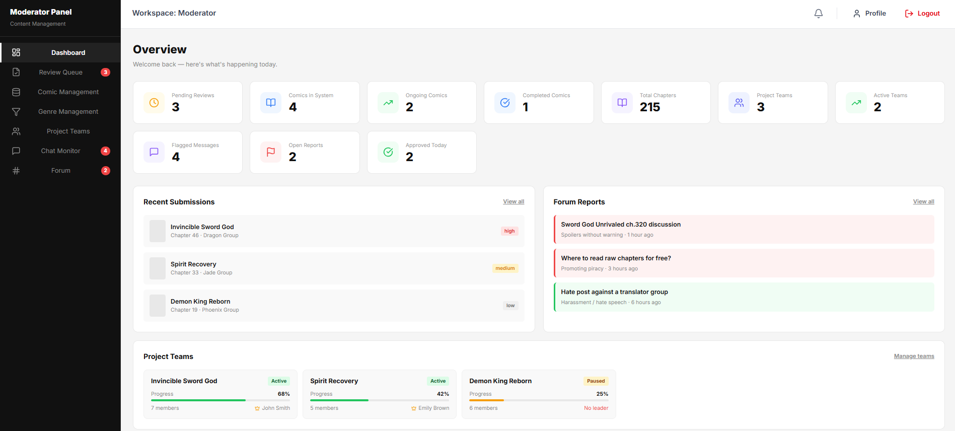
Figure 37:Moderator Dashboard

4.37 — Comic Approval Queue Page
Page ID | P-37
Screen name | Comic Approval Queue
Design file | Figma — Frame "Comic Approval Queue"
SRS Feature | FT-04
SRS Scenario | SC-03
Roles with access | Moderator

Screen States
State | When It Appears | Design File Frame
Loading | Submission queue data is being loaded. | Loading Frame
Empty | No comic submissions are awaiting review. | Comic Approval Queue – Empty
Populated — default | One or more submissions are available for review. | Comic Approval Queue – Default
Error | Submission data cannot be retrieved or moderation action fails. | Error Frame
Filtered | Status or priority filters are applied. | Comic Approval Queue – Filtered

Layout Description
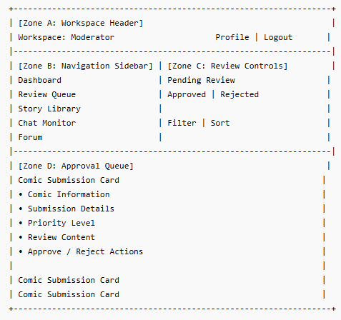

Zone descriptions:
- Zone A – Moderator Workspace Header: Displays the current moderator workspace context together with notification controls, profile access, and logout functionality.
- Zone B – Moderator Navigation Menu: Provides navigation links to moderator modules including Dashboard, Review Queue, Story Library, Chat Monitor, and Forum. The active module is highlighted.
- Zone C – Review Queue Controls: Provides moderation workflow controls including Pending Review, Approved, and Rejected tabs together with priority filtering and sorting options. Moderators can quickly navigate between review states and prioritize submissions.
- Zone D – Submission Review List: Displays comic chapter submissions awaiting moderation review. Each submission includes comic information, chapter details, submitting group, submission time, view statistics, priority indicators, and moderation actions for reviewing, approving, or rejecting content.

Key Interactions
User Action | What Happens | Notes
Click Review Content | Opens the submitted chapter and review details. | FT-04 AC-01
Click Approve | Approves the selected submission and moves it to the Approved tab. | FT-04 AC-02
Click Reject | Opens a rejection workflow and records the moderation decision. | FT-04 AC-03
Switch Between Pending Review, Approved, and Rejected | Displays submissions matching the selected moderation state. | FT-04 AC-01
Select Priority Filter | Displays submissions matching the selected priority level. | FT-04 AC-01
Select Sort Option | Reorders submissions according to the selected sorting criteria. | FT-04 AC-01
View Submission Details | Displays additional information about the selected chapter submission. | FT-04 AC-01
Approve Invalid Submission State | System blocks the action and displays an error message. | FT-04 NAC-01
Retry After Error | Reloads submission data and retries failed moderation operations. | FT-04 NAC-02

Mockup
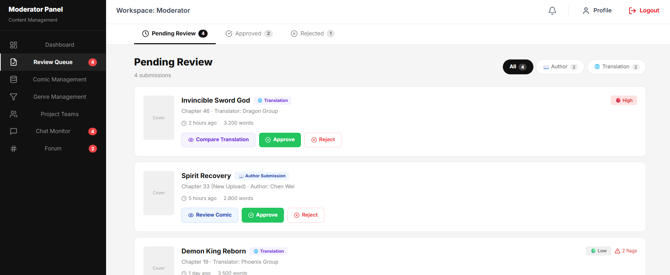
Figure 38 :Comic Approval Queue

4.38 — Moderator Compare Translation
Page ID | P-38
Screen name | Moderator Compare Translation
Design file | Figma — Frame "Moderator Compare Translation"
SRS Feature | FT-07, FT-09
SRS Scenario | SC-03
Roles with access | Moderator

Screen States
State | When It Appears | Design File Frame
Loading | Original and translated chapter pages are being retrieved. | Moderator Compare Translation — Loading
Empty | No translation submission or comparison data is available. | Moderator Compare Translation — Empty
Populated — default | Original and translated pages are displayed successfully. | Moderator Compare Translation — Default
Reviewing | The Moderator is comparing pages and reviewing changed text bubbles. | Moderator Compare Translation — Reviewing
Success | The translation is approved or a revision request is submitted. | Moderator Compare Translation — Success
Error | Chapter images, translation data, or review actions cannot be loaded or processed. | Moderator Compare Translation — Error

Layout Description

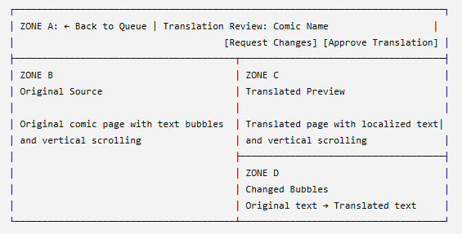

Zone descriptions:
- Zone A: Displays review information, navigation back to the queue, and moderation actions.
- Zone B: Displays the original chapter page for comparison.
- Zone C: Displays the translated chapter preview.
- Zone D: Lists modified text bubbles with the original and translated content.

Key Interactions
User Action | What Happens | Notes
Click Back to Queue | Returns to the translation review queue. | Unsaved review data may be discarded.
Scroll original or translated page | Displays other areas of the chapter page. | Supports detailed visual comparison.
Select a changed bubble | Highlights the related text area on the page. | Shows original and translated text.
Click Approve Translation | Approves the translation for publication or the next workflow stage. | Moderator permission required.
Click Request Changes | Opens a form to enter revision feedback. | A reason should be required.
Submit revision feedback | Returns the translation to the Translator for correction. | Status becomes Changes Requested.
Review action succeeds | Displays a success message and returns to the queue. | Review status is updated.
Review action fails | Displays an error and allows retry. | Existing submission remains unchanged.

Mockup
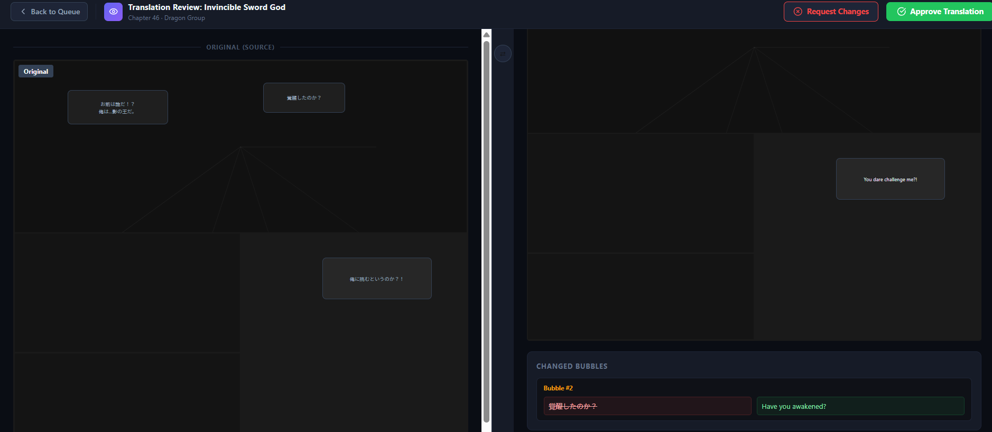
Figure 39: Moderator Compare Translation

4.39 — System Comic Management
Page ID | P-39
Screen name | Comic Management
Design file | Figma— Frame "Comic Management"
SRS Feature | FT-04 – Comic Management
SRS Scenario | SC-03
Roles with access | Moderator

Screen States
State | When It Appears | Design File Frame
Loading | Comic records are being loaded from the system. | Loading Frame
Empty | No comics match the current search or filter criteria. | Comic Management – Empty
Populated — default | Comics are available and displayed in the management table. | Comic Management – Default
Error | Comic data retrieval or management action fails. | Error Frame
Filtered | Search keywords or status filters are applied. | Comic Management – Filtered

Layout Description
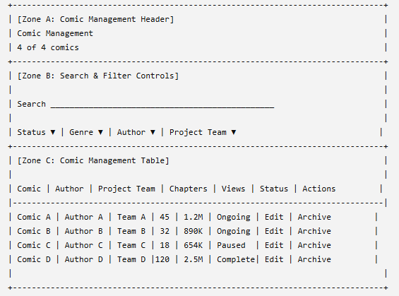

Zone descriptions:
- Zone A – Comic Management Header: Displays the page title and summary information about the number of comics currently managed by the system.
- Zone B – Search & Filter Controls: Provides search and filtering functionality for comic records. Users can search by comic title, author name, or project team, and filter results by status, genre, author, or project team to quickly locate specific records.
- Zone C – Comic Management Table: Displays a list of comics together with associated metadata including comic title, genres, author, project team, chapter count, total views, publication status, and management actions. Authorized moderators can review comic information and perform administrative actions directly from the table.

Key Interactions
User Action | What Happens | Notes
Enter Search Keyword | Reloads the comic list with matching results. | FT-04 AC-01
Select Status Filter | Displays comics matching the selected publication status. | FT-04 AC-01
Select Genre Filter | Displays comics belonging to the selected genre. | FT-04 AC-01
Select Author Filter | Displays comics associated with the selected author. | FT-04 AC-01
Select Project Team Filter | Displays comics associated with the selected project team. | FT-04 AC-01
Click Edit | Opens the selected comic for modification. | FT-04 AC-02
Click Archive | Displays a confirmation dialog and archives the selected comic after confirmation. | FT-04 AC-03
Click Comic Title | Opens the comic detail page. | FT-04 AC-01
Apply Multiple Filters | Reloads the table using all selected criteria. | FT-04 AC-01
Retry After Error | Reloads comic data and retries the failed operation. | FT-04 NAC-02

Mockup
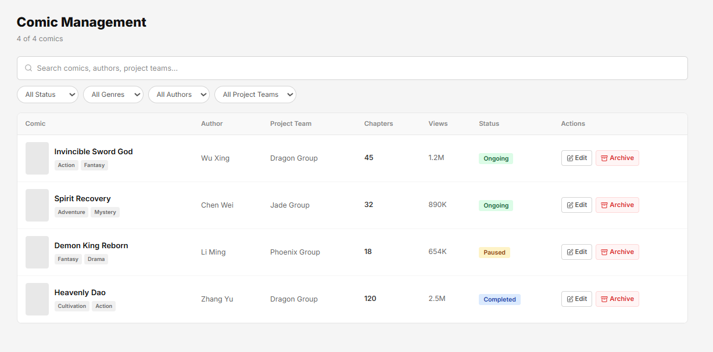
Figure 40 : Comic Management

4.40 — Comic Genre Management
Page ID | P-40
Screen name | Comic Genre Management
Design file | Figma — Frame "Comic Genre Management"
SRS Feature | FT-09
SRS Scenario | SC-03
Roles with access | Moderator

Screen States
State | When It Appears | Design File Frame
Loading | Genre records are being loaded from the system. | Loading Frame
Empty | No genres have been configured in the system. | Genre Management – Empty
Populated — Default | Genre cards are successfully loaded and displayed. | Genre Management – Default
Error | Genre data retrieval or management action fails. | Error Frame
Filtered | The Moderator searches or filters the genre list, and only matching genres are displayed. | Comic Genre Management — Filtered

Layout Description
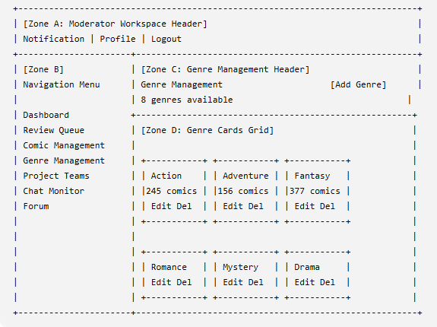
Zone descriptions:
- Zone A – Moderator Workspace Header: Displays the current moderator workspace context together with notification controls, profile access, and logout functionality.
- Zone B – Moderator Navigation Menu: Provides navigation links to moderator modules including Dashboard, Review Queue, Comic Management, Genre Management, Project Teams, Chat Monitor, and Forum. The active module is highlighted.
- Zone C – Genre Management Header: Displays the Genre Management page title, the total number of available genres, and the Add Genre action used to create new genres.
- Zone D – Genre Cards Grid: Displays all configured genres as individual cards. Each card shows the genre name, total comic count associated with that genre, and management actions including Edit and Delete.

Key Interactions
User Action | What Happens | Notes
Click Add Genre | Opens the Create Genre modal. | FT-09 AC-01
Click Edit on a Genre Card | Opens the Edit Genre modal populated with existing data. | FT-09 AC-01
Click Delete on a Genre Card | Displays a confirmation dialog before deleting the selected genre. | FT-09 NAC-03
Confirm Delete | Removes the selected genre from the system. | FT-09 AC-03
View Genre Card | Displays genre name and associated comic count. | FT-09 AC-01
Delete Genre Containing Restricted Data | System blocks deletion and displays a validation message. | FT-09 NAC-02
Retry After Error | Reloads genre data and retries the failed operation. | FT-09 NAC-03

Mockup
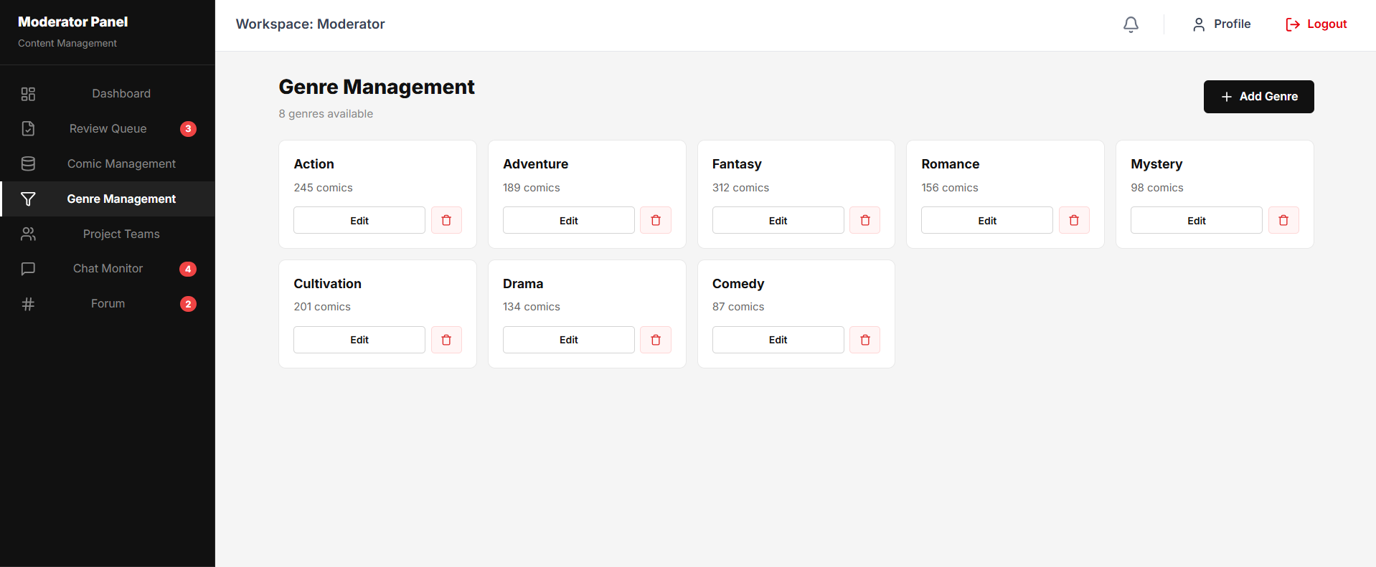
Figure 41: Comic Genre Management

4.41 — Edit Genre
Page ID | P-41
Screen name | Edit Genre
Design file | Figma — Frame "Edit Genre "
SRS Feature | FT-09
Roles with access | Moderator

Screen States
State | When It Appears | Design File Frame
Loading | Existing genre information is being loaded into the form. | Loading Frame
Populated — Default | Genre information is successfully loaded and ready for editing. | Edit Genre – Default
Validation Error | Required fields contain invalid or missing values. | Edit Genre – Validation Error
Error | Failed to load or update genre information. | Error Frame
Updated | Genre information has been successfully saved. | Edit Genre – Success

Layout Description
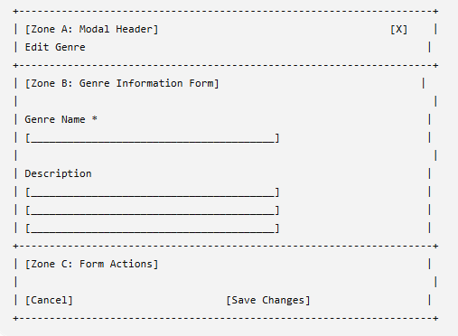

Zone descriptions:
- Zone A – Modal Header: Displays the Edit Genre title and provides a close action for dismissing the modal without saving changes.
- Zone B – Genre Information Form: Allows moderators to modify genre information including genre name and genre description. Required fields are validated before changes can be saved.
- Zone C – Form Actions: Provides actions to cancel editing or save updated genre information.

Key Interactions
User Action | What Happens | Notes
Edit Genre Name | Updates the genre name field. | FT-09 AC-01
Edit Description | Updates the genre description field. | FT-09 AC-01
Click Save Changes | Validates input and saves updated genre information. | FT-09 AC-02
Click Cancel | Closes the modal without saving changes. | FT-09 AC-01
Click Close (X) | Closes the modal and discards unsaved changes. | FT-09 AC-01
Submit Empty Genre Name | Validation error is displayed and save operation is blocked. | FT-09 NAC-01
Save Operation Fails | System displays an error message and allows retry. | FT-09 NAC-03
Retry After Error | Attempts to save genre information again. | FT-09 NAC-03

Mockup
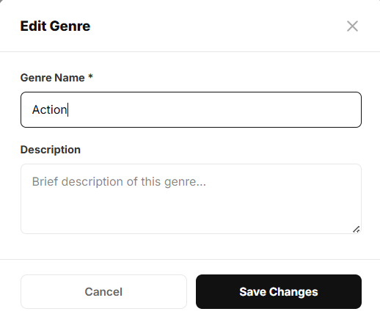
Figure 42: Edit Genre

4.42 — Chat Monitor
Page ID | P-42
Screen name | Chat Monitor
Design file | Figma — Frame "Chat Monitor"
SRS Feature | FT-13
SRS Scenario | SC-05
Roles with access | Moderator

Screen States
State | When It Appears | Design File Frame
Loading | Chat messages and moderation statistics are being loaded. | Loading Frame
Empty | No chat messages are available in the selected channel. | Chat Monitor – Empty
Populated — default | Chat messages and moderation data are displayed. | Chat Monitor – Default
Error | Chat data retrieval or moderation action fails. | Error Frame
Filtered | A channel, keyword, or violation filter is applied. | Chat Monitor – Filtered

Layout Description
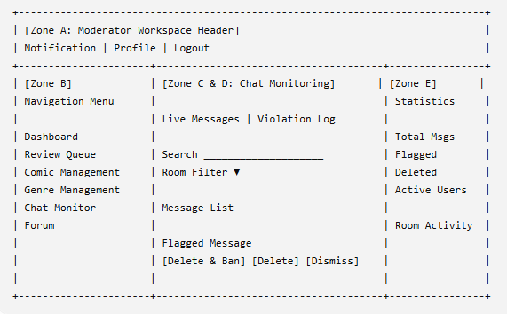

Zone descriptions:
- Zone A – Moderator Workspace Header: Displays the current moderator workspace context together with notification controls, profile access, and logout functionality. This header remains visible throughout the moderation workspace.
- Zone B – Moderator Navigation Menu: Provides navigation links to moderator modules including Dashboard, Review Queue, Comic Management, Genre Management, Chat Monitor, and Forum. The active module is highlighted to indicate the current page.
- Zone C – Chat Monitoring Controls: Provides monitoring tools including Live Messages and Violation Log views, message search functionality, and room filtering options. Moderators can quickly locate messages, users, or flagged content requiring review.
- Zone D – Chat Message Review Panel: Displays real-time chat messages and flagged conversations from monitored chat rooms. Moderators can review reported content, inspect message details, and perform moderation actions such as deleting messages, banning users, or dismissing reports.
- Zone E – Moderation Statistics Panel: Displays moderation metrics including total messages, flagged messages, deleted messages, active users, and room activity summaries. This section provides an overview of chat system health and moderation workload.

Key Interactions
User Action | What Happens | Notes
Switch between Live Messages and Violation Log | Updates the displayed message list according to the selected monitoring mode. | FT-13 AC-01
Search Messages or Users | Filters chat records matching the entered keyword. | FT-13 AC-01
Select Room Filter | Displays messages from the selected chat room. | FT-13 AC-01
Click Delete Only | Removes the selected message while retaining the associated user account. | FT-13 AC-02
Click Delete & Ban | Removes the selected message and bans the associated user after confirmation. | FT-13 AC-03
Click Dismiss | Marks the flagged message as reviewed without taking further action. | FT-13 AC-02
Click a Flagged Message | Displays additional moderation details and report information. | FT-13 AC-01
Retry After Error | Reloads chat data and retries failed moderation actions. | FT-13 NAC-01

Mockup
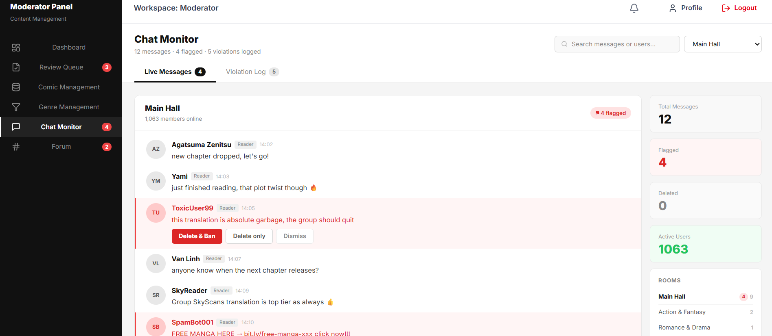
Figure 43: Chat Monitor

4.43 — Forum Management
Page ID | P-43
Screen name | Forum Management
Design file | Figma — Frame "Forum Management"
SRS Feature | FT-13
SRS Scenario | SC-05
Roles with access | Moderator

Screen States
State | When It Appears | Design File Frame
Loading | Forum threads and reports are being loaded. | Loading Frame
Empty | No forum threads match the selected filter. | Forum Management – Empty
Populated — default | Forum threads are available and displayed. | Forum Management – Default
Error | Thread data retrieval or moderation action fails.Data fetch failed or action failed | Error Frame
Filtered | Category, report, or search filters are applied. | Forum Management – Filtered

Layout Description
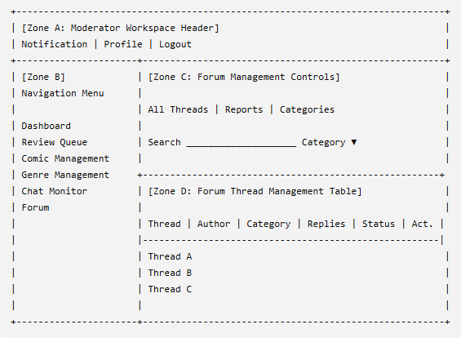

Zone descriptions:
- Zone A – Moderator Workspace Header: Displays the current moderator workspace context together with notification controls, profile access, and logout functionality.
- Zone B – Moderator Navigation Menu: Provides navigation links to moderator modules including Dashboard, Review Queue, Comic Management, Genre Management, Chat Monitor, and Forum. The active module is highlighted.
- Zone C – Forum Management Controls: Provides moderation controls including thread view tabs (All Threads, Reports, Categories), thread search functionality, and category filtering options. Moderators can quickly locate discussion threads and reported content requiring review.
- Zone D – Forum Thread Management Table: Displays forum threads together with thread title, author information, category, reply count, moderation status, and available actions. Moderators can review discussions and perform moderation actions such as viewing, locking, archiving, or deleting threads.

Key Interactions
User Action | What Happens | Notes
Click a Thread Title | Opens the selected forum thread and displays its details. | FT-13 AC-02
Switch Between All Threads, Reports, and Categories | Updates the displayed thread list according to the selected view. | FT-13 AC-02
Search for a Thread | Reloads the thread list using the entered keyword. | FT-13 AC-02
Select a Category Filter | Displays only threads belonging to the selected category. | FT-13 AC-02
Click View | Opens the selected thread for moderation review. | FT-13 AC-02
Click Lock | Locks the selected thread and prevents further replies after confirmation. | FT-13 AC-03
Click Archive | Moves the selected thread to archived status after confirmation. | FT-13 AC-03
Click Delete | Removes the selected thread after moderator confirmation. | FT-13 NAC-03
Retry After Error | Reloads forum data and retries failed moderation operations. | FT-13 NAC-01

Mockup
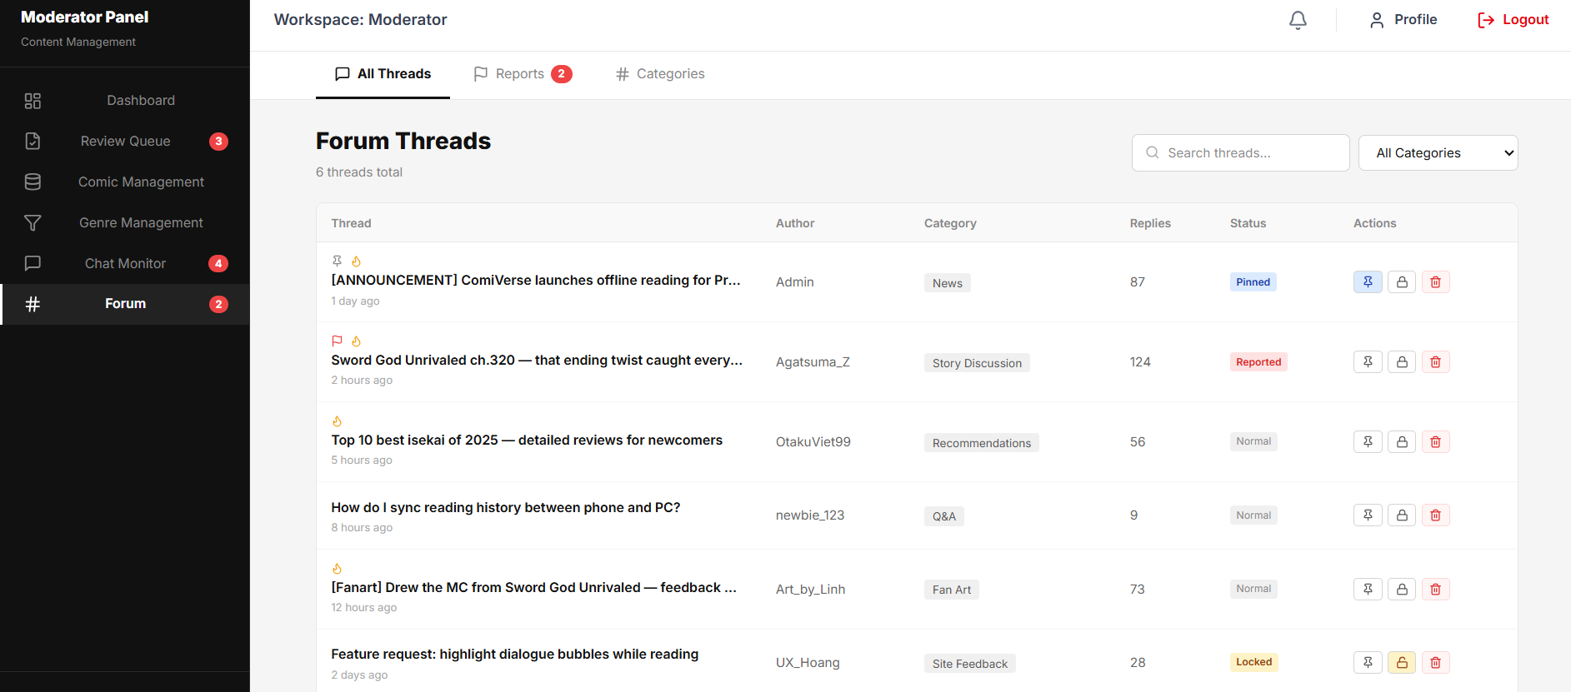
Figure 44: Forum Management

4.44 — Project Teams Management
Page ID | P-44
Screen name | Project Teams Management
Design file | Figma — Frame "Project Teams Management"
SRS Feature | FT-13
SRS Scenario | SC-02
Roles with access | Moderator

Screen States
State | When It Appears | Design File Frame
Loading | Project team data and progress information are being loaded. | Loading Frame
Empty | No project teams exist or no teams match the current criteria. | Project Teams Management – Empty
Populated — Default | Project teams are successfully displayed. | Project Teams Management – Default
Error | Project team retrieval or management action fails. | Error Frame
Filtered | Project teams are filtered by status or search criteria. | Project Teams Management – Filtered

Layout Description
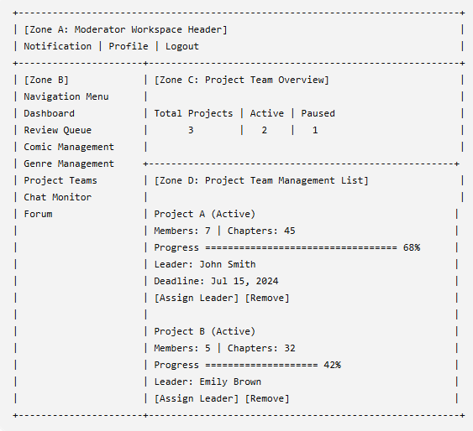

Zone descriptions:
- Zone A – Moderator Workspace Header: Displays the current moderator workspace context together with notification controls, profile access, and logout functionality.
- Zone B – Moderator Navigation Menu: Provides navigation links to moderator modules including Dashboard, Review Queue, Comic Management, Genre Management, Project Teams, Chat Monitor, and Forum. The active module is highlighted.
- Zone C – Project Team Overview: Displays summary statistics including total projects, active projects, and paused projects. Moderators can quickly monitor the overall status of translation teams across the platform.
- Zone D – Project Team Management List: Displays project teams together with project name, status, member count, chapter count, completion progress, assigned leader, project deadline, and management actions. Moderators can assign leaders and remove project teams when necessary.

Key Interactions
User Action | What Happens | Notes
Click Create Project Team | Opens the project team creation workflow. | FT-05 AC-01
Click a Project Team Card | Opens detailed information about the selected project team. | FT-06 AC-01
Click Assign Leader | Opens a member selection dialog and assigns a leader to the project team. | FT-06 AC-02
Click Remove | Displays a confirmation dialog and removes the selected project team after confirmation. | FT-06 AC-03
View Project Progress | Displays current completion progress and team statistics. | FT-06 AC-01
Access Unauthorized Project | System blocks access and displays an authorization error. | FT-06 NAC-01
Project Team Data Fails to Load | System displays an error message and provides a retry option. | FT-06 NAC-02
Retry After Error | Reloads project team data and retries the failed operation. | FT-06 NAC-02

Mockup

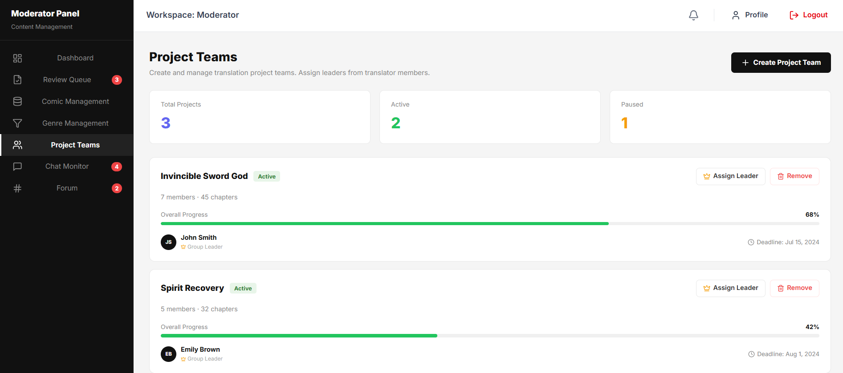
Figure 45: Project Teams Management

4.45 — Create Project Teams
Page ID | P-41
Screen name | Create Project Teams
Design file | Figma — Frame "Create Project Teams"
SRS Feature | FT-05 – Translation Group & Project Management
SRS Scenario | SC-02
Roles with access | Translator Group Owner, Group Manager, Admin

Screen States
State | When It Appears | Design File Frame
Loading | Required project creation data is being loaded. | Loading Frame
Populated — Default | The project creation form is displayed and ready for input. | Create Project Teams – Default
Validation Error | One or more required fields contain invalid or missing values. | Create Project Teams – Validation Error
Error | Failed to create the project or load required data. | Error Frame
Step Completed | Step 1 validation succeeds and the user proceeds to Step 2. | Create Project Teams – Step 2

Layout Description
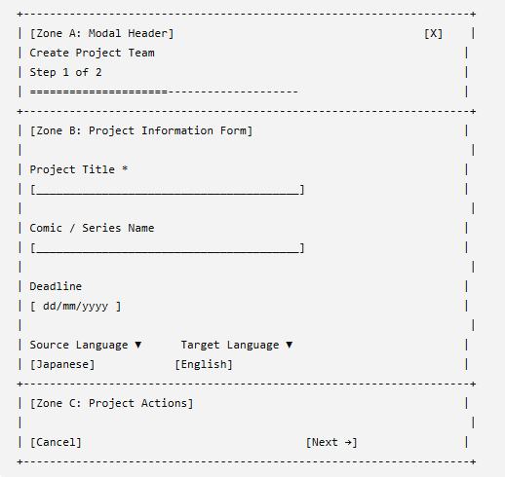

Zone descriptions:
- Zone A – Modal Header: Displays the project creation title, workflow step indicator, progress bar, and modal close action.
- Zone B – Project Information Form: Provides input fields for project title, comic or series name, deadline, source language, and target language required for project creation.
- Zone C – Project Actions: Provides controls for canceling the operation or proceeding to the next step of the project creation workflow.

Key Interactions
User Action | What Happens | Notes
Enter Project Title | Updates the project title field. | FT-05 AC-01
Enter Comic / Series Name | Updates the comic or series name field. | FT-05 AC-01
Select Deadline | Sets the project completion deadline. | FT-05 AC-01
Select Source Language | Updates the source language used for translation. | FT-05 AC-01
Select Target Language | Updates the target language used for translation. | FT-05 AC-01
Click Next | Validates required fields and proceeds to Step 2. | FT-05 AC-02
Click Cancel | Closes the modal without creating a project. | FT-05 AC-01
Click Close (X) | Closes the modal and discards unsaved changes. | FT-05 AC-01
Submit Incomplete Information | Validation errors are displayed and progression is blocked. | FT-05 NAC-01
Project Creation Initialization Fails | The system displays an error message and allows retry. | FT-05 NAC-02

Mockup
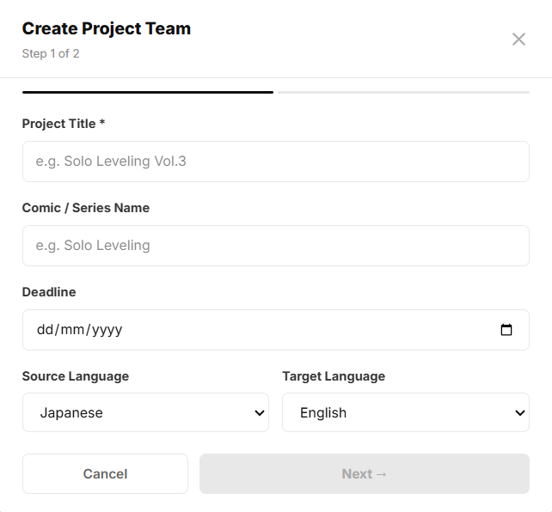
Figure 46 : Create Project Teams

4.46 — Admin Dashboard
Page ID | P-46
Screen name | Admin Dashboard
Design file | Figma — frame "Admin Dashboard"
SRS Feature | FT-18
SRS Scenario
Roles with access | Admin

Screen States
State | When It Appears | Design File Frame
Loading | Platform statistics, analytics metrics, and dashboard reports are being retrieved from the server. | Loading Frame
Empty | No statistical data is available for the selected reporting period. | Admin Dashboard – Empty
Populated — Default | Platform statistics, KPI cards, and analytics charts are successfully displayed. | Admin Dashboard – Default
Error | Dashboard statistics or analytics data cannot be loaded due to network, authorization, or server errors. | Error Frame
Filtered | Dashboard metrics and charts are displayed for the selected reporting period or filter criteria. | Admin Dashboard – Filtered

Layout Description
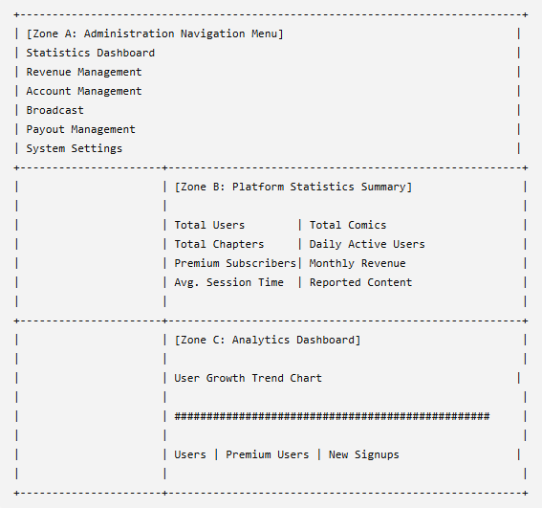

Zone descriptions:
- Zone A – Administration Navigation Menu: Provides navigation links to administrative modules including Statistics Dashboard, Revenue Management, Account Management, Broadcast, Payout Management, and System Settings.
- Zone B – Platform Statistics Summary: Displays key platform performance indicators including total users, comics, chapters, daily active users, premium subscribers, monthly revenue, average session duration, and reported content metrics.
- Zone C – Analytics Dashboard: Displays statistical charts and trend visualizations that help administrators monitor platform growth, user engagement, subscription performance, and overall system activity.

Key Interactions
User Action | What Happens | Notes
Open Statistics Dashboard | Loads platform statistics and analytics data. | FT-18 AC-01
View Statistics Card | Displays summarized information for the selected metric. | FT-18 AC-01
View Analytics Chart | Displays platform growth and engagement trends. | FT-18 AC-01
Hover Chart Data Point | Displays detailed values for the selected period. | FT-18 AC-02
Change Reporting Period | Refreshes dashboard statistics using the selected timeframe. | FT-18 AC-02
Refresh Dashboard | Reloads the latest platform statistics and reports. | FT-18 AC-01
Statistics Retrieval Fails | System displays an error message and provides a retry option. | FT-18 NAC-01
Retry After Error | Attempts to reload dashboard data. | FT-18 NAC-01

Mockup
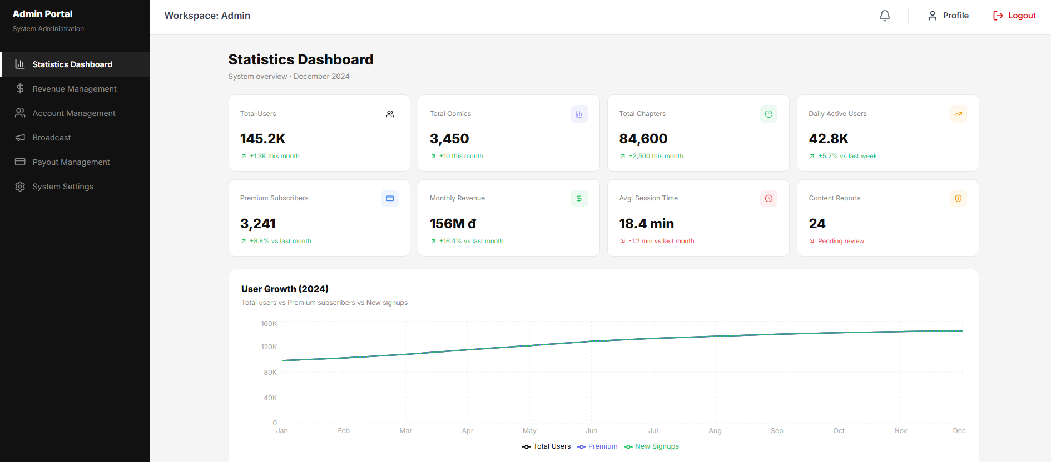
Figure 47:Admin Dashboard

4.47 — Revenue Management
Page ID | P-47
Screen name | Admin Revenue Management
Design file | Figma — frame "Admin Revenue Management"
SRS Feature | FT-16
SRS Scenario | SC-04
Roles with access | Admin

Screen States
State | When It Appears | Design File Frame
Loading | Revenue statistics and subscription data are being retrieved. | Admin Revenue Management — Loading
Empty | No revenue or subscription transactions are available for the selected period. | Admin Revenue Management — Empty
Populated — default | Revenue metrics, charts, and breakdown data are loaded successfully. | Admin Revenue Management — Default
Filtered | The Admin selects a different financial period or revenue category. | Admin Revenue Management — Filtered
Error | Revenue data cannot be loaded due to a network, database, or server error. | Admin Revenue Management — Error

Layout Description
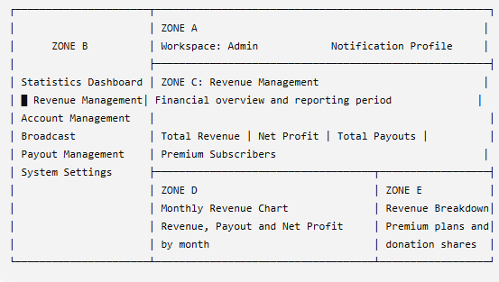
Zone descriptions:
- Zone A: Displays the Admin workspace header, notification control, profile access, and logout action.
- Zone B: Provides navigation to Admin modules. Revenue Management is highlighted as the active section.
- Zone C: Displays financial summary cards, including total revenue, net profit, total payouts, and premium subscribers.
- Zone D: Displays the monthly revenue chart with revenue, payout, and net-profit data.
- Zone E: Displays the revenue breakdown by subscription plan and donations.

Key Interactions
User Action | What Happens | Notes
View summary cards | Displays current revenue, profit, payout, and subscriber totals. | FT-16
Select reporting period | Refreshes statistics and charts for the selected period. | Data is recalculated
Hover over chart data | Displays detailed values for the selected month. | —
View revenue breakdown | Displays the percentage contributed by each revenue source. | FT-16
Click Payout Management | Opens the payout request management page. | Admin access only
Click another sidebar item | Navigates to the selected Admin module. | —
Click Profile | Opens the Admin profile page. | —
Click Logout | Ends the session and redirects to the Login page. | FT-01
Retry after an error | Reloads financial statistics and chart data. | Existing records are unchanged

Mockup
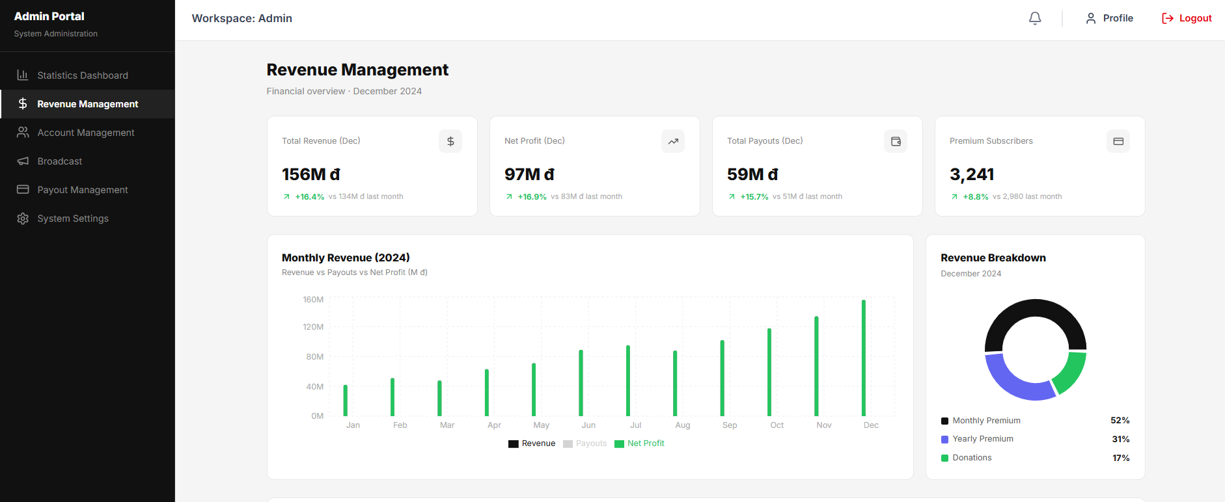
Figure 48:Admin Revenue Management

4.48 — Admin Account Management
Page ID | P-48
Screen name | Admin Account Management
Design file | Figma — frame "Admin Account Management"
SRS Feature | FT-18
Roles with access | Admin

Screen States
State | When It Appears | Design File Frame
Loading | User account data is being loaded. | Loading Frame
Empty | No user accounts match the current search or filter criteria. | Admin Account Management – Empty
Populated — default | User accounts are available and displayed. | Admin Account Management – Default
Error | Account retrieval or management action fails. | Error Frame
Filtered | Search keywords or role filters are applied. | Admin Account Management – Filtered

Layout Description
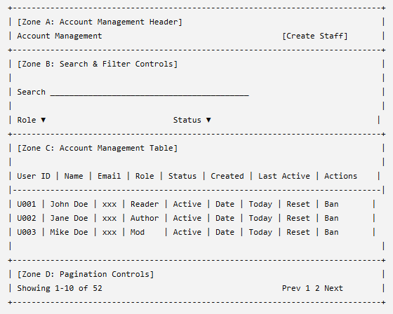

Zone descriptions:
- Zone A – Account Management Header: Displays the Account Management page title, account count summary, and the Create Staff Account action used to create new administrator or moderator accounts.
- Zone B – Search & Filter Controls: Provides account search and filtering functionality. Administrators can search accounts by name, email address, or username and filter records by role and account status.
- Zone C – Account Management Table: Displays user account information including user ID, name, email address, assigned role, account status, creation date, last activity timestamp, and available management actions. Administrators can manage user permissions and account status directly from this table.
- Zone D – Pagination Controls: Displays record count information and page navigation controls for browsing multiple pages of account records.

Key Interactions
User Action | What Happens | Notes
Click Create Staff Account | Opens the staff account creation form or modal. | FT-18 AC-01
Enter Search Keyword | Reloads the account table with matching user records. | FT-18 AC-01
Select Role Filter | Displays accounts matching the selected role. | FT-18 AC-01
Select Status Filter | Displays accounts matching the selected account status. | FT-18 AC-01
Click Reset PW | Displays a confirmation dialog and resets the selected user's password. | FT-18 AC-02
Click Ban | Displays a confirmation dialog and suspends the selected account after confirmation. | FT-18 AC-03
Click Unban | Restores access for a previously suspended account. | FT-18 AC-03
Click User Record | Opens the selected user's detailed account profile. | FT-18 AC-01
Change Page | Loads the selected page of account records. | FT-18 AC-01
Retry After Error | Reloads account data and retries the failed operation. | FT-18 NAC-01

Mockup
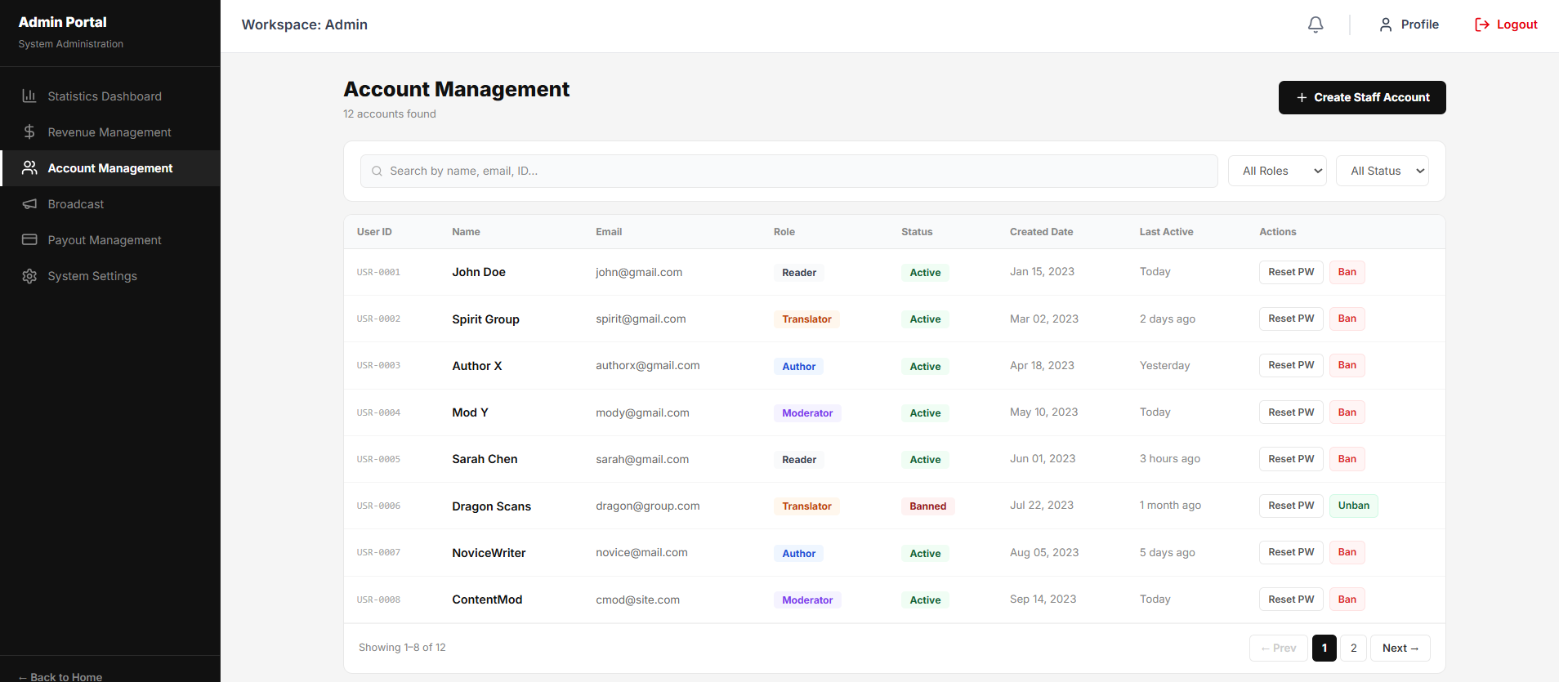
Figure 49:Admin Account Management

4.49 — Admin Broadcast
Page ID | P-49
Screen name | Admin Broadcast
Design file | Figma — Frame "Admin Broadcast"
SRS Feature | FT-11 – System Notification & Broadcast Management
SRS Scenario | SC-10 – System Administration
Roles with access | Admin

Screen States
State | When It Appears | Design File Frame
Loading | Broadcast data and announcement history are being loaded. | Loading Frame
Empty | No announcements have been sent yet. | Admin Broadcast – Empty
Populated — Default | Broadcast form and announcement history are successfully displayed. | Admin Broadcast – Default
Validation Error | Required fields are missing or contain invalid values. | Admin Broadcast – Validation Error
Error | Failed to send a broadcast or retrieve broadcast history. | Error Frame
Broadcast Sent | Announcement has been successfully delivered to the selected audience. | Admin Broadcast – Success

Layout Description
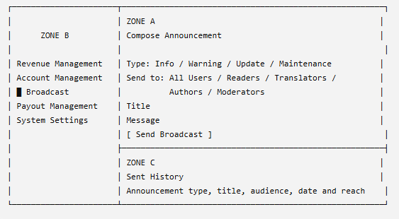
Zone descriptions:
- Zone A: Contains the broadcast composition form, including announcement type, target audience, title, message, and Send Broadcast button.
- Zone B: Provides navigation to Admin modules. Broadcast is highlighted as the active section.
- Zone C: Displays previously sent announcements with their type, title, content summary, target audience, delivery count, and sent time.

Key Interactions
User Action | What Happens | Notes
Select announcement type | Sets the broadcast as Info, Warning, Update, or Maintenance. | One type can be selected.
Select target audience | Defines which user roles receive the announcement. | All Users or one or more roles.
Enter title | Records the announcement title. | Required field.
Enter message | Records the broadcast content. | Required field and subject to length limits.
Click Send Broadcast | Validates and sends the announcement to the selected audience. | FT-11 AC-01
Submit missing fields | Displays validation errors and blocks submission. | FT-11 NAC-01
Broadcast succeeds | Displays a success message and adds the item to Sent History. | Delivery count is recorded.
Broadcast fails | Displays an error and allows retry. | Entered content is retained.
View Sent History | Displays previous announcements and delivery information. | Most recent announcements appear first.
Click another sidebar item | Navigates to the selected Admin module. | Admin access required.

Mockup
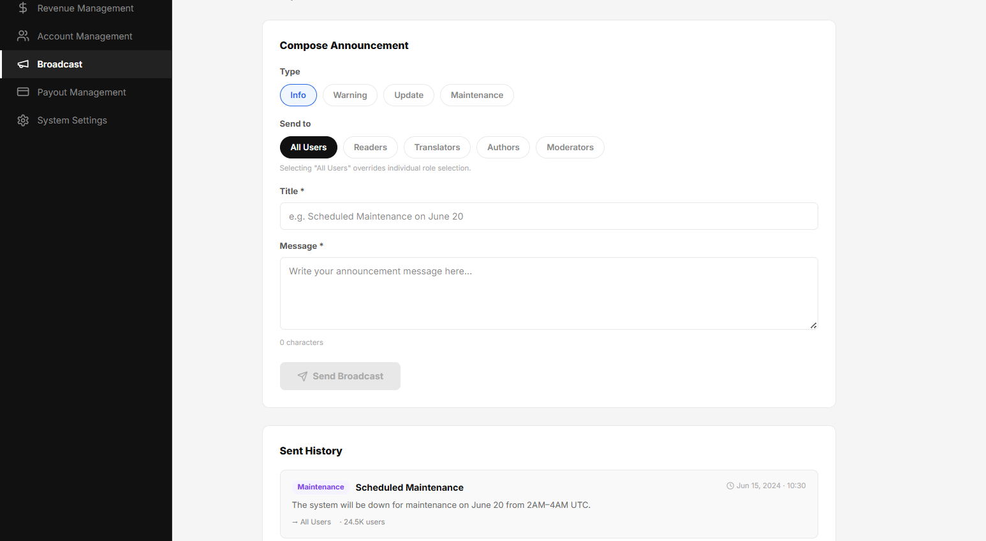
Figure 50 : Admin Broadcast

4.50 — Payout Management
Page ID | P-50
Screen name | Payout Management
Design file | Figma — Frame "Payout Management"
SRS Feature | FT-17 – Revenue & Payout Management
SRS Scenario | SC-10 – Manage Payout Requests
Roles with access | Admin

Screen States
State | When It Appears | Design File Frame
Loading | Payout requests and payout statistics are being retrieved from the server. | Loading Frame
Empty | No payout requests exist or no requests match the selected filters. | Payout Management – Empty
Populated — Default | Payout requests and payout statistics are successfully displayed. | Payout Management – Default
Error | Failed to load payout data or process a payout action. | Error Frame
Filtered | Status filters are applied to the payout request list. | Payout Management – Filtered

Layout Description
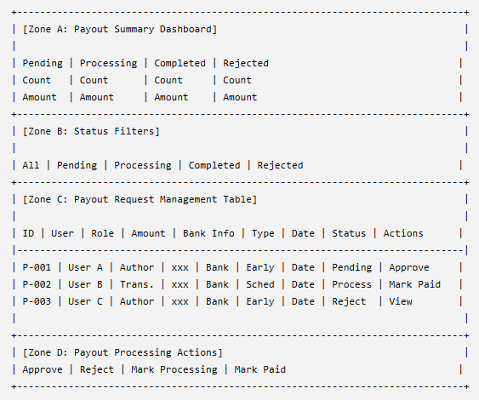

Zone descriptions:
- Zone A – Payout Summary Dashboard: Displays payout processing statistics including the number of pending, processing, completed, and rejected payout requests together with aggregated payout amounts for each category.
- Zone B – Status Filters: Provides quick filtering options for payout requests. Administrators can switch between All, Pending, Processing, Completed, and Rejected requests to review specific payout categories.
- Zone C – Payout Request Management Table: Displays payout requests submitted by Authors and Translators. Each record includes request identifier, user information, user role, payout amount, banking information, payout type, request date, processing status, and available administrative actions.
- Zone D – Payout Processing Actions: Provides administrative actions used to approve, reject, mark payouts as processing, or mark payouts as completed depending on the current payout status.

Key Interactions
User Action | What Happens | Notes
Click Status Filter | Reloads the payout request table using the selected status filter. | FT-17 AC-01
Click Approve | Approves the selected payout request and changes its status to Processing. | FT-17 AC-02
Click Reject | Displays a confirmation dialog and rejects the selected payout request. | FT-17 AC-03
Click Mark Paid | Marks the payout request as completed after payment has been successfully transferred. | FT-17 AC-04
View User Information | Displays additional payout request and user details. | FT-17 AC-01
Process Invalid Request | System blocks the action and displays a validation message. | FT-17 NAC-01
Attempt Duplicate Processing | System prevents duplicate payout processing. | FT-17 NAC-02
Retry After Error | Reloads payout data and retries the failed operation. | FT-17 NAC-03

Mockup
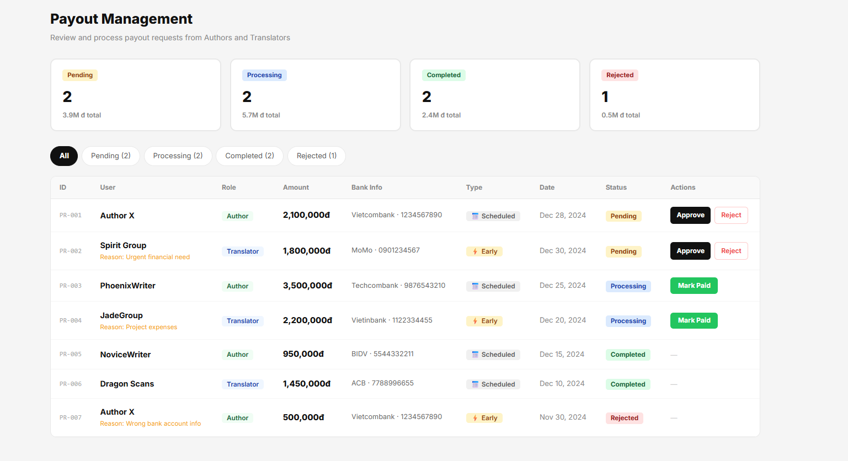
Figure 51 : Payout Management

4.51 — Premium Plan Setting
Page ID | P-51
Screen name | Premium Plan Setting
Design file | Figma — Frame "Premium Plan Setting"
SRS Feature | FT-18
SRS Scenario | SC-04
Roles with access | Admin

Screen States
State | When It Appears | Design File Frame
Loading | Premium plan prices and benefit information are being loaded. | Premium Plan Setting — Loading
Empty | No premium plan or benefit information has been configured. | Premium Plan Setting — Empty
Populated — Default | Monthly and yearly prices and premium benefits are displayed successfully. | Premium Plan Setting — Default
Editing | The Admin modifies plan prices or premium benefits. | Premium Plan Setting — Editing
Validation Error | A price is missing, invalid, or a benefit contains invalid content. | Premium Plan Setting — Validation Error
Error | Premium settings cannot be loaded or saved. | Premium Plan Setting — Error
Updated | Premium plan settings are saved successfully. | Premium Plan Setting — Success

Layout Description
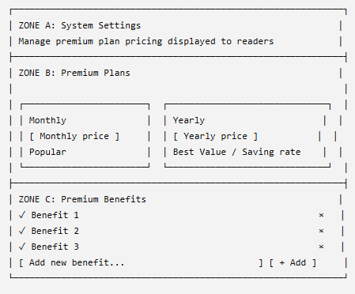

Zone descriptions:
- Zone A: Displays the System Settings title and page description.
- Zone B: Allows the Admin to configure monthly and yearly premium plan prices and displays plan labels and savings information.
- Zone C: Displays the list of premium benefits and allows benefits to be added or removed.

Key Interactions
User Action | What Happens | Notes
Edit monthly price | Updates the monthly premium price. | Must be a positive numeric value.
Edit yearly price | Updates the yearly premium price. | Must be a positive numeric value.
Change plan prices | The system recalculates the yearly saving percentage. | FT-18 AC-01
Enter a new benefit | Records a new premium benefit. | Cannot be empty.
Click Add | Adds the benefit to the premium benefit list. | FT-18 AC-02
Click × on a benefit | Removes the selected benefit. | Confirmation may be required.
Enter an invalid price | Displays a validation error and blocks saving. | FT-18 NAC-01
Save settings | Validates and updates premium plan information. | Changes are shown on the Premium upgrade page.
Save operation fails | Displays an error and allows retry. | Existing settings remain unchanged.
Save succeeds | Displays a success notification and refreshes the settings. | FT-18 AC-03

Mockup
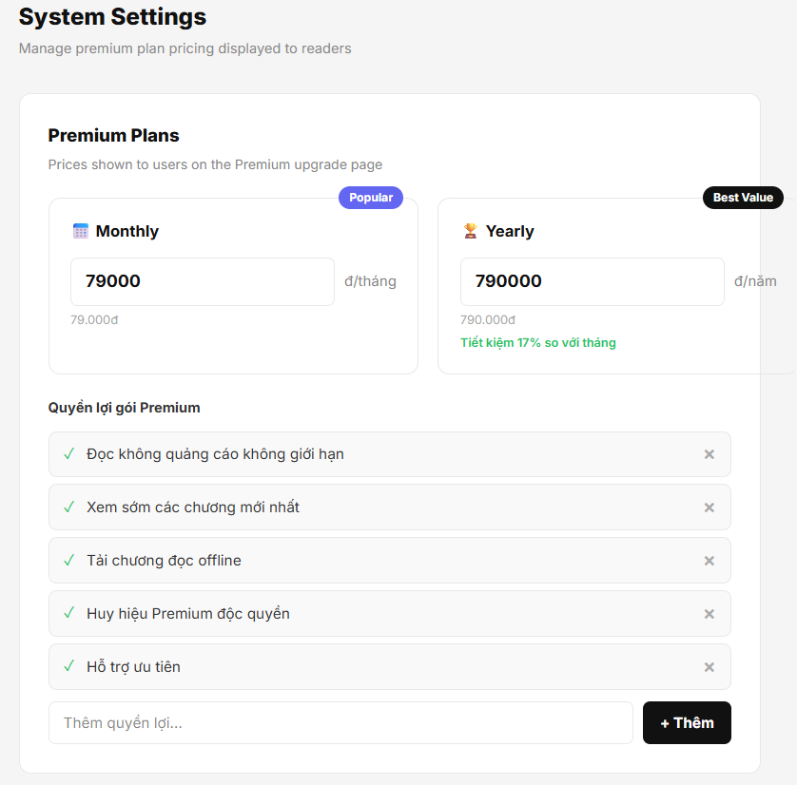
Figure 52: Premium Plan Setting

Part 5 — Responsive Rules

5.1 Navigation
Breakpoint | Behaviour
Desktop (≥ 1025px) | External: Full top navigation bar — 64px height; logo, primary navigation items, global search, notification bell, and user profile menu visible.  Internal: Full sidebar — 240px width; all navigation icons, labels, role-specific menu items, and badges visible.
Tablet (768–1024px) | External: Compact top navigation bar — 64px height; lower-priority items collapsed into an overflow menu.  Internal: Collapsed sidebar — 64px width; icons visible, labels revealed through tooltip or temporary expansion, badges remain visible.
Mobile (< 768px) | External: Top navigation bar — 56px height; hamburger menu opens a full-width overlay navigation drawer.  Internal: Hidden sidebar; hamburger menu opens a full-screen overlay drawer containing all navigation destinations and role-specific actions.

5.2 Content Layout
Breakpoint | Layout Behaviour
Desktop | Multi-column layout — 2–3 column card grids; full-width tables; side-by-side short form fields; 24px content padding on all sides.
Tablet | Adaptive layout — 2-column card grids; mixed side-by-side and stacked form fields; tables with many columns may require horizontal scrolling; 16–24px content padding.
Mobile | Single-column layout — vertically stacked cards and sections; all form fields displayed full-width; tables support horizontal scrolling or mobile-friendly representations; 16px content padding.

5.3 Data Tables
Pattern A — Horizontal scroll:
- Full table layout; the table container scrolls horizontally.
- Recommend sticky first column (e.g., ID, Name, Title) for tables with 5+ columns.
- Preserve header visibility during scrolling where practical.
- Use when: all columns are important and need to be compared at a glance.
Pattern B — Card reflow:
- Each table row transforms into an individual card on mobile devices.
- Cards display the 3–4 most important fields.
- Remaining fields are accessible via expand/collapse controls or a dedicated detail page.
- Row-level actions remain accessible within the card layout.
- Use when: rows represent entities (e.g., users, comic series, subscriptions, orders, translation requests) that naturally have a detail page.

5.4 Typography Scaling
Breakpoint | Heading Adjustment
Desktop | Full type scale as defined in Part 1.3
Tablet | Heading-1 reduces to the Heading-2 size; all other typography styles remain unchanged.
Mobile | Heading-1 reduces to approximately 24px; Heading-2 reduces to approximately 20px; body text sizes remain unchanged to preserve readability.

5.5 Touch Targets
Element | Visual Size | Minimum Touch Target
Primary buttons | [design spec] | 44px height minimum
Icon-only buttons | [e.g. 24px icon] | 44 × 44px tap area via padding
Checkboxes / radio | [e.g. 18px] | 44 × 44px tap area
Navigation items (drawer) | [variable] | 48px height minimum
Table row (mobile card) | [variable] | Full row tappable; 48px min height

Appendix A — Screen Index & Design File

A.1 Screen Index
Page ID | Screen Name | SRS Feature | Flows | Spec Section | Design Frame | Status
P-01 | Login Page | FT-01 | F-01 | 4.1 | Login Page | Approved
P-02 | Register | FT-01 | F-xx | 4.2 | Register Screen | Approved
P-03 | Recover Password | FT-01 | F-xx | 4.3 | Recover Password | Approved
P-04 | Homepage | FT-09, FT-12 | F-01 | 4.4 | Homepage | Approved
P-05 | Comic Details | FT-10, FT-12 | F-01, F-06 | 4.5 | Comic Details | Approved
P-06 | Comic Reader | FT-10, FT-11 | F-01, F-05 | 4.6 | Comic Reader | Approved
P-07 | Search & Filter Screen | FT-09 | F-06 | 4.7 | Search & Filter Screen | Approved
P-08 | Ranking Page | FT-12 | F-xx | 4.8 | Ranking Page | Approved
P-09 | Personal Library Page | FT-11 | F-05, F-06 | 4.9 | Personal Library Page | Approved
P-10 | Forum Page | FT-13 | F-03 | 4.10 | Forum Page | Approved
P-11 | Premium Plan Page | FT-16 | F-01 | 4.11 | Premium Plan Page | Approved
P-12 | Personal Profile | FT-02 | F-xx | 4.12 | Personal Profile | Approved
P-13 | Resign Translator Modal | FT-05 | F-xx | 4.13 | Resign Translator Modal | Approved
P-14 | User Change Password | FT-02 | F-xx | 4.14 | User Change Password | Approved
P-15 | Translator Dashboard | FT-17 | F-02 | 4.15 | Translator Dashboard | Approved
P-16 | Translator Projection | FT-06 | F-02 | 4.16 | Translator Projection | Approved
P-17 | Project Team Homepage | FT-06, FT-13 | F-02 | 4.17 | Project Team Homepage | Approved
P-18 | Translator Team Members | FT-06 | F-02 | 4.18 | Translator Team Members | Approved
P-19 | Translator Member Requests | FT-05 | F-xx | 4.19 | Translator Member Requests | Approved
P-20 | Members Application Profile | FT-05 | F-xx | 4.20 | Members Application Profile | Approved
P-21 | Translator Tasks Management | FT-07 | F-02 | 4.21 | Translator Tasks Management | Approved
P-22 | Trans. Leader Create Task Modal | FT-07 | F-02 | 4.22 | Trans. Leader Create Task Modal | Approved
P-23 | Trans. Leader View Task Modal | FT-07 | F-02 | 4.23 | Trans. Leader View Task Modal | Approved
P-24 | Translator Workspace Canvas | FT-08 | F-02 | 4.24 | Translator Workspace | Approved
P-25 | Translator Leader Task Review | FT-07, FT-08 | F-02 | 4.25 | Translator Leader Task Review | Approved
P-26 | Translator Project Team Setting | FT-06 | F-xx | 4.26 | Translator Project Team Setting | Approved
P-27 | Translator Payout / Revenue | FT-16 | F-08 | 4.27 | Translator Payout | Approved
P-28 | Request Payout Modal | FT-16 | F-08 | 4.28 | Request Payout Modal | Approved
P-29 | Author Dashboard | FT-17 | F-04 | 4.29 | Author Dashboard | Approved
P-30 | Author Comic Management | FT-03 | F-04 | 4.30 | Author Comic Management | Approved
P-31 | Upload New Comic Modal | FT-03 | F-04 | 4.31 | Upload New Comic Modal | Approved
P-32 | Author Comic Detail | FT-03 | F-04 | 4.32 | Author Comic Detail | Approved
P-33 | Author Add Chapter Modal | FT-03 | F-04 | 4.33 | Author Add New Chapter Modal | Approved
P-34 | Author Revenue Analytics | FT-16, FT-17 | F-04, F-08 | 4.34 | Author Revenue Analytics | Approved
P-35 | Author Payout | FT-16 | F-08 | 4.35 | Author Payout | Approved
P-36 | Moderator Dashboard | FT-17 | F-03 | 4.36 | Moderator Dashboard | Approved
P-37 | Comic Approval Queue | FT-04 | F-03 | 4.37 | Comic Approval Queue | Approved
P-38 | Moderator Compare Translation | FT-04, FT-08 | F-03 | 4.38 | Mod Compare Translation | Approved
P-39 | System Comic Management | FT-04 | F-03 | 4.39 | Comic Management | Approved
P-40 | Comic Genre Management | FT-18 | F-xx | 4.40 | Comic Genre Management | Approved
P-41 | Edit Genre | FT-18 | F-xx | 4.41 | Edit Genre | Approved
P-42 | Chat Monitor | FT-15 | F-03 | 4.42 | Chat Monitor | Approved
P-43 | Forum Management | FT-13, FT-15 | F-03 | 4.43 | Forum Management | Approved
P-44 | Project Teams Management | FT-06 | F-xx | 4.44 | Project Teams Management | Approved
P-45 | Create Project Teams | FT-05 | F-xx | 4.45 | Create Project Teams | Approved
P-46 | Admin Dashboard | FT-17 | F-07 | 4.46 | Admin Dashboard | Approved
P-47 | Admin Revenue Management | FT-16, FT-18 | F-08 | 4.47 | Admin Revenue Management | Approved
P-48 | Admin Account Management | FT-18 | F-xx | 4.48 | Admin Account Management | Approved
P-49 | Admin Broadcast | FT-14 | F-07 | 4.49 | Admin Broadcast | Approved
P-50 | Payout Management | FT-16, FT-18 | F-08 | 4.50 | Payout Management | Approved
P-51 | Premium Plan Setting | FT-16, FT-18 | F-xx | 4.51 | Premium Plan Setting | Approved

A.2 Design File Structure
[ComiVerse Master Design File]
│
├── Foundations
│ ├── Colour Palette (Dark Theme Tokens)
│ ├── Typography Scale
│ ├── Grid, Spacing & Elevations
│ ├── Iconography
│ └── Reader-Specific UI Components (Toolbars, Bubbles)
│
├── Flows
│ ├── [F-01] Authentication & Public Discovery Flow
│ ├── [F-02] Translator Project & Task Management Flow
│ ├── [F-03] Content Moderation & Compliance Flow
│ ├── [F-04] Author Comic Upload & Asset Management Flow
│ ├── [F-05] Cross-Platform Reading & Library Sync Flow
│ ├── [F-06] Search, Filter & Recommendation Flow
│ ├── [F-07] Global Admin Configuration Flow
│ └── [F-08] Monetization, Ledger & Payout Flow
│
├── Screens — Desktop
│ ├── [4.0] Shared Layout Shell (Authenticated)
│ │
│ ├── [Auth Module]/
│ │ ├── [P-01] Login Page
│ │ ├── [P-02] Register
│ │ └── [P-03] Recover Password
│ │
│ ├── [Core Discovery & Reader]/
│ │ ├── [P-04] Homepage
│ │ ├── [P-05] Comic Details
│ │ ├── [P-06] Comic Reader
│ │ │ ├── [P-06] Comic Reader — Loading (Skeleton)
│ │ │ ├── [P-06] Comic Reader — Populated (Vertical Scroll)
│ │ │ └── [P-06] Comic Reader — Error (Quarantined/Locked)
│ │ ├── [P-07] Search & Filter
│ │ ├── [P-08] Ranking Page
│ │ └── [P-09] Personal Library
│ │
│ ├── [Community & Payment]/
│ │ ├── [P-10] Forum Page
│ │ └── [P-11] Premium Plan Page
│ │
│ ├── [Translator Workspace]/
│ │ ├── [P-15] Translator Dashboard
│ │ ├── [P-16] Project Projection
│ │ ├── [P-21] Task Management
│ │ ├── [P-24] Translator Workspace Canvas
│ │ │ ├── [P-24] Workspace — Populated (Active Editor)
│ │ │ └── [P-24] Workspace — Empty (No Asset Uploaded)
│ │ └── [P-17 to P-26][Remaining Workspace Screens& Modals]
│ │
│ ├── [Creator Studio]/
│ │ ├── [P-29] Author Dashboard
│ │ ├── [P-30] Author Comic Manager
│ │ └── [P-31 to P-35] [Creator Screens & Analytics Modals]
│ │
│ ├── [Content Moderation Hub]/
│ │ ├── [P-36] Moderator Dashboard
│ │ ├── [P-37] Approval Queue
│ │ └── [P-38 to P-44] [Compliance & Ticket Processing Screens]
│ │
│ └── [Admin Control Panel]/
│ ├── [P-46] Admin Dashboard
│ ├── [P-47] Admin Revenue Mgt
│ └── [P-48 to P-51] [Global Settings & Account Mgt Screens]
│
└── 📱 Screens — Mobile
├── [Reader Engine Mobile Viewports]/
│ ├── [P-06] Comic Reader (Touch-optimized controls)
│ └── [P-04] Mobile Homepage & Discovery
└── [Mirror structure of Desktop for Auth & Discovery]

A.3 Glossary
Term | Definition
P-xx | Page ID — used in the Site Map and Part 4 for screen traceability.
F-xx | Flow ID — references a Screen Flow in Part 3.
FT-xx | SRS Feature ID.
SC-xx | SRS Scenario ID.
AC-xx | SRS Acceptance Criterion (positive condition).
NAC-xx | SRS Negative Acceptance Criterion (failure or boundary condition).
BV-xx | SRS Boundary Value note — valid/invalid ranges.
Screen state | A distinct visual variant of a screen (loading, empty, populated, error, etc.).
Happy path | The main flow where everything goes as expected.
Design file | Figma / draw.io source; the visual source of truth for all mockups.
Mockup | Hi-fi design showing final visual appearance; created from this spec.
Wireframe | Lo-fi layout sketch showing structure only; typically precedes the mockup.
App Shell | The global layout interface container (bg-base) that remains persistent across navigation modules.
2FA Verification | Two-Factor Authentication; a privileged access security check required for Admin or Moderator roles upon login.
Local Cache | Client-side local data storage used to temporarily cache un-synchronized payloads when network connectivity drops.
DMCA | Digital Millennium Copyright Act; statutory framework governing emergency takedown commands for copyright or safety violations.
Unpublish | An emergency moderation command that instantly removes global visibility of a comic asset.
Kanban Board / Column | A project workflow status visualization interface split into Backlog, In Progress, Under Review, and Completed.
Quality Gate | A system status-transition constraint that blocks submission if constituent sub-tasks remain incomplete or unapproved.
Watermark | A dynamic image protection overlay processing User ID + UTC timestamp onto premium chapter image assets.
Cooldown Period | A system engagement rate-limiting safety constraint that blocks consecutive database writes within a specific timeframe (e.g., 30 seconds for comments).
Anonymize | A scheduled background policy and audit task that scrubs PII and replaces email data with randomized hashes after 365 days of account inactivity.
PII | Personally Identifiable Information; sensitive user data subjected to automated privacy and anonymization cron jobs.
Strike Escalation | An automated policy tracking system that triggers global account suspension and token revocation upon the 3rd verified violation.
Wallet Deficit | A financial transaction failure condition triggered when a user requests premium content costing more tokens than available.
Ledger Imbalance | A critical financial database exception where transaction credits do not match debits, causing an atomic rollback.
Atomic Rollback | A database transaction safety mechanism that reverses conflicting or failed balance mutations to preserve the historical ledger state.
Optimistic Locking | A concurrency control pattern enforced to save the first edit request during glossary term or data updates and alert subsequent colliding users.
File Tree / Explorer | A layout zone panel showing hierarchical project documents, pages, and active chapter progress statistics.
Translation Canvas | The primary interactive editing workspace used to display comic pages, select text regions, and apply font formatting.
Glossary Tab | An active workspace component containing terminology references and standardized group translation data matching the source text.
Sync Scroll | A component configuration setting in the comparison view enabling dual-panel synchronous page scrolling.
Request Changes | A reviewer feedback workflow action that generates comment tickets, blocks approval transitions, and returns a task to an editable state.
Broadcast | An administrative console system notification tool to push Info, Warning, Update, or Maintenance notices to target role groups.
Card Reflow | A data table responsive UI pattern that dynamically collapses tabular rows into independent layout cards on mobile devices.

— End of Report —

